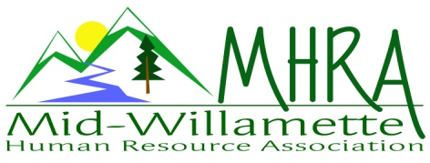
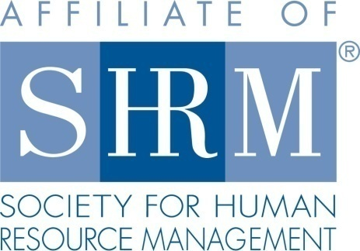

MHRA Mission Statement: to provide knowledge, skills, and resources while working to enhance personal and professional development.

BOARD MEETING (Chapter 202) March 28, 2018 7:30 a.m. to 9:00 Allan Bros. Albany, Oregon

DeeDee Kaundart | President |  | Lucille Valley | Website Chair
Kristen Taylor | Certification/Past President |  | Laurie LeRiche | /Workforce Readiness
Claudia Hamilton | Sponsorship Chair |  | Karlina Christensen Lee | Programming
Darcee LaCalli | Legislative Liaison |  | Kathy Westberg | Foundation Chair
Jason Bushnell | Treasurer/President Elect |  | Jill Sharp | Membership Chair
Bonny Ray | Secretary |  | Robin Bilyeu | Treasurer Elect
Ginny Kroshus | Diversity Chair
Highlighted designates PRESENT.

The meeting began at 7:30 a.m. Welcome by DeeDee of Robin Bilyeu who will be working with Jason as Treasurer Elect.

Approval of Minutes: The Board reviewed and approved the February 28, 2018 minutes with changes.

President’s Report: The March Chapter meeting was entertaining and engaging. The diversity focused training co-sponsored with the Employer Partnership for Diversity was also excellent and well attended. Thirteen MHRA members were registered. Dee Dee explained that she is looking at the RSVP count at meetings for the past few months to find out if the large number of individuals not showing up are the same individuals or a mixed group. If they are the same we could send a targeted message. If not we could send out a general e-mail reminding members about the cost to the chapter of RSVPing and not attending. Darcee volunteered to help approach members regarding this issue. We have an all day training HR Basics II sponsored by Barren Liebman on April 24, 2018. If Board members have made their SHRM Foundation donation they can attend for free plus the cost of meals which is $16.50. Attendees will receive 6.5 credits.

Treasurer’s Report: Jason reported on financials. There were more expenses then income. We received $115 for Eventbrite and at the door tickets for the March meeting. We expenses of $74 for Board meeting breakfast, $350 to the Farm Home for the chapter meeting breakfast, $30 for speaker gifts, $500 donation for the student NHRMA conference donation, $140 raised and sent to the SHRM Foundation. The assets were $19231.23. Jason also rolled $1000 into a new CD. We are expecting sponsorship checks from Colonial Life, Saalfeld Griggs, Barker Uerlings and NW Community Credit Union also provided a check today. Dee Dee asked if we should raffle off a ticket to the April HR Basics II to help with Foundation donations and the Board approved. Dee Dee will connect with Karlina and Kathy regarding this.

Certification: Kristen reported both the April Chapter meeting and the HR Basics training were submitted and approved for credit. May is pending. Our membership is growing which helps with our certification goals. Also if SHRM members renew before the end of 2018 our chapter will receive a payment.

Website: Lucille regularly goes to the website to update it including job and membership updates. She asked if we used the membership login page and if some content was for members only. We do not currently use this. She will activate 11 more people on the website now who are SHRM members but not certified. It would still be helpful to have a co-chair for the website if the Board can find a volunteer.

Workforce Readiness: Laurie is working with the NHRMA student conference and will be attending April 6-7 as part of her role with the Oregon State Council. The theme is HR Leaders of Tomorrow. It is in Seattle and 25 Oregon students are going with 10 from OSU, 14 from PSU and 2 from Willamette. Due to donations from chapters like ours all of the students who applied for funding are able to attend.

Sponsorship: Claudia reported that we have sponsors for April, June, August and September. NW Community Credit Union will also sponsor either May or July.

Membership Update: Jill sent an e-mail report. We have 111 members currently. Several who fell off of the roster have re-enrolled. She provided information about the past few meetings: In March 40 members sent at RSVP but only 21 showed. In February 44 sent an RSVP and only 28 showed. In December 42 sent an RSVP and only 20 showed. The Board brainstormed about this to try to solve this issue. It was decided that we would move the sign in table closer to the meeting room because it is possible that people are actually showing up but not signing in. We will also send a reminder e-mail about the importance of notifying Karlina or Kristen if plans change and members are unable to attend and know in advance. We will also pass around the sign in sheet for members/attendees to check off their names.

Legislative: Darcee reported that we met the goal of 10,000 advocacy members. DOL is also doing a pilot program were companies can admit they have FSLA issues and receive consultation/assistance in regard to how to fix the issues. Darcee asked if we could send a letter to companies such as Home Depot that have an HR department but are not attending or affiliated with MHRA. The Board also brainstormed about having an after-hours cocktail event to network with potential new members.

Programming: Karlina was absent but sent an update. The registrations for the April 24 HR Basics II are low so please encourage people to register and get the word out. The cost is $129 for non-members and $99 for MHRA members and includes meals plus 6.5 recertification credits.

Other Discussion: What if we had a spotlight on new members at the chapter meetings were Jill read the names of those in attendance and those unable to attend that day. Those in attendance could stand up and be recognized. Also we could do a Board spotlight every few months so that members could have insight into what each Board Member position looks like. Claudia will be highlighted in April.

Also, Dr. Laurence Houston would be a good future speaker on diversity.

Next Board Meeting: April 25, 2018 7:30-9:00am.

Meeting adjourned at 9:00 a.m.

