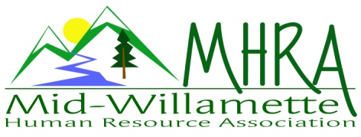
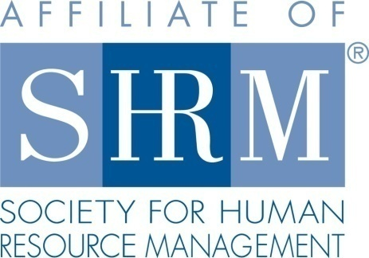

MHRA Mission Statement: to provide knowledge, skills, and resources while working to enhance personal and professional development.

BOARD MEETING (Chapter 202) September 26, 2018 7:30 a.m. to 9:00 Allan Bros. Albany, Oregon

DeeDee Kaundart | President |  | Lucille Valley | Website Chair
Kristen Taylor | Certification/Past President |  | Laurie LeRiche | /Workforce Readiness
Claudia Hamilton | Sponsorship Chair |  | Karlina Christensen Lee | Programming
Darcee LaCalli | Legislative Liaison |  | Kathy Westberg | Foundation Chair
Jason Bushnell | Treasurer/President Elect |  | Jill Sharp | Membership Chair
Bonny Ray | Secretary |  | Robin Bilyeu | Treasurer Elect
Ginny Kroshus | Diversity Chair
Highlighted designates PRESENT

The meeting began at 7:30 a.m. Welcome by DeeDee.

Approval of Minutes: The Board reviewed and approved the July 25, 2018 minutes.

President’s Report: DeeDee brought up information about StarChapter a software program to help chapters manage all their functions. She asked that each Board member review it. Kristen suggested asking if other chapters had experience with this on the Volunteer Leader Forum. DeeDee asked about what Board position individuals were interested in. DeeDee and Karlina are working on adding some programs. A possible session on suicide prevention in the workplace and on job descriptions are being considered.

Treasurer’s Report: Budget reports were submitted by Robyn for both August and September to the Board by e-mail. Notes from Budget Report: August paid their sponsorship for August. We purchased stamps and new checks. We received the NHRMA check for $1100. We were billed for our breakfast charges for June and August. Robyn was able to set up a P.O. Box for the year in Salem for $82. We received a quarterly payment from SHRM $668.75. We also raised $49 for the SHRM foundation with the basket raffle in September.

Membership update/report: Jill was absent.
Position Reports
Certification: Kristen provided an update on programming. The August program qualified for business credit with HRCI. This program and the September program were both well attended by certified members seeking credit. All other programs to date have been submitted and are pending final HRCI approval. SHRM PDC’s are complete. HRCI is now requiring Kristen to upload a program agenda for any program exceeding 3 credits. We will need to ask facilitators to provide this info as we plan future add on programs. All programs are submitted for credit through the end of December. Kristen is tracking certified membership and we are on track to increase this number for the year.

Website: Lucille provided an update by e-mail as she was not able to attend the Board meeting. She has completed a number of tasks. She posted all jobs requested by MHRA members, sent reminders of meetings/trainings/conferences twice monthly (at least 10-15 days out and one week before, posted SHRM news and conferences, and updated the website as appropriate.

Workforce Readiness: Laurie met with Michelle Swift regarding the OSU SHRM chapter. They have three initiatives that they would like help with. The first one is a speed networking/connecting event where MHRA members are invited to come to OSU campus to meet with students in January or February. The second initiative is member speakers. The student chapter is looking for speakers for the next school year. The chapter meets every Wednesdays in Austin Hall. For example this month the HR Director for NIKE is speaking. Anyone interested should call Michelle Swift. The third initiative is “meet the firm” employer visits. These visits are intended to give students an overview of business operations, meet and greet business partners in the firm and hear about initiatives. This is something they experienced in Seattle at the Student SHRM conference. It is meant for students to learn about organizations and is not necessarily intended for job seeking purposes. Anyone willing to partner with their organization for this event should contact Michelle Swift. Laurie is also discussing with Michelle Swift a joint Workforce Readiness opportunity for the student chapter and MHRA to complete together. This is in process but a possible topic relates reaching out to individuals with disabilities and/or veterans. Robin mentioned that checking with the employment department might be a good idea.

Secretary: Bonny provided an update on the NHRMA conference preparation. The conference dates are October 9-11, 2019. It will be held in Portland. For programming we have chosen the program tracks and are moving on to call for presenters to submit program ideas/proposals. Presenters will need to provide proposals by January 11, 2019. The program tracks include Talent Acquisition and Retention, Global HR, Strategic Leadership, Compensation and Benefit Strategies, Legal Compliance and Diversity and Inclusion. Laurie said some students may be willing to volunteer at the conference. Kristen mentioned that if the conference committee needed help to let her know.

Legislative: Darcee was absent.

Programming: Programing is on track for the remained of 2018. October is Stacey Stack from Express. November is Transgender issues in the workplace. December is Board Lead on HR Rockstars. Speakers are confirmed for January on engagement and February on legal updates. Karlina is working on the Board Lead Training program for December. It will be centered on HR Rock stars- with 5 focuses areas of:
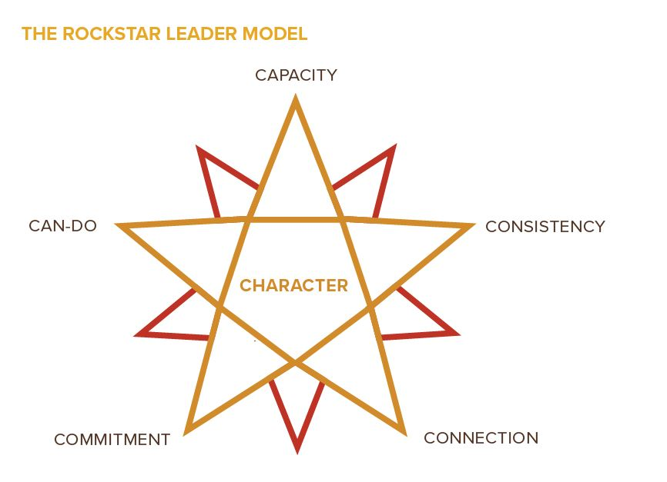

Kathy mentioned that Michelle Swift gave a relevant presentation on the Generations and it might be a good program topic for next year. It was relevant to the current workforce and an updated version of what was presented in the past.

Foundation: Our goal to meet at least $450 is not yet reached. Maybe we should try a 50/50 raffle. It would help to encourage individuals to bring checks or cash ahead of time for the raffle.

Diversity: Ginny was absent.

Sponsorship: LBCC provided their payment and they are sponsoring in October. Zoup is sponsoring in November. Sponsorship brought in $3150 so far this year.

Other Discussion:

Board Membership/Commitments – DeeDee asked members in attendance to state what they would like to do. Everyone in attendance will stay in their same role except Jason who will be President and Robin will be Treasurer. DeeDee will reach back out to Ginny, Jill and Lucille about their thoughts on positions for next year.

Bylaw 6.5 Election – Term of Office…DeeDee mentioned that the State SHRM Board changed their bylaws. Should we consider longer terms for Board Members? There was a discussion about this. DeeDee will send out the bylaws for Board Discussion to propose some language through e-mail and put it forth for Board consideration at the November Board meeting.

HRCI/Fee for 2019 – It has been waived for 2019.

Fundraising Event – A 50/50 raffle in November was considered.

1st time free for membership meetings – This was discussed. Should it be just for individuals seeking chapter membership?

Star Chapter- Give DeeDee any further feedback.

Gift Bags for December Meeting/Request $200 was discussed and approved.

Next Board Meeting date: October 24, 2018

Next Board Meeting: November, 2018 7:30 a.m. to 9:00 a.m.

Meeting adjourned at 9:00 a.m.

