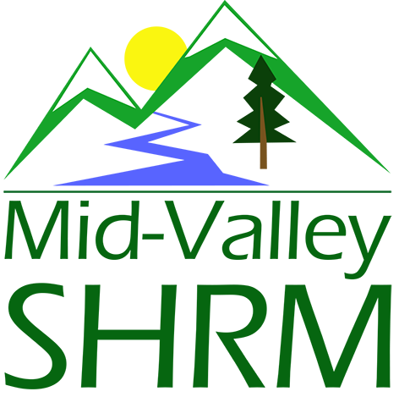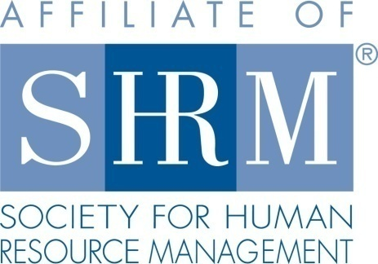

Mid-Valley SHRM Mission Statement: To provide knowledge, skills, and resources while working to enhance personal and professional development.

BOARD MEETING (Chapter 202) October 23, 2019 7:30 a.m. - 9:15 a.m. Allan Bros. Coffee House/ Albany, Oregon

DeeDee Kaundart | Past President |  | Claudia Hamilton | Sponsorship Chair
Jason Bushnell | President |  | Jill Sharp | Membership Chair & President Elect
Kristen Taylor | Certification Chair |  | Darcee LaCalli | Legislative Liaison
Kathy Westberg | Foundation Chair |  | Bonny Ray | Secretary
Susan Ellingson | Website Chair |  | Karlina Christensen | Programming
Tim Nortz | Workforce Readiness |  | Lucille Valley | Diversity Chair
Robin Bilyeu | Treasurer

Highlight if PRESENT

The Board Meeting began at 7:30 a.m.
Approval of Minutes: The minutes from the September meeting were reviewed and approved. Kathy motioned for approval and Darcee seconded.

President’s Updates and General Discussion Items:

- NHRMA Feedback – Jason, Robin, Darcee, Jill, Karlina, Claudia, Bonny attended. One speaker was in a car accident and a back up was able to arrive. We need to consider what are back up is in the event that we do not have a speaker showed up for our monthly meeting. Darcee said that there is a thumb drive in the bag. She will remind us of the back up program. Darcee also discussed that we could do table top discussion on legislative
- A job posting company has reached out to Jason and would like us to send a message to our members for awareness. They would like us to send an announcement about the service. Susan would like us to send it. We discussed promoting it though linked in and facebook. We agree a one-time message could be good. Jill will put it on the slide.
- We need put a vote to our member body for Board Positions.
- Jill completed a membership Audit on Website member list. Jill will have update for October 31st to ensure active members get an email for voting.

- Everyone except Dee Dee and Bonny have agreed to hold positions next year. We must send voting out by the end of October. We need to know the format. Jason will follow up with DeeDee for process in past. Susan may be able to do it via survey monkey.
- Jason will be gone in November. Jill will introduce the speaker. We need to get speaker gift for our next monthly meeting. It may be good to keep a few in the money bag. Typically we give $10.00 for the speaker gift. We will make plans to meet up with Karlina. Paula has not asked for help with handouts or other material yet.

Position Reports:

Treasurer:
SHRM Payment, Sponsor for November, Board Breakfast. Income in. Expecting more from SHRM. NHRMA payment. We need to vote to extend 3 month CD. See report for information on higher interest on a savings account. We discussed taking money out of CD and put it into a higher interest saving account. We used to say if we have one year of liquid. It makes sense to get a higher yield. There is penalty, even if we need to take it out early with the restriction. Our checking must have a minimum of $10,000 grand to avoid fees. We plan to move $10,000. New Citizens CD – We will move CD that matures in November, and Money from Checking to open two CD, 1 year at 2.25% and a 2 year APY 2.3%. Kathy motioned to move the money, Lucille seconded. We will look at the other CD that mature in February at a later time. The report was approved by all. Remember to make your donation to SHRM. $ 30.00.
- Completed budget report for the month
  - SHRM Quarterly deposit came through
  - Need to renew 3-month CD
- Options for better investments
  - High-Yield Online Savings
    - Citizens Access has 2% APY with $5,000 minimum balance (no fees)
      - Cannot write checks from & only 6 withdrawals/transfers per statement cycle (meant to be savings account)
    - https://www.nerdwallet.com/best/banking/high-yield-online-savings-accounts
  - CDs
    - Citizens Access has minimum deposit of $5000
      - 6 month APY 1.75%
      - 1 year APY 2.25%
      - 2 year APY 2.30%
    - https://www.nerdwallet.com/best/banking/cd-rates
- Reminder to everyone to go online and make your foundation donations. The Giving Report on SHRM Foundation was updated 8/21/2019. Donations from our Chapter were up to $337.50, including:
  - $177.50 from the Chapter ($25 additional raised but hasn’t been donated yet)
  - Jason Bushnell
  - Karlina Christensen-Lee
  - Deedee Kaundart
  - Renew Consulting (Darcee LaCalli)
  - Patricia Schilling
  - Kristen Taylor

- Talked about scholarships.
- Next meeting will have a personality assessment available. Leadership test – Different rates. Jill will make a slide and make an announcement at the November meeting.
- We are paying the speaker in December. Her fees and sponsorship may cancel out. Eventbrite invitation out.

Certification: Programming has been submitted for remainder of 2019. I will need to renew our Approved Provider status in December. The HRCI website has been updated. It’s not terrible, but its not better. It’s almost like they want to make things incrementally more complicated until SHRM puts them out of business.

Foundation: Kathy provided the following update: She plans to do basket for November meeting. The Board voted to pay the remaining budgeted number to SHRM Foundation to get recognized at VLMB. Jason motioned, Kathy second, all agreed

Legislative:
Darcee provided the following update:
Square – Darcee was able to use a square at NHRMA, She researched for our meetings. Usually non members forget to pay. It could cost them $29.00. 2.6% + .10 for each transaction.
Disclose that charges will be added at the door. We discussed paying more at the door. $15.00 at the door $30.00 non-members using credit card and cash. Remind members. Jill will make a slide.

What would late registration be. What is the date at Trillium. Friday before meeting. Registration closes Friday at 5:00 p.m. Monday might be better. People may know more about their schedule. Cut off Monday at noon. Talk to Karlina about cutting off Eventbrite.

EEOC will not require wage reviews next year.

EEOC won't renew pay data collection after current cycle
- The U.S. Equal Employment Opportunity Commission (EEOC) will not renew its request to collect employer pay data, also known as EEO-1 Component 2, according to a Notice of Information Collection published Thursday.
- The notice will not affect the EEOC's collection of Component 2 data for the 2017 and 2018 calendar years that employers with 100 or more employees and certain federal contractors are required to submit to the agency by Sept. 30, it said in a statement. Further, the agency said it must seek a three-year approval on the extension of EEO-1 Component 1 demographic data collection from the White House's Office of Management and Budget (OMB). The EEOC said it intends to request this approval under a new control number, one separate from the control number under which Component 1 data collection for 2016, 2017 and 2018 — and Component 2 data collection for 2017 and 2018 — have been approved.
- The EEOC said its Office of Enterprise Data and Analytics found the agency's method of calculating the burden of EEO-1 data collection on employers for its previous EEO-1 approval "insufficiently calculated" that burden. The agency has now developed a "more accurate" methodology estimating a higher burden, it said; it still intends to renew collection of Component 1 data despite this burden but it does not intend to do the same for Component 2. The notice is subject to a public comment period ending November 12.
- Square Point of Sale-Free Software/1st Reader is Free/2.6% + 10¢ per transaction

Programming: Karlina was absent but provided an update. We will need someone to meet the speaker for the November meeting as she will by flying to VLBM. It is Paula Barran.
- December meeting offers 4 ticket types. There are the breakfast only for member and non-member and also additional tickets to take the leadership development assessment that goes with the training at a reduced price. We will be paying our presenter for this.
- Eventbrite is built for January already.
- On a side note we need to put the board list for 2020 to our members to vote on.

Past President Report: DeeDee was not in attendance.

Sponsorship:
Claudia reported on the following:
November – All Star
December – Red Kite

January 2019 was Best Western and was a trade. We are set to meet budget.

Membership:
Membership Audit spreadsheet was completed by Jill and sent by Jason to SHRM by the due date.

CURRENT ACTIVE MEMBER STATS

Current active member count: 114

There is no word on an audit yet. SHRM is behind due to staff turnover.

Jill wants to compare the Eventbrite list and the membership list to see if we are capturing all members.
Jill also asked about changing the e-mails. Jason reported that Karlina has a quote from g-mail and we are waiting for one from Yahoo.

CURRENT ACTIVE MEMBER STATS

CURRENT ACTIVE MEMBER STATS

Current active member count: 114

New Members:

Name | Company | Title | Date
No New Members

Members that are no longer affiliated

Name | Company | Title | Date

ACTIVITIES

- Received and completed SHRM 2019 Chapter Audit report by due date.
- Audited Email List from website to member list:
  - We have 114 active members.
  - 42 of our active members are not listed on the website email list.
  - 40 active members on the list do not have an emails listed
  - 23 have emails that do not match SHRM List
  - 64 inactive members on the list are not listed.
- Inactivated all members that are expired.
- Created list of members to add to web list.

TO DO
- Create slides for November Meeting
- Create slips for door prize entries when no business card is available.
- Add missing members to web list.
Current active member count: 114

New Members:

Name | Company | Title | Date
No New Members

Members that are no longer affiliated

Name | Company | Title | Date

SEPTEMBER MEETING STATS

Total Registered: 27
Meeting Attendance: 28 (Members 26 Non-Members: 1 Speaker: 1)
No Shows: 2
Attendees Not Registered: 4 (including speaker)
Members Paid at Door: 4 = $40.00
No Charge Speaker = 1

Diversity: Lucille reported the following: October 15, 2019 joined webcast. Work place Toxicity. 58% leave for jobs because of Manager. 70% Managers set the culture for the workplace. 1-3 say their manager does not know how to lead them. 3-10 do not encourage open communication and transparency. Look for slides from Lucille.

Workforce Readiness: OSU Chapter Meeting. Ideas for programming. Can they volunteer for Check In or other events. We would welcome the help. But what does it mean, they do not need to pay?
Our program is already scheduled. Too many unknowns. Discuss at future meeting with Tim.

I am currently working on connecting with the state level workforce readiness Director. In the meantime, I have met with the OSU SHRM chapter and Michelle Swift for my 2nd monthly meeting.
The student chapter has several goals for 2019-20:
- Increase membership
- Diversify programming
- Become more involved in MVSHRM

To discuss with Mid-Valley Board:

- Ideas for programming with the student chapter.
  - They are considering Diversity and Inclusion, HR metrics and Professional attire with respect to gender identity in the workplace.
- They would like to assist MV SHRM with monthly programming or other events to stay involved. Can they volunteer for check-in or other events?

Meeting adjourned at 9:00 a.m.

Next Meeting: November 27, 2019

.

.

