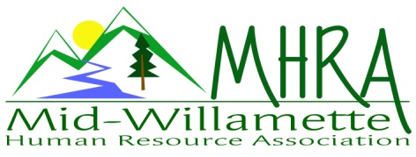
1 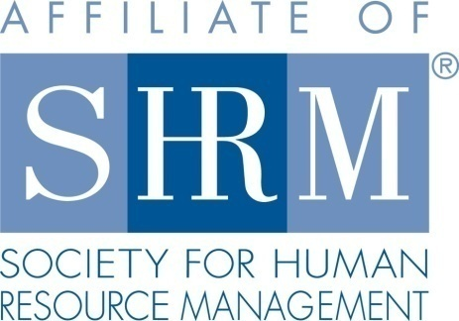

MHRA Mission Statement: to provide knowledge, skills, and resources while working to enhance personal and professional development.

BOARD MEETING (Chapter 202) May 24, 2017 7:30 a.m. to 9:00 Allan Bros. Albany, Oregon

Kristen Taylor | President |  | Jared Haddock | Website Chair
DeeDee Gordon | Certification/President Elect |  | Laurie LeRiche | Diversity/Workforce Readiness
Claudia Hamilton | Sponsorship Chair |  | Karlina Christensen Lee | Programming
Darcee LaCalli | Legislative |  | Kathy Westberg | Foundation Chair
Jason Bushnell | Treasurer |  | Cindy Bene | Membership Chair
Bonny Ray | Past President/Secretary
Highlighted designates PRESENT.

The meeting began at 7:45 a.m.

Approval of Minutes: The April 2017 minutes were reviewed and Karlina moved for approval. Jason seconded the motion. The minutes were approved.

June Membership Meeting Logistics: Kristen talked to the coordinator about the space issue and it will be resolved. They had multiple meetings going on that day and will set us up differently in the future. The location is good overall. There was a mix up with the June/July registration link and Karlina is reaching out to those registered to clarify. June is Jennifer Bouman Steagall speaking on culture and she is sponsoring. Darcee will do membership check in at the meeting. We have books for door prizes.

Treasurer’s Report: Jason passed out the budget. It was fantastic month with $3000 in income and $700 in expenses. We are almost to $20,000 in total assets! Sponsorship of $900 came in this month. Claudia will send Jason an e-mail regarding sponsorship charges to verify what has been received and what is pending. We received $2000 from SHRM. It is unclear what the payment is for but it is the first payment we received from SHRM this year. Kristen will e-mail Kimberly or Diana to find out what this payment is for. We received the Platinum Excel award. Expense wise we were invoiced for breakfast costs at Farm Home and Board breakfast costs. Our three-month CD is rolling over. The Board voted to roll the CD over. Citizen Bank did not call Karlina back about the Eventbrite issues. Karlina will need to purchase more Starbuck cards for speaker gifts so this will be an additional expense.

Membership Update: Kristen received all the membership materials that Cindy had. She also received an updated audit list from Kimberly at SHRM. We are at 108 to SHRM’s 101 so Kristen is reconciling this. We might compare the audit list from last fall to see who else has fallen off as we were closer to 118 at that time. Kristen also sent designation forms to five individuals who expressed membership interest at the website. We should have designation forms at the meeting. It would be a good idea to do a welcome card or letter to new members. Karlina’s team can provide this.

Position Reports

Certification: Credits have been submitted through September and approved. One individual passed her exam and was acknowledged.

Workforce Readiness/Diversity: The student chapter is up and running and it will take some coordinating to see how we can support them. We could reach out and sponsor pizza for their first meeting. It would be helpful to have someone in the roll of college relations.

Foundation: Dee Dee provided some information in Kathy’s absence. We have a $140 donation in February and Dee Dee’s $30 contribution. Darcee and Bonny have made their donations also. Our leadership team donations do not count toward the chapter donation amount. They count toward the state council contributions. We need another foundation fundraiser. Would sport’s fans donate toward a signed football from Joey Harrington? Karlina has one. The Board thought so. We also will have a ticket to the strategic conference to raffle off. Claudia also has an OSU basketball connection that might be willing to donate a ball. We are trying to top $345 from last year. Dee Dee suggested we have a change jar for SHRM donations at our meetings. Claudia recommended a 50/50 raffle also. We should also announce on the Eventbrite when we are doing the raffle so that members can bring cash.

Legislative: The overtime rule is delayed until June 30, 2017. Trump also signed a law regarding drug testing individuals to qualify for unemployment. It goes back to the house. Pay Equity is pending probably headed to a vote soon.

Programming:. Jennifer is June. July is the Mental Illness in the workplace topic. October will be a speaker named Emily Drew from Willamette on facilitating difficult conversations which is a diversity topic. This might be a possible ½ day workshop. She provided training at Bonny’s employer and it was an excellent three hour presentation. There is a comedian who will come in March next year that Karlina has booked. This would be a good evening meeting. Karlina is working on lining up a speaker for a ½ day training. December topic may be an improv group coming in with their presentation focus on scenarios HR professionals encounter. The Board agreed to pay $200 for this. November is Deborah Jefferies and she will be speaking on a strategic topic. There is an individual willing to speak on Harassment. Darcee has her contact information and will give it to Karlina. SamFit and WinCo are possible ideas for new sponsors in the future.

Sponsorship: In June Jennifer will sponsor at $300. July is AKT sponsoring at $450. September is Corvallis Clinic $450. October is Willamette Neighborhood Housing at $300. We could possibly move our October sponsor to November if we charge for our October meeting. Saafeld Griggs has not sponsored yet so Claudia will approach them about August where they could give a legislative update to. Best Western is sponsoring our speaker’s hotel for July. Karlina has two possible sponsors Pacific Source and a tech company that she will pass on to Claudia.

Website: No Update.

Workforce Readiness: No Update

Future Planning: We are working on at least one half day program for the future that we could charge for. Board succession planning is also a concern. Kristen is willing to take on membership next year. Jill Sharp might want to join our group from Garmin.

Next Board Meeting: June 28, 2017 same place and time.

Meeting adjourned at 8:55 a.m.

