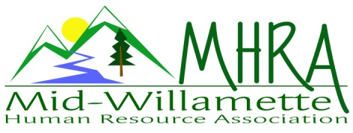
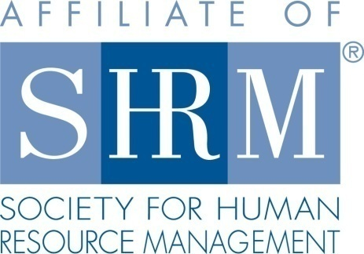

MHRA Mission Statement: to provide knowledge, skills, and resources while working to enhance personal and professional development.

BOARD MEETING (Chapter 202) February 25, 2015, 7:30 – 9:00 am – Corvallis, Oregon

Jean Bonifas | Past President/Membership
DeeDee Gordon | Diversity Chair |  | Robynn Pease | Workforce Readiness
Claudia Hamilton | Sponsorship Chair |  | Karlina Christensen Lee | President
 |  |  | Kathy Westberg | Foundation Chair
Jason Bushnell | Treasurer |  | Jared Haddock | Website Chair
Bonny Ray | President Elect |  | Cindy Bene | Legislative Chair
Kristen Taylor | Secretary/Certification
Highlighted designates PRESENT.

Approval of Minutes: Jared moved to approve to accept the January 28, 2015, minutes. Robynn seconded. Motion carried.

SHAPE: Karlina printed SHAPE books, will be distributed electronically as well. Each board meeting will dedicate some time to assess our current SHAPE progress.

Programming: Bonny presented survey results. Members were asked about SHRM credentials. 5 have obtained, 1 wants more information, 4 not pursuing. Every respondent really liked the new venue. There was some feedback about the food. Program content responses were very positive. Future programs for safety, team building, and performance reviews were suggested. Claudia has a safety director who may be able to do a program later this year. Suggested speaker for union/labor relations is not local. He may still speak for us while he is here on other business. Member interest is high in this area. 35% stated interest in attending 2 half day events. Interest was higher in attending a single event. Cascade employer council has offered to do a free training for the chapter. Bonny will follow up with Ann Gilles to firm up program length for the August meeting. Jennifer Paul (speaker last month) expressed interest in becoming more involved with the chapter. March and April programs are solidified.

Sponsorship: Saalfeld Griggs is committed to sponsor again this year, but not finalized yet. Corvallis Knights are signed up for March. OSU credit union is in the works. 4 total sponsorships are confirmed. There are still many opportunities in the works. Goal is for each remaining meeting to be sponsored.

Treasurer’s Report: Jason not in attendance today. Treasurer’s report will be sent electronically for the group to review.

SHRM/HRCI Certification: Perhaps try to partner with the OSU study group. They are switching to the SHRM format for study groups. If we can partner and offset costs for course it may qualify us for the SHAPE initiative. Reach out to Dennis Carr to see if this is a possibility. All programs that were previously approved for HRCI are now also approved for SHRM credit. Waiting on May program information as next needed information. We asked members to stand at the January meeting who have already obtained the SHRM credential. There were 5 in attendance. Consider offering a scholarship process for members to attend the SHRM study group. Kristen will lead a task force to explore the partnership option and work with Jean. If we are announcing the course, they may be open to announcing MHRA events to class participants. Next class starts in Spring--April 2, 2015.

Minutes—February 25, 2015
Page 2

Diversity: DeeDee not in attendance today.

Foundation: Offers scholarships to take SHRM test and/or materials. We raised $105.00 at the last meeting for the raffle held on 1.28.15. OEC may need our help obtaining SHRM credits for the State Conference. Perhaps exchange for a free registration we could raffle.

Legislative Updates: Cindy sent an email yesterday to the group for review. Need to get the information to members. Jared will email member group each month as a link with the monthly meeting reminders. Updates will be posted to the website.

Membership: There were 40 people who rsvp’d for the January meeting. This is higher than normal. Some OSU employees asking about options for some evening events since mornings are so hard to attend for this group. Jean and Robynn to reach out the head of OSU business centers to encourage support for member attendance at chapter meetings. Consider hosting a SHRM CP/SCP informational promotion in the evening at the Campus Hilton. There are at least 5 new members since the beginning of the year. Another attended the January event, but is not local, so she will not designate, but wants to attend meetings as available. In addition to a regular May meeting we may also do an additional networking event. Details still to be confirmed. Also look at an August membership event at Sage Gardens. Claudia suggested doing some member spotlight opportunities at meetings if people want to share additional information or promote their organizations.

Workforce Readiness: Robynn is setting up a meeting with the career readiness department at OSU. Will review options for SHRM promotion for graduating students. David Byrd from LBCC works with over 400 students needing intern placement. Program is growing, hoping to double. Need company hosts. Consider inviting him to do an announcement at a chapter program or networking meeting. Internship programs can be either paid or unpaid. Consider a website section that links opportunities for internships. ASGR meeting to support veterans in the work place tomorrow—Robynn, Karlina and DeeDee.

Website: Jared cross checked the email list to make sure all members are receiving updated. Icon on the page to advertise both SHRM PDC and HRCI credit for programs. Promotion of NHRMA events to members can result in money back for the chapter. There is a foundation event coming to Portland in April.

Other:

Jean, Claudia and Kristen will manage reception for the March meeting,

Employment Law Council Conference: Claudia won the raffle and can’t attend. She is willing to give it away first come first serve.

Meeting adjourned at approximately 9:00 a.m.

