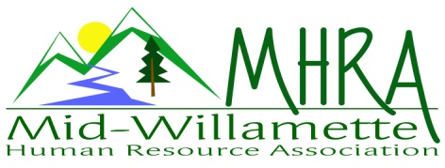
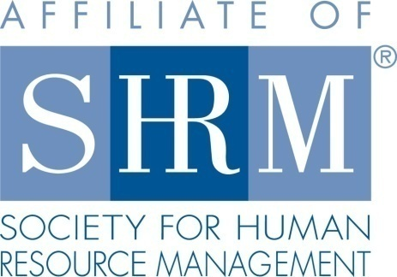

MHRA Mission Statement: to provide knowledge, skills, and resources while working to enhance personal and professional development.

BOARD MEETING (Chapter 202) March 22, 2017 7:30 a.m. to 9:00 Allan Bros. Albany, Oregon

Kristen Taylor | President |  | Jared Haddock | Website Chair
DeeDee Gordon | Certification/President Elect |  | Laurie LeRiche | Diversity/Workforce Readiness
Claudia Hamilton | Sponsorship Chair |  | Karlina Christensen Lee | Programming
Darcee LaCalli | Legislative |  | Kathy Westberg | Foundation Chair
Jason Bushnell | Treasurer |  | Cindy Bene | Membership Chair
Bonny Ray | Past President/Secretary
Highlighted designates PRESENT.

The meeting began at 7:40

Approval of Minutes: The February 2017 minutes were reviewed and approved. Karlina motioned and Laurie seconded the motion.

April Meeting Logistics: April is our first meeting at the Farm Home Old School. Kristen will give them a head count. Karlina will look at the list for double registrations and provide Kristen with a count the Friday before the meeting. Kristen has the bag. It would be helpful to have several Board members arrive early and help direct members to the room location. Karlina will ask the Mennonite Home to post a sign in case members go to the old location. There is parking all around the building. Jean is speaking on Flexibility in the Face of Change. It will qualify as Business Credit (formally Strategic) as well. We will alert members to this unique credit option through e-mail. Karlina has a door prize. Kristen has a DVD. We will get a set of DVD’s from the Foundation to collect a jar of change for the Foundation ongoing fundraising. There is not a sponsor this month. Last month the sponsor provided hotels not a financial donation.

Treasurer’s Report: Jason provided a budget report. We had limited income and expenses this past month. Mennonite Village has not billed us for the past two months. We received an Eventbrite deposit of $15. We have some interest. Our expenses were Board breakfast and the pending bills from the Mennonite Village. We rolled over 2 CD’s this past month. There is an Eventbrite issue with Citizen’s Bank. It appears to be related to only our partial account number coming through. The bank said we have not missed any payments but the process is not working well. Karlina and Jason are working on this with the bank. Total assets are above $17,000. Jason adjusted the budget. He did not receive feedback regarding this but people can still provide. Motion to approve the Treasurers report by Kathy and Darcee.

Membership Update: Kristen asked Cindy for a report and it is pending. There are three new members this past month. We continue to grow. Karlina and Kristen said SHRM is requiring that we have our own process related to our enrollment of chapter members. Kristen will request a new list from Kimberly Goodwin and compare our chapter roster that Cindy is maintaining to the SHRM roster. Kristen is keeping designation form copies.

Position Reports

Certification: Dee Dee is out ill but sent a report. April credit is Business credit! Dee Dee is submitting program information as she receives it. She is going to pick up congratulation cards from the Board to sign and send to members as they pass their certification tests. Deborah Jefferies sent an e-mail inviting us to collaborate with a SHRMA Certification Class. We will also continue to acknowledge members at the chapter meeting who have passed recently.

Workforce Readiness/Diversity: The Oregon State Council Diversity Director has invited all the Diversity Chairs to a training in December. The training is specific to Diversity Chair function. Workforce Readiness wise Laurie was notified that the student chapter is having a case competition and are looking for volunteers to help with the logistics. Laurie joined Michelle Swift’s class for several hours to help students become workforce ready. Laurie asked the group why we thought we don’t see more members volunteering for this. The group brainstormed how members could show their employers the benefit of volunteering.

Foundation: Kathy is working on getting the Foundation DVD’s.

Legislative: Retirement plan changes are happening and on the horizon. Different Board Members shared how their companies administer their 401Ks. They often have lunch and learn or annual financial wellness meetings.
Karlina shared about SHRM’s position statement on Repeal and Reform. There is also a Workplace Flexibility bill in the works. If companies meet the Federal minimum requirements for flexibility and sign on to this bill they will have a reduced reporting burden. Karlina asked about DeFazio or Merkley having local town hall meetings. SHRM has notified members of their stance on 2017 policies and have policy stance guidelines. Darcee will ask Jared to post these on the website. We should also download the SHRM advocacy app so that we can interact and add our input in Oregon. Oregon SHRM members need to log this in the app. Oregon needs Advocacy Captains for our Senators. A judge overturned the double overtime rule from BOLI also.

Programming: Karlina has a contact with a Motivational Comedian who might speak for free but would like travel reimbursement. This might be a good December meeting. We also need a June speaker. Karlina has contacted Diversity speakers but the cost is prohibitive at $1800. Bonny suggested contacting the Oregon Humanities Group that have a catalog of diversity speakers. Also, Emily Drew is an option too. She is a professor at Willamette who specializes in Sociology/Diversity. She is facilitating an Employer Partnership for Diversity event on facilitating Difficult Conversations this spring. A Difficult Conversations speaker is a possibility. He would charge a $900 fee for a ½ day workshop. Karishna’s firm might be willing to do a mock trial dinner event. Laurie asked about mediation training options such as Chris Seasley. We still need a topic with Jennifer Bouman Steagall. Saafeld Griggs is willing to do HR basics for us as a ½ day workshop. Jason and Laurie saw them provide a harassment training that was informative and had great role plays.

Sponsorship: No update

Website: No update. We need a Facebook page. Karlina will set up the basic page by the April meeting. She will provide some information to Jared as well as to MHRA Board Members.

Future Planning: Additional programming in addition to regular meetings

Next Board Meeting: April 26, 2017 same place and time.

Meeting adjourned at 8:57 a.m.

