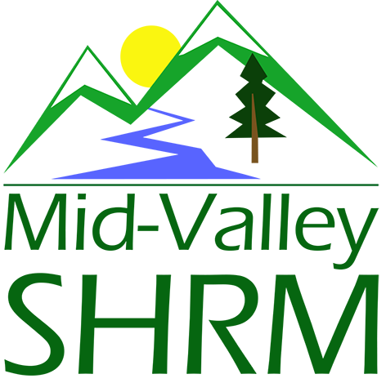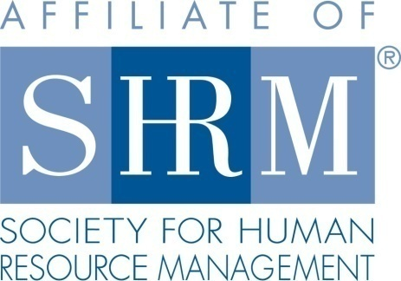

MHRA Mission Statement: To provide knowledge, skills, and resources while working to enhance personal and professional development.

BOARD MEETING (Chapter 202) July 24, 2019 7:30 a.m. - 9:00 a.m. Allan Bros. Coffee House/ Albany, Oregon

DeeDee Kaundart | Past President |  | Claudia Hamilton | Sponsorship Chair
Jason Bushnell | President |  | Jill Sharp | Membership Chair & President Elect
Kristen Taylor | Certification Chair |  | Darcee LaCalli | Legislative Liaison
Kathy Westberg | Foundation Chair |  | Bonny Ray | Secretary
Susan Ellingson | Website Chair |  | Karlina Christensen | Programming
Tim Nortz | Workforce Readiness |  | Lucille Valley | Diversity Chair
Robin Bilyeu | Treasurer

Highlight if PRESENT

The Board Meeting began at 7:30 a.m.

Approval of Minutes: The Board reviewed the June 2019 minutes. Motioned to approve by Claudia, second by Kristen. Minutes were approved.

President’s Updates and General Discussion Items: Jason suggested discussing position reports first. The Board covered these first and Jason provided the following additional updates at the end of the meeting.

- A future topic at another meeting is social media management. It would be good to have this discussion when Susan can participate. Some ideas include posting weekly on legislative or diversity topics.
- Board e-mail addresses are still in the works. Karlina is pricing this out. The e-mails will be by role not by name.
- The D and O insurance is in place.
- The by-laws are in the works.
- Oregon SHRM is starting to contract to a Virtual Job Board. We might consider this. An external company would manage this and make it look very professional. NHRMA is currently using this. It would cost $100 to post a job. It would require a three year contract. The Board approved this.

Position Reports:

Treasurer:

Robin explained the financial statement. Purchase wise there were gift cards, stamps and Board meeting breakfast costs. She will send an invoice to All Star staffing. The Board discussed asking for donations at the October Veteran’s training for the Foundation. Also the SHRM Foundation will administer a Foundation scholarship for us if we make a five year commitment. Robin reported the following in her written update:

- Paperwork to update our Citizen’s Bank account was turned in and is on hold, we are waiting on updated paperwork from IRS
  - Continue to have checks written to Mid-Willamette Human Resources Association until name is changed at bank
- Completed budget report for the month
  - August Sponsor - I sent a second invoice to Randy at Saalfeld Griggs (no response)
  - November Sponsor - Claudia’s going to let me know what sponsor level All Star Staffing is interested in so I can get an invoice out to them
- All members and Board are encouraged to donate to the foundation. The member Giving Report for the SHRM Foundation, as of April 10, 2019 donations from our Chapter was up to $160, including:
  - Jason Bushnell
  - Karlina Christensen-Lee
  - Deedee Kaundart
  - Kristen Taylor
  - Patricia Schilling
  - Renew Consulting
  - Additional donations I’m aware of:
    - Our Chapter $177.50 (donated late April)
    - Our Chapter raised but hasn’t donated yet $25

Certification: Kristen reported that the August and September programs are submitted and pending with HRCI. November will be submitted soon. We are promoting certification at the chapter meeting including certification deadlines. SHRM has a new rule that up to 20 credits for advancing your organization and up to 30 for advancing your profession will carry over for SHRM credits during you grace period if you re-certify early. Pre-approved credits at Mid-Valley SHRM meetings are in the category of advancing your education.

Foundation: The communication about our members receiving scholarships was positive. It would be beneficial to ask a member who has received a scholarship to share about their experience as it could enhance the club’s momentum for the SHRM Foundation. Study groups are listed on the NHRMA website. Our chapter can also purchase books at a special price if we buy at least five. There are opportunities for scholarships coming up in August through the foundation also. We will post deadlines on the website. Jill will complete a slide regarding it.

We are planning for a Veterans training in October supported by the SHRM Foundation. The Board discussed providing a breakfast and asking for a suggested taxable donation of $25 for the SHRM Foundation at this meeting. Attendees could donate online or pay at the meeting. Attendees will get 10 credits and a badge. We need to finalize the date and promote it to the chapter. Karlina had communication with the Foundation and believes we will have details set by next week. DeeDee could do an e-blast and an e-mail. We could do a save the date slide. There is pre-work required. We can send an e-mail a week before to confirm attendance. The date selected is October 23, 2019 which also is the OSU career fair for Engineering. The Board discussed if this is a conflict we should consider. The Board decided to hold the date at this point still as it may not be a big conflict for most of our members.

The Board would also like to thank the Farm Home Old School Conference Center. We could recognize them at a meeting to thank them and allow them to promote their facility. The Old School asked us to do a google review on behalf of SHRM. Individual Board members are encouraged to do this.

Legislative: Darcee reported on the following updates:

- Paid Family and Medical Leave Law (“HB 2005”). HB 2005 provides workers with 12 weeks of paid leave for family or medical reasons (and in some cases, up to 14 weeks paid leave for limitations related to pregnancy). Paid leave will be funded by a benefit pool that will be administered by the State with employees contributing 60% of premiums and employers contributing 40%. Employers with fewer than 25 employees may be exempt from paying. Contributions start in 2022 and workers may begin receiving paid benefits starting 2023.

- Oregon Workplace Fairness Act (“SB 726”): The Oregon Workplace Fairness Act addresses issues surrounding workplace discrimination and harassment. Most notably, SB 726 extends the time for filing claims to five years, limits the use of nondisclosure, non-disparagement, and no-rehire provisions, and requires written anti-harassment and anti-discrimination policies. The statute of limitations change applies to events that occur on or after September 29, 2019. The restrictions on nondisclosure agreements and written policy requirements go into effect October 1, 2020. Our recent E-Alert details SB 726’s impact on employer’s policies and practices moving forward.

- HRA Legislation: A newly issued regulation could transform how employers pay for employees' health coverage, its advocates claim. The U.S. Departments of Health and Human Services, Labor and the Treasury issued a final rule allowing employers of all sizes to fund a new kind of health reimbursement arrangement (HRA), known as an individual coverage HRA (ICHRA). The departments also posted FAQs on the new rule. Starting Jan. 1, 2020, employees will be able to use employer-funded ICHRAs to buy individual-market insurance, including insurance purchased on the public exchanges formed under the Affordable Care Act (ACA).

- The Pay Equity Fix Bill (“SB 123”). SB 123 makes technical fixes to the Oregon Equal Pay Act. Most notably, SB 123 provides that, in certain circumstances, an employer is not in violation of the pay equity requirements for paying a different level of compensation to an employee with a compensable workers’ compensation injury who is on modified work. Additionally, it provides that an employer may pay employees for work of comparable character at different compensation levels on the basis of bona fide factors contained in a collective bargaining agreement. SB 123 is awaiting the governor’s signature and, once signed, will become effective January 1, 2020.

- Notification of Federal Inspection of Employment Eligibility Records (“SB 370”). SB 370 requires employers to notify employees of upcoming federal inspections of employers’ records regarding employees’ identity and employment eligibility. Employers must provide notice to employees within 72 hours of receiving notice of inspection from a federal agency. SB 370 was signed and went into effect on June 6, 2019.

Programming: Karlina gave the following update:

The August meeting is prepped. Stacy Stack is the speaker.
- Pages are built till November and November and December Eventbrite pages are in the works.
- If we build pages out before Eventbrite changes their prices we keep the price for the time we submitted it.
- The November topic is Legal Holds with Paula Barren.
- There will not be an October meeting due to NHRMA conference.
- The Board discussed adding a Mental Health topic next year as well. This might be a good topic for a panel.
- Still holding on extra programs for members. Would like to do a survey of members to see what topics may interest them for additional topics or do we take a break for a year? We could also ask about membership input for interest in extra programming to understand if we want to continue to plan these. Susan is willing to put together a survey and send it out to membership.

- Draft- 2020 Schedule:

  - January- Leading with Creativity and Innovation – WOU Professor

  - Feb- Labor Law 2020 with Randy Sutton
  - March- Kyle Abrams- NLRB Updates
  - April- Laurie Grenya- equal pay and paid leave/pay strategy
  - May- Devon Hughes – Leadership topic
  - June- Jennifer Bouman Steagall
  - July- John Berg- Littler
  - August
  - September
  - October – Paula Barren
  - November – Stacey Stack
  - December- Deborah Jeffries- Employee Motivation

Past President Report: DeeDee contacted Dianna from SHRM about Bylaws. The review for approval is in process and may take up to four (4) months.

The Room reservation is confirmed at the CFH Old School for Wednesday, 10/23/19 8 am to 12:00 noon for the “Vets to Work” programming. Review Chapter Promotion Email Program in the next few months.
.
Sponsorship: Claudia reported on Sponsorships thru end of the year.

May: The Corvallis Clinic
June: No sponsor as of yet
July: No sponsor as of yet
August: Saalfeld Griggs
September: Tentative: Collaborative Employee Innovations
October: No meeting
November: All Star Labor & Staffing
December: Jennifer Bauman/RedKite

Membership: Jill reported that we currently have 113 active members. There were 4 non-members at last month’s meeting. She will encourage non-members to join. Jill has requested a current list for cross check. Jill continues to do the pre-meeting slide show. This has been well received. Karlina will export e-mail addresses to Jill each month for meeting attendees. There are sometimes issues in Eventbrite depending on the browser individuals are using.

CURRENT ACTIVE MEMBER STATS

Current active member count: 113

New Members:

Name | Company | Title | Date
Janice Becker | Harts Nursery
Nannette Buck | Lincoln County
Denise Downs | Consumer Powers Inc.
Travis Gray | Selmet
Kacie Marken
Caitlin Moore | JD McGee Inc.
Serena Randall | HR Block

Members that are no longer affiliated

Name | Company | Title | Date
Bonnie Bertalotto | Mid-Valley Gastro
Marc Stewart | Hollingsworth
Rick Rebel | Aldrich Benefits

JULY MEETING STATS

Total Registered: 19
Meeting Attendance: 19; Members: 17; Non-Members: 2
No Shows: 3
Attendees Not Registered: 3

ACTIVITIES

- Created slides for July Monthly Meeting.
- Audit Active Member List with SHRM Member Relations List

TO DO
- Create slides for August meeting.
- Audit active member list with website member list.

Communications/Website: Susan was unable to attend in person but sent an update:

- Cleaned up email. Creating folders and organizing so that information is easy to find. Answered questions that have come in and forwarded to the appropriate chairperson.

- Reviewed website to see what needs to be updated, changed, added, or taken off.

Diversity: Lucille is back to the Board in this role starting today. She reported that she sent Board members the list of job descriptions. Lucille is thinking of coming up with work related diversity tips that can be posted or mentioned monthly on our social media. Also it would be helpful to survey employees about their interest in this area if we send out a survey.

The next Board Meeting is August 21, 2019.

Meeting adjourned at 9:00 a.m.

