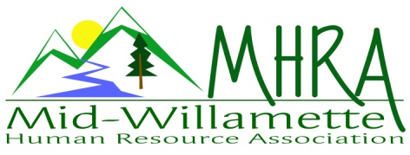
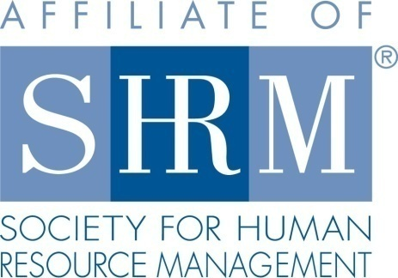

MHRA Mission Statement: To provide knowledge, skills, and resources while working to enhance personal and professional development.

BOARD MEETING (Chapter 202) May 22, 2019 7:30 a.m. - 9:00 a.m. Allan Bros. Coffee House/ Albany, Oregon

DeeDee Kaundart | Past President |  | Claudia Hamilton | Sponsorship Chair
Jason Bushnell | President |  | Jill Sharp | Membership Chair & President Elect
Kristen Taylor | Certification Chair |  | Darcee LaCalli | Legislative Liaison
Kathy Westberg | Foundation Chair |  | Bonny Ray | Secretary
Lucille Valley | Website Chair |  | Karlina Christensen | Programming
VACANT | Workforce Readiness |  | VACANT | Diversity Chair
Robin Bilyeu | Treasurer

Highlight if PRESENT

The Board Meeting began at 7:40 a.m.

Approval of Minutes: The Board reviewed and approved the April 24, 2019 minutes.

President’s Update: Jason welcomed everyone.

- Susan Ellingson is interested in the Communications role but was not able to attend today but will come to our next meeting. Tim Nortz is also interested in the Workforce Readiness position. Lori Rowe is also interested in joining the Board.
- The May chapter meeting was very successful with great attendance along with three new members. Bylaws are in the process of being changed. SHRM should have them back to us by June to ratify.
- Robin is working on getting our name changed with Citizens Bank.
- Bonny asked about considering WebEx for members to call in and watch chapter meetings when it is a barrier to get to the meeting site.
- Jill shared that several individuals registered as members that were not members. Darcee and Jill try to catch this ahead of time. They will e-mail the individuals who registered this way and offer a membership affiliation form.
- We received a new quote for D&O insurance also. The quote is $600. The Board approved purchasing this.
- The Vet’s at work certification program is set for October 23, 2019. The time is not set yet. June 12, 2019 Kathy and DeeDee are going to present on the SHRM foundation. There is not a sponsor for June so this will work time wise. Karlina has a gift basket to bring. Jason and Karlina also have some door prize items they will bring. There are also some Allan Bros. gift cards that can be used. DeeDee is putting together another e-blast.
- Jason reached Jared and was able to help Jill login and check the g-mail account. Jill found job posting requests and SHRM updates in the box. It is unclear where membership requests that people initiate on the website are going. Also there were requests from members asking for information/resource sharing. The Board discussed that we could send these requests out once a month and also post the SHRM VLM website resource information.
- Name changes continue to happen on g-mail, Yahoo and Eventbrite.
- Yahoo has an option where we can purchase SHRM e-mails that the Board can use instead of their work or personal accounts. It can be set up based on Board titles so that it is professional and transferrable. We could drop the g-mail account. It costs $150 a year. Everyone will need to agree to check the boxes weekly.
- Survey Discussion: We could send a survey out. Brainstorming on questions to ask: Programming preferences (extra meetings, ½ day, full day, socials, timing of meetings, topics, etc.); sponsorship suggestions, speaker suggestions. We can use survey monkey for free if we keep it to 10 questions.
- NHRMA Update - Jason will send a link to the Board for volunteering at the NHRMA conference. Board members can sign up to be session hosts and other volunteer jobs to reduce their conference costs. Karlina will check on hotel room holds for volunteers too.

Position Reports:

Treasurer: Robyn provided a copy of the budget and explained it. Robyn is now putting dates for the Eventbrite deposits. We received our quarterly payment from SHRM. Robyn also made a spreadsheet showing the amount coming in for each month since we are now charging for meetings. This will show where we are at each month with costs and revenue. CD maturing this month. The Board approved rolling it over.

Certification: Kristen was absent but sent an update. 2018 SHRM Recertification Payment
We receive $20 payment for every current SHRM national member primarily coded who is SHRM-certified, and who completed the process to recertify their SHRM-CP or SHRM-SCP credential during the 2018 calendar year. We received 480.00 in payment for this. As a reminder, 2019 will be the last planned year for incentive payments related to recertification initiatives. Please make sure to encourage recertification at the chapter and State Council levels to ensure optimization of your incentive. We currently have 63 certified members in our chapter as of the 1st quarter membership report.

Foundation: Kathy provided an update regarding the June membership meeting presentation providing education on the SHRM Foundation. She will present with DeeDee.
Legislative: Getting Talent back to work pledge you can sign it as a chapter or an individual. It is an initiative to give opportunities to qualified people with a criminal record, deserving of a second chance. Jason signed it as a chapter. . Read more and sign on here: www.gettingtalentbacktowork.org. Jill will make a slide on this for the June meeting. If you re-certify you can get a $20 discount and a free tote bag. There is an app. now where you can take a picture of the certification numbers. This may be challenging with confirming attendance. The Equal Employment Opportunity Commission (EEOC) has announced that employers must report pay data, broken down by race, sex and ethnicity, from 2017 and 2018 payrolls. The pay data reports are due Sept. 30.
Programming: Karlina provided an update:
- June, August and September pages are built for registration
- Focus on getting Eventbrite pages built for rest of year.
- Q1 of 2020 is scheduled.
  - January – Diversity
  - February- Legal Updates- Randy Sutton
  - March- NLRB updates- Kyle Abraham
- Website it current with programming.

Past President Report: DeeDee was absent.

Sponsorship: Claudia was absent.

Membership: Jill provided the following update:

CURRENT ACTIVE MEMBER STATS

Current active member count: 108

New Members:

Name | Company | Title | Date
Tim Nortz | BBSI | Consultant
Karen Chambers | All Star Labor
Susan Ellingson | MEI Wet Process
Cassandra Rugh | Samaritan Health Services

Members that are no longer affiliated

Name | Company | Title | Date
Not reviewed this month

MAY MEETING STATS

Total Registered: 30
May Meeting Attendance: 30 Members 26 Non-Members 4
No Shows: 2
Attendees Not Registered: 2

Attendees on list that are not current members

- Erin Frenzel x 2
- Laurie Simpson x 3

ACTIVITIES

- Added new members to membership list
- Created slides for May Monthly Meeting. Will redesign for June.
- I was able to get into the Gmail account today. Scanning for any important emails.

TO DO
- Create slides and table tents for June meeting.
- Complete review of inbox.

Website: Vacant Role

Workforce Readiness: Vacant Role

Diversity: Vacant Role

Next Board Meeting: June 26, 2019

Meeting adjourned at 9:00 a.m.

