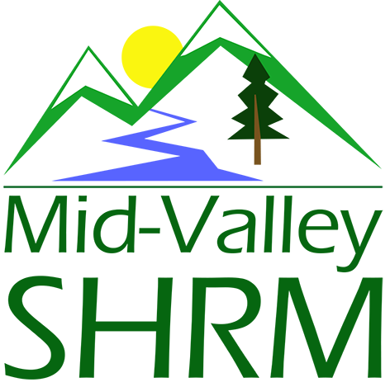
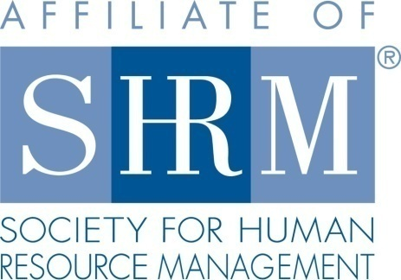

MHRA Mission Statement: To provide knowledge, skills, and resources while working to enhance personal and professional development.

BOARD MEETING (Chapter 202) March 20, 2019 7:30 a.m. - 9:00 a.m. Allan Bros. Coffee House/ Albany, Oregon

DeeDee Kaundart | Past President |  | Claudia Hamilton | Sponsorship Chair
Jason Bushnell | President |  | Jill Sharp | Membership Chair & President Elect
Kristen Taylor | Certification Chair |  | Darcee LaCalli | Legislative Liaison
Kathy Westberg | Foundation Chair |  | Bonny Ray | Secretary
VACANT | Website Chair |  | Karlina Christensen | Programming
VACANT | Workforce Readiness |  | VACANT | Diversity Chair
Robin Bilyeu | Treasurer

Highlight if PRESENT

The Board Meeting began at 7:30 a.m.

Approval of Minutes: The Board reviewed the February 26, 2019 minutes. DeeDee motioned to approve, Karlina seconded. Minutes were approved.

President’s Updates and General Discussion Items:
- Reviewed website today to ensure we are fully updated with new name and other current information in the absence of a dedicated website chair. Each role has its own page. Karlina did a brief tutorial for using the board only page. Chairs will want to go in and drop job description, tips for meeting role needs, etc. This way we have built in succession assistance for new people coming into the roles in the future.
- Logo—Still waiting for final SHRM approval. Moving forward with the square design.
- March extra program cancelled due to low enrollment. We may be on the hook for the food order due to late cancellation. Old School has not billed us yet.
- Meeting location: Has been a little conflict recently in regard to our contract and whether we will be charged a room fee for extra events. That has not been historically true, but has been on the invoices as of late. Need to confirm the 4/19/19 extra meeting and that it does not replace the April chapter meeting. DeeDee to reach out to Emily/Kierra at the Old School to discuss. Maybe Mennonite Village is an option again? Jason to reach out to Kristen Gregory to engage that conversation.
- We have extra programming speakers lined up, need to assess attendance to see if we are going to move forward. Consider a member survey to see how much value there is and what topics are of greatest interest.
- March chapter meeting was well attended (30+). This is good news with it being the first meeting that we initiated the fee for attendance.
- Vets at work certification: Karlina has books. It is free for certification through the Foundation. This could be a half or full day program and would want it to be free for participants (including room/catering). It is approved for 10 PDC credits. Consider running the program in the Fall as we near Veteran’s Day. Be cognizant of attendance in relation to other events happening at this busy time.
- Student NHRMA conference: Alan Cabelly has reached out for solicitation of support from the Chapter. This is the Portland Student Chapter. Would we rather dedicate the dollars towards the Corvallis/OSU Chapter? Jason proposed $500.00 specifically dedicated to support the OSU students. DeeDee moved to approve the 500.00. Kristen seconded. Motion carried. Karlina has a sponsor badge we add to our website once the donation is complete.
- College Relations board member: We do not currently have one, but we should consider reaching out to Scott Lee who is already doing this for the State Council. Suzanne Steinhabel, Jared Haddock, and David Parrish have also expressed interest in joining/coming back to the board.
- PHRMA board has begun promoting its annual Strategic Management Conference. We can help promote. It is generally approved for 7 HRCI Business credits.
- NHRMA conference planning is well underway. Board members who volunteer will receive steeply discounted rate for attendance. There are some great events planned in addition to the conference itself.

Position Reports:

Treasurer: We made almost 300.00 from the registration at the March meeting. Still waiting for sponsorship payment from Barker Uerlings. All others are paid. See Robin’s report for full details.

Certification: Certificates are updated to reflect our new name, but have been waiting on logo approval prior to changing that. April chapter and extra program are both entered for HRCI and SHRM credit.

Foundation:
- Foundation: Fundraiser for April’s meeting
- April meeting when Dianna will be presenting on SHRM membership and Foundation

Diana Gould from SHRM was going to come do a presentation, but was not available in June when we were hoping. She can send the presentation to us, however. We can do the presentation ourselves or run some of the slides in the pre-meeting slide deck. Idea is to better educate our membership about what the Foundation is providing. We are going to do a Foundation basket for raffle at the April Chapter Meeting. The basket is made out of the left over leadership books we collected for the State Council Conference.

Legislative:

Darcee provided the following update:
- EEO-1 Pay-Data Reporting Decision regarding if employers will need to report pay info. by race, ethnicity and sex or not, is due from EEOC, OMB by April 3, 2019.
- $15 Federal Min.-wage bill (over the next 6 yrs.) moved to a full House vote. This would not apply to small business under 10 employees.
- NLRB Further Limits Mandatory Union Fees-affects employees who exercise their right to decline full union membership.
Programming: Update from Karlina:
- Working on half day training with Barran Liebman attorneys on 4/19.
- April and May pages are built.
- Focus on getting Eventbrite pages built for rest of year.
- Q1 of 2020 is scheduled.
  - January – Board lead rockstar
  - February- Legal Updates- Randy Sutton
  - March- NLRB updates- Kyle Abraham

Past President Report:

DeeDee reported that the EXCEL report is done and submitted.
- Eblast pending finalized content
- Foundation fund raising-coordinating with Kathy
- Diana G. Not available to present at June meeting. Consider myself and/or Kathy doing presentation
- Board member- talking with David Parrish and is interested. Details to follow.
- DeeDee to coordinate a SHRM eBlast to promote the April extra program as well as a plug to like us on FaceBook.

Sponsorship: Claudia has updated website with current sponsorship detail. Question: how many guests can a sponsor bring to the meeting under the new system of charging? Consensus that a Gold sponsor can have 3 guests, Silver can bring 2. Additional guests beyond that will be charged the 10.00 registration fee. Will do a reach out to All Star Staffing, Blue Sun, and Samaritan as potential sponsors. There are 4 open months. Send Claudia your ideas if you have them. Email contact information is preferable.

March Sponsor: Columbia Soft $300.00
April Sponsor: Barker Uerlings $450.00
May Sponsor: The Corvallis Clinic $450.00
August Sponsor: Saalfeld Griggs $450.00
December Sponsor: Jennifer Bouman Steagall $300.00
Still needing sponsors for June, July, September and November

Membership: We currently remain at 106 members. Who is checking our Gmail? Doesn’t sound like we are actively responding. Robin gave password to Jill who will check it out.

Current active member stats
Current active member count: 106
New Members: None

March meeting stats
Total Registered: 30
March Meeting Attendance: 28 ( 25 Members / 3 Non Members)
No Shows: 3 (Members)
Attendees Not Registered: 1 (Member - paid)

Attendees on list that are not current members: Zero

Activities
- Sent email blast to members about Meet the Author.
- Created slides and table top tents for monthly meeting.
- Requested an Active Member List from Kimberly Weaver to do a quarterly audit on active members.

To do
- Learn how to check email box
- Update Membership application when logo is approved

Communications/Website: Website seems to be pretty user friendly as we are getting in there and updating. Still recruiting for a lead in this role. Some chapters are charging employers for job postings on the website. They are managed through a professional service. This may be something to consider for the future.

Workforce Readiness: Vacant Role

Diversity: Vacant Role

Next Board Meeting: April 24, 2019

Meeting adjourned at 9:15 a.m.

