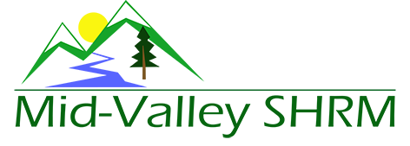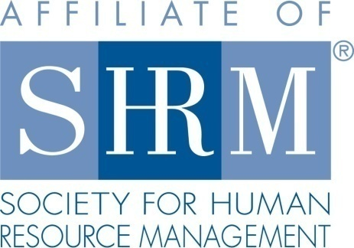

MHRA Mission Statement: To provide knowledge, skills, and resources while working to enhance personal and professional development.

BOARD MEETING (Chapter 202) March 20, 2019 7:30 a.m. - 9:00 a.m. Allan Bros. Coffee House/ Albany, Oregon

DeeDee Kaundart | Past President |  | Claudia Hamilton | Sponsorship Chair
Jason Bushnell | President |  | Jill Sharp | Membership Chair & President Elect
Kristen Taylor | Certification Chair |  | Darcee LaCalli | Legislative Liaison
Kathy Westberg | Foundation Chair |  | Bonny Ray | Secretary
VACANT | Website Chair |  | Karlina Christensen | Programming
VACANT | Workforce Readiness |  | VACANT | Diversity Chair
Robin Bilyeu | Treasurer

Highlight if PRESENT

The Board Meeting began at 7:35 a.m.

Approval of Minutes: The Board reviewed the February 27, 2019 minutes. Karlina motioned to approve, Darcee seconded. Minutes were approved.

President’s Updates:
- Logo—The new logo design was reviewed. Suggested edit to drop the “SHRM” letters below Mid-Valley instead of next to. This shifts the logo from a rectangular to a square design which fits better on Eventbrite and other postings. With this minor edit, Darcee moved to approve the logo and Kathy seconded. Logo is approved for submission to SHRM. Reminder that we can’t actually use the logo until we get final SHRM approval.
- Table toppers and transitioning information slides were piloted at the February meeting. Everything looked great. Thank you Jill for your work put into this. Consensus is to keep the information slides to about 5 and keep them refreshed with new content. If you have an announcement you would like highlighted send you request to Jill and Jason in advance of the chapter meeting. We will start promoting the NHRMA conference on this. They have provided us with promotional slides.
- March 6th evening program: still only has 6 registered participants. We will do a final email push through the chapter distribution list and make a decision on Thursday about proceeding versus cancelling. Darcee and Kristen have not registered yet, but have committed to do so if it sways the decision.
- March Chapter Meeting: Currently has 10 registered participants. We will track closely how registration and attendance is impacted by the decision to charge. The decision to charge members a $10.00 fee to cover meeting cost was announced at the February meeting.
- Jason, Jill, and Claudia attended a student chapter event at OSU on 2/6/19. Report is that the chapter is engaged and active.
- D & O Insurance: Need to complete the application in order to submit for quotes. This is a strongly recommended safety net that we have been lacking to date.
- Discussed Diana G. from SHRM doing a brief presentation at our April meeting. Concern is noted that we already have a sponsor (Barker Uerlings) that likes to utilize their speaker time and a hot topic for the program (OR Pay Equity updates). We may need to consider adding some time to program or look at a different meeting for Diana. She is going to present at the Oregon SHRM conference tomorrow. We will review presentation content and timing in effort to make recommendation.
- Taxes: Reminder that we will need to do chapter taxes in May.
- Members bringing in sponsors: Discussed that any chapter member who secures a sponsor can be given up to one free year of chapter meetings (remainder of the calendar year in which the sponsorship was secured).
- Eblast: Jason and DeeDee working on this. Highlight upcoming programs and vacant board positions including the perks of becoming a board member—leadership development, HRCI/SHRM credit, etc.
- Succession planning documents: Each board member to create a one page “how to” for your position that can be saved to our board member documents page in case a board member has to vacate with out a training/cross over period.
- SHAPE/EXCEL: SHAPE is done and submitted for 2018. EXCEL will be done in the next week or so.

Position Reports:

Treasurer: See Robin’s report for detail with the notation that the Eventbrite income for the February program is not yet reflected. This will offset the meeting cost by a couple hundred dollars. All CD’s are due to mature this week. Karlina moved to roll them over, Kathy seconded. All CD’s are approved to roll over.

- Paperwork to change name on business registry was submitted (check was cashed)
- Financial numbers were shared with Karlina/Jason for insurance quote
- Completed budget report for the month
- Received sponsor payment from Corvallis Clinic

Certification: No new detail beyond position report for the meeting. Programming to date is submitted for credit. The extra program in March will be SHRM PDC only as HRCI did not deem the content specific to HR education. We will continue to educate currently uncertified members as to the benefits of and resources towards certification. I did hear of a newly certified chapter member at the February chapter meeting! My SHRM Foundation donation of $30.00 was mailed today.

Foundation:
- Foundation: Fundraiser for April’s meeting
- April meeting when Dianna will be presenting on SHRM membership and Foundation

Legislative: We discussed recent changes to OSHA reporting and posting regulations. Posting regulations have relaxed a bit. Check for your specific industry to see if any changes apply to you.

- EEOC report is now due in May due to the government shutdown
- OSHA online reporting deadline is 3-2-19

Programming:
- Working on half day training with Barran Liebman attorneys on 4/19.
- April and May pages are built.
- Focus on getting Eventbrite pages built for rest of year.
- Q1 of 2020 is scheduled.
  - January – Board lead rockstar
  - February- Legal Updates- Randy Sutton
  - March- NLRB updates- Kyle Abraham

Past President Report: DeeDee was not in attendance today.

Sponsorship: Claudia was not in attendance today but sent a report of sponsors for the year so far:

March Sponsor: Columbia Soft $300.00
April Sponsor: Barker Uerlings $450.00
May Sponsor: The Corvallis Clinic $450.00
August Sponsor: Saalfeld Griggs $450.00
December Sponsor: Jennifer Bouman Steagall $300.00
Still needing sponsors for June, July, September and November

Membership: We are currently at 106 members.

CURRENT ACTIVE MEMBER STATS

Current active member count 106.

New Members:
Name | Company | Title | Date
Lonnie Owens-Wink | Samaritan Albany Gen | Sr. Employee Relations Generalist | 02/08/2019

FEBRUARY MEETING STATS

February Meeting Attendance: 41
Total Registered: 47
No Shows: 14
Attendees Not Registered: 8

Attendees on list that are not current members and did not pay:

- Phaedra Huntington
- Shannon Kerekanich

Website: Karlina has given every board member restricted access. Check to make sure your log in credentials are working and screen the website in general for corrections or feedback. We want to make sure we are saving board function information and all documentation to the board page for organizational memory.

Workforce Readiness: Vacant Role

Diversity: Vacant Role

Next Board Meeting: March 27th, 2019

Meeting adjourned at 9:15 a.m.

