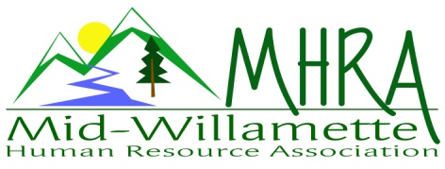
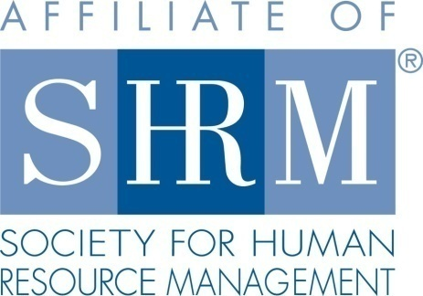

MHRA Mission Statement: to provide knowledge, skills, and resources while working to enhance personal and professional development.

BOARD MEETING (Chapter 202) Sept. 23, 2015, 7:30 – 9:00 am – Corvallis, Oregon

Jean Bonifas | Past President/Membership |  | Darcee LaCalli | Guest attendee
DeeDee Gordon* | Diversity Chair |  | Robynn Pease* | Workforce Readiness
Claudia Hamilton | Sponsorship Chair |  | Karlina Christensen Lee* | President
 |  |  | Kathy Westberg | Foundation Chair
Jason Bushnell | Treasurer |  | Jared Haddock* | Website Chair
Bonny Ray* | President Elect |  | Cindy Bene | Legislative Chair
Kristen Taylor* | Secretary/Certification |  | Danae Overman | Guest attendee
Highlighted designates PRESENT. *Indicates SHRM Foundation donation made for 2015.

Approval of Minutes: -- moved to accept the August minutes. -- seconded. Motion carried.

SHAPE: We are tracking well for 2015 Shape. Most of our Shape goals are already met or in progress for the year. We will announce the next round of SHRM prep classes at the member meeting on Friday. Membership goals are being tracked. We are on track for Platinum again this year.

Programming: 50 participants are registered for the HR Basics event on Friday. Kathy is coordinating food, juice and water. DeeDee has gotten coffee from TFS. Jean will bring paper products. SHRM advocacy and designation forms are being included in the materials that will be given to participants. Training runs 8am-12pm.

2016 Planning session: We need 5 initiatives for 2016 SHAPE including membership and certification. Categories for voluntary initiatives include: diversity, workforce readiness, college relations, advocacy. Ideas were discussed as follows:

Workforce Readiness: Danae presented an idea for workforce readiness with the high school outreach and education programs. This could be coordinated with the LBCC high school job fairs. Karlina also has connections with Willamette U. HR students for mock interviews. Opportunities can be presented via the website and gmail group list.

Diversity: DeeDee has continued options for diversity connections that she may be able to line up for programming purposes. She also proposed a diversity statement for the chapter and components that go with that. Bonny proposed partnering with the OSU diversity events that occur on MLK weekend. Robynn suggested the Chamber events may be applicable to our membership. WSU has a rep who focuses her work on applicant demographic collection and how this impacts hiring decisions. Interest in offering another Veterans recruiting/social event for 2016. Consider it as a partner event rather than sole sponsor.

Membership: Jared proposed partnering with OSU for their upcoming conference with BOLI as an outreach effort for new members. Reaching out the at large list is an on-going membership initiative. Bonny discussed improved ways to automate the yearly membership efforts.

Programming: Krishna is confirmed for an early 2016 chapter meeting/half day event. January is wellness in the workplace (Mike Waters, Timberhill Athletic). February will be legislative updates again. Jared presented idea for a program on the new State mandatory sick leave. Perhaps approach OEC to work with BOLI on this since they get a reduced price. SHRM chapter does a mock EEOC trial in Reno. This is an interesting idea for program. Red Kite is also confirmed for a chapter meeting-topic to be determined. Debra Jeffries with HR Answers is often receptive to training. Renae Coombs from SAIF may also be an idea—Comp claim reduction through wellness initiative. Injury reduction in general is a programming idea.

Website: Renewal information is provided by SHRM. Email reminders for renewal information may be helpful for members. This may help reduce those who drop off the chapter list due to letting the national membership expire. Member testimonials can be added to the website for member value.

Foundation: The foundation has free dvd trainings. We may be able to get dvd’s that line up with the monthly programming for participants. These are also approved for credits. Discussed the idea of having a photographer who can offer professional head shot photos for LinkedIn with an accompanying foundation donation.

Legislative: Reach out to legislators in August after the session is over as a means to provide education re: SHRM. Karlina will be the State Legislative Director for next year. Proposed a “day on the hill” to educate members on how to advocate with legislators. Also suggested having State reps talk with the group about legislative impact.

College relations: Research local college career service websites to get our information on there for college student resources.

Certification: Chapter may sponsor a study group this year. Danae has access to materials. We may consider buying several sets of books for member check out.

Positions for 2016: Workforce Readiness, Legislative, Secretary are open at this time. Kristen will pursue President Elect and maintain certification. Bonny President, DeeDee Diversity, Kathy Foundation, Claudia Sponsorship, Cindy Membership, Jason Treasurer, Claudia Sponsorship, Karlina Programming, Jared Website. Darcee and Danae will let us know their specific area of interest.

2016 Sponsorship: Reach out to Mike Waters to see if he is interested in sponsoring his own meeting. We have repeat annual sponsors that Claudia will confirm (Saalfeld Griggs, RedKite). AKT, Willamette Dental, Corvallis Clinic, Samaritan, and Wells Fargo and others are likely. Ideally we would sponsor all the monthly events plus the additional adjunct programming.

Treasurer’s Report: Treasurer’s report was distributed earlier via email. DeeDee moved to approve, Cindy seconded. Vote by email to approve report was confirmed 9/22/15.

SHRM/HRCI Certification: Need to check the annual fee for HRCI starting next year. Kristen will research and email the board. Board recommendation is to continue offering both HRCI and SHRM credit in the coming year. Many of our members still wish to maintain HRCI. Need to budget for this expense.

Membership: Jean reports 91 members on the SHRM roster for the August report.

Chapter Bylaws: Karlina distributed and reviewed changes to the bylaws.

Other: Some position reports not given due to 2016 brainstorm efforts. The Nov. meeting is currently set for the day before Thanksgiving. Confirmed sufficient attendance—meeting with stand as scheduled.

Reception table for September: DeeDee and Robynn will be at the reception table for October 14. DeeDee and Claudia 9/25.

Meeting adjourned at 9:00 a.m.

