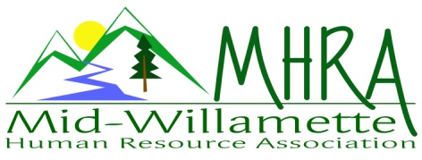
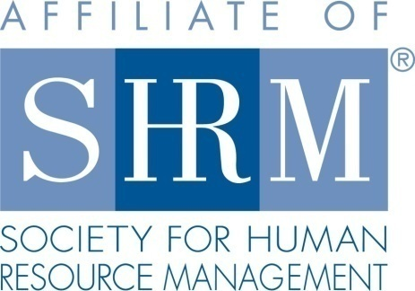

MHRA Mission Statement: to provide knowledge, skills, and resources while working to enhance personal and professional development.

BOARD MEETING (Chapter 202) August 26, 2015, 7:30 – 9:00 am – Corvallis, Oregon

Jean Bonifas | Past President/Membership
DeeDee Gordon* | Diversity Chair |  | Robynn Pease* | Workforce Readiness
Claudia Hamilton | Sponsorship Chair |  | Karlina Christensen Lee* | President
 |  |  | Kathy Westberg | Foundation Chair
Jason Bushnell | Treasurer |  | Jared Haddock* | Website Chair
Bonny Ray* | President Elect |  | Cindy Bene | Legislative Chair
Kristen Taylor* | Secretary/Certification
Highlighted designates PRESENT. *Indicates SHRM Foundation donation made for 2015.

Approval of Minutes: Jean moved to accept the July minutes with correction to the availability of her loft. DeeDee seconded. Motion carried.

SHAPE: We are tracking well for Shape. Most of our Shape goals are already met or in progress for the year. We do need to verify membership numbers to ensure superstar status is maintained.

Programming: 32 people are registered for the September HR 101 program. This is increased significantly after the mailing went out. CFH will provide coffee service. We still need to buy breakfast goods. Agreed on Costco versus having it catered. Kathy will coordinate the food . Recommending that we explore resources to start running corporate credit cards as a means of allowing people to register for our paid events. Consider a “square” or charge through eventbrite. August event survey gave very high marks. We do receive consistent feedback that it is difficult to hear speakers at our current location. Strategic partnership and FLSA were proposed as future event topics. 25 people are RSVP’d for the September chapter meeting. October 22 is an additional evening meeting to cover NLRA topics. It is a 2 hour event running 4:30 to 6:30pm. The regular October morning meeting also addresses labor relations. Both October meetings will be held at the usual Mennonite Village location. October eventbrite invites will be available by the end of the week. November regular chapter meeting is an evening event on 11/12. It will be a veteran’s panel discussion. Light snacks will be catered by Mennonite Village. December will be “HR Super heroes.”

Sponsorship: Jennifer at Red Kite is sponsoring her own presentation next month. Claudia is confirming SHRM for December. All other months are confirmed for 2015. Continue sending ideas to Claudia for next month.

Treasurer’s Report: Jason presented treasurer’s report. Income was higher than expenses again this month. Sponsorship funds of 600.00 came in. Quarterly deposit of 550.00 from SHRM deposited. 60.00 donated towards raffle, this will go to the foundation. Total assets are increasing and remain over 10K. Jean moved to roll over the CD. Kathy seconded, motion carried. Robynn motioned to approved, DeeDee seconded. Motion to approve the report carried.

SHRM/HRCI Certification: Need to check the annual fee for HRCI starting next year. Kristen will research and email the board. Board recommendation is to continue offering both HRCI and SHRM credit in the coming year. Many of our members still wish to maintain HRCI. Need to budget for this expense. October credit has been submitted and approved for the regular October chapter meeting. Kristen will submit for the secondary October program this week once location is confirmed today. Still waiting on programming information for November and December.

Foundation: Foundation goal has been met with a total donation of 315.00 year to date. We are still going to do one more basket raffle for this year. Holiday themed, probably for the November meeting.

Legislative Updates: SHRM is actively involved in discussions around the proposed FLSA rules. Karlina is working with Cindy to stay connected with this initiative.

Membership: Jean reports 87 members on the SHRM roster for the July report. Our records show an increased number over that. Jean is working on reconciling the two. Many members are scheduled to renew in the next month or so. She will work on proactively contacting those who are due to renew in the coming months. Bonny will send Jean the monthly RSVP list prior to the next meeting so we can recognize new members in attendance.

Workforce Readiness: Robynn is staying connected with David Bird from LBCC about intern placement in local businesses. He is wanting to know if we can share business names from our membership. Jean will contact him. We cannot share personal member info, but there is limited business information we can share. Proposed Shape initiative would include a closer connection with OSU for HR internship placements in local businesses.

Website: Jared not in attendance today. No website update at this time.

Diversity: DeeDee has ordered a book called reinventing diversity. Will share ideas with the group from this resource. This month’s programming about unconscious bias was well received and got people talking about diversity in the workplace.

Other: Consider doing a food drive for our December meeting. September board meeting will remain at Market of Choice and will serve as the 2016 brainstorming session. Discussed ideas for sharing member value options with our members who don’t necessarily come to meetings regularly. Also discussed providing time in monthly meetings for general member announcements of job openings, events, etc. Value is added with the power of the personal networking connection. Karlina proposed a $50.00 gift card for Kris Pattison for the work she has done in getting the Chapter meetings set up. Motion was seconded and approved.

Darcie LaCalli and Danae Overman have expressed interest in board membership for next year.

Reception table for September: Bonny will be at the reception table for September 9th. DeeDee and Robynn for October. DeeDee and Claudia 9/25 and 10/22.

Meeting adjourned at 9:00 a.m.

