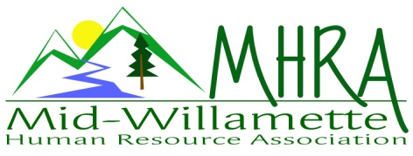
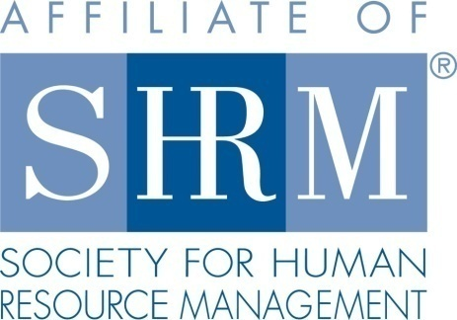

MHRA Mission Statement: to provide knowledge, skills, and resources while working to enhance personal and professional development.

BOARD MEETING (Chapter 202) August 24, 2016, 4-6pm – Ciddici’s Pizza Albany, Oregon

 |  |  | Darcee LaCalli* | Legislative
DeeDee Gordon* | Diversity Chair |  | Laurie LaRiche | Workforce Readiness
Claudia Hamilton | Sponsorship Chair |  | Karlina Christensen Lee* | Past President/Programming/Sec.
 |  |  | Kathy Westberg* | Foundation Chair
Jason Bushnell* | Treasurer |  | Jared Haddock* | Website Chair
Bonny Ray* | President |  | Cindy Bene | Membership Chair
Kristen Taylor* | President Elect/Certification
Highlighted designates PRESENT. *Indicates SHRM Foundation donation made for 2016.

Approval of Minutes: Darcee moved to accept the July minutes. Claudia seconded. Motion carried.
Presidents Update: Plans are underway for the OSU partnership meeting in the fall -- items discussed were
o We’ll pay our normal food cost and they’ll handle the rest.
o As of now the location is the Presbyterian church – parking may be an issue.
o Self catering vs. Forks & Corks or Costco items.
o There could be over 100 guests.
o No charge for guests as the purpose is to build membership/expand the regions.
Future Planning/SHAPE: Kristen handed out copies of each of our roles and the ones that need to be filled (Workforce Readiness and Membership—duties were pared down and will be handed out at the Sept. meeting). Also let them know that SHRMM credit is received for all Board positions and committee membership is an option for credits. We’re looking into co-sponsoring the NHRMA Conference in the Fall of ’18 -- possible locations are the Resort at Skamania/Salishan Lodge.
Treasurer’s Report: Jason presented current treasurer’s report. Our assets have reached an all-time high. 3 month CD will be rolled over. Discussed a possible toy drive instead of a food drive.

September Meeting: Saalfeld Griggs—Jason has door prize.

Oct. 7th Additional Program: SHRMA partnership program. E-blast has gone out. Registration has been slow. There is only one person registered so far. We can continue to do promotions in conjunction with the Salem group as well. We will also promote at the August chapter meeting via paper flyer and announcement. Darcee, Jason, and Claudia are confirmed volunteers for this program.

Workforce Readiness: The Veterans Job Fair in Portland is coming up, Laurie will get the details. She also presented an update on her last year.

Diversity: Discussed having a panel covering the Transgender topic for 2017.

Membership: 88 members last year and currently we’re at 109, Cindy has done a great job keeping up.

Programming: Laurie suggested the Identity Theft Workshop and handed out a flyer. Bonny suggested “Life’s an Improvisation” as a future topic. Jared recommended a larger ½ or full day event/conference with a raffle of the BOLI/SHRMM books.

Website: June min. need to be added. Jared cross checked rosters with the email list and they don’t match—he’s working on it. Several updates are in the works.

Foundation: No need for further income. Kristin will email the form as a reminder for members to make the yearly donation if they haven’t already done so.

Legislative: No new updates as this time.

2016 Sponsorship: Sept/SAIF Oct/AKT Nov/Dec undecided and Corvallis Clinic a possibility down the road.

SHRM/HRCI Certification: Programming is approved to date and goals are met.

Reception table: Kristen and Laurie will cover September reception. Discussed being there by 7am since many people seem to showing up early recently.

Meeting adjourned at 6:00 pm.

