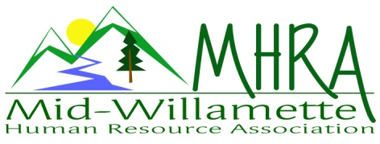
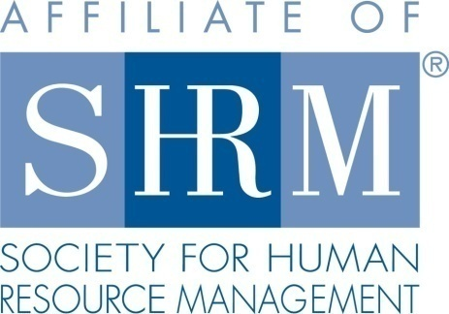

MHRA Mission Statement: to provide knowledge, skills, and resources while working to enhance personal and professional development.

BOARD MEETING (Chapter 202) July 27, 2016, 7:30 – 9:00 am – Albany, Oregon

 |  |  | Darcee LaCalli* | Legislative
DeeDee Gordon | Diversity Chair |  | Laurie LaRiche | Workforce Readiness
Claudia Hamilton | Sponsorship Chair |  | Karlina Christensen Lee* | Past President/Programming/Sec.
 |  |  | Kathy Westberg* | Foundation Chair
Jason Bushnell* | Treasurer |  | Jared Haddock* | Website Chair
Bonny Ray* | President |  | Cindy Bene | Membership Chair
Kristen Taylor | President Elect/Certification
Highlighted designates PRESENT. *Indicates SHRM Foundation donation made for 2016.

Approval of Minutes: Karlina moved to accept the June minutes. Darcee seconded. Motion carried.

SHAPE: 2016 goals are either met or in progress.

Treasurer’s Report: Jason not in attendance today. He will email treasurers report in the coming days.

Aug. Meeting: Dennis Carr will send two people from OSU to promote the SHRM Certification preparation class starting this Fall. Jared would like to do a website overview prior to the start of the meeting if there is time. No sponsor is set for this meeting so this time could be used for this.

Oct. 7th Additional Program: SHRMA partnership program. E-blast has gone out. Registration has been slow. There is only one person registered so far. We can continue to do promotions in conjunction with the Salem group as well. We will also promote at the August chapter meeting via paper flyer and announcement. Darcee, Jason, and Claudia are confirmed volunteers for this program.

Workforce Readiness: Laurie met with career development center at OSU regarding internship posting processes as well as wage and hour regulations around paid versus unpaid internships. We can link this information to the website. Discussed the learning agreement criteria for internship. This may also be a good programming idea—how to create a valuable internship experience, recruit the best student talent, and meet all regulations. We can tie a 2017 Shape initiative the promotion and programming.

Diversity: No new updates at this time.

Membership: We are currently at 107 members per MHRA records. SHRM roster shows 110. Cindy is working to reconcile this. We will also have Jared audit against the email distribution list. We are now a medium size chapter designation. Cindy is not currently able to commit to continuing in the membership role. She will stay on board remotely until we can find a replacement. Bonny reviewed our member roster with the board.

Programming: Still need to confirm a speaker and date for our additional FLSA event. This could be due to the multiple appeals to change the new ruling. Perhaps address the session more form a strategy in the changing environment perspective as opposed to pure implementation. Look towards an evening program perhaps in November. 2017 programming is being built.

Website: Jared not in attendance today.

Foundation: Reminder to board members to make their 25.00 donation if not done already. Basket raffle earned $65.00 last month. We need to audit our total chapter donation amount so far for the year to make sure we are exceeding last years’ total. Bonny will ask Jason to provide that in his emailed treasurer’s report.

Legislative: Darcee to promote the SHRM advocacy app at the next meeting. Reviewed the current legislative efforts currently underway. There are currently several changes being made with OSHA regulations and fee structure. There are efforts currently being pushed to reduce the new minimum salary level for exemption. If this is successful it will lower the new threshold by about 10K and slow the increases. All members are encouraged to submit the advocacy letter drafted by SHRM to support this. Darcee will work with Jared to get the link to letter out via email.

2016 Sponsorship: We are moving to a three tiered sponsorship system for 2017. This allows for a lower cost “Bronze” level at $200.00. Karlina made an updated flyer for membership and new sponsor distribution. This needs a few minor edits prior to final release. No sponsor for August. September sponsor is Saalfeldt Griggs. Still working on December sponsorship. Assurant is a possible new sponsor. Consider opening up the meeting to sponsor guests as a free professional development opportunity for the sponsors staff. Would need to define the number—self and a guest or perhaps up to 2 or 3 additional guests based on sponsor level.

SHRM/HRCI Certification: 2015 closed with 43 SHRM certified members. We show 45 certified members as of the 2016 first quarter summary report. Flyer for Deborah Jefferies certification class was emailed to membership yesterday as well as posted to the website. OSU class will be advertised at the August meeting. Shape goals for certification are met.

Credit for all current meetings and supplemental seminars has been submitted and approved.

2017 Board Membership and planning: We will want a co-programming chair for 2017 to back up Karlina and her new mom status. Planning session for 2017 will be held in lieu of the August (8/24) board meeting from 4-7pm. Bonny has confirmed a room at the downtown Ciddici’s pizza location. Spreadsheet with current board interest for next year was passed around today. Kristen will print the SHRM job descriptions and condense for all available roles so we can review with those expressing interest in next year. SHRMA is committed to co-sponsoring a NHRMA conference with MHRA in looking to the future for 2018.

Board members need to be at the professional level SHRM status as per by-laws.

Reception table: Darcee will cover August reception. She has the bag. Discussed being there by 7am since many people seem to showing up early recently.

Meeting adjourned at 9:00 a.m.

