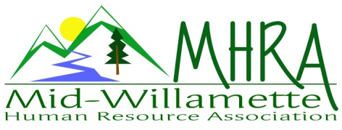
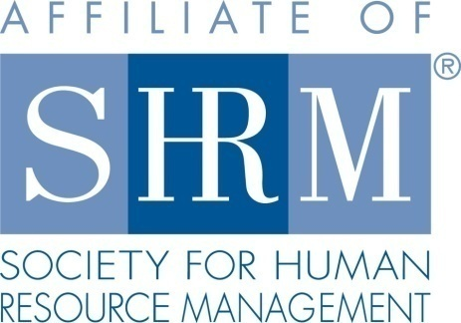

MHRA Mission Statement: to provide knowledge, skills, and resources while working to enhance personal and professional development.

BOARD MEETING (Chapter 202) July 22, 2015, 7:30 – 9:00 am – Corvallis, Oregon

Jean Bonifas | Past President/Membership
DeeDee Gordon | Diversity Chair |  | Robynn Pease* | Workforce Readiness
Claudia Hamilton | Sponsorship Chair |  | Karlina Christensen Lee* | President
 |  |  | Kathy Westberg | Foundation Chair
Jason Bushnell | Treasurer |  | Jared Haddock* | Website Chair
Bonny Ray* | President Elect |  | Cindy Bene | Legislative Chair
Kristen Taylor* | Secretary/Certification
Highlighted designates PRESENT. *Indicates SHRM Foundation donation made for 2015.

Approval of Minutes: Kathy moved to accept the June minutes with the addition that Cindy also participated at the July reception table. Cindy seconded. Motion carried.

SHAPE: We are solidly on track for Platinum. Most of our Shape goals are already met or in progress for the year.

Programming: The July survey information is not compiled yet. That will be reviewed at the next board meeting. The October program is confirmed with Sally Ellis, a presenter who has both experience as a manager and as a union advocate. The topic is "The Labor Relations Continuum". The labor relations presenter from Tennessee also contacted Bonny and offered to do a free presentation in October. Board discussed doing a second event in the evening on 10/21/15. Venue TBD. Bonny/Karlina provided a flier for the August half-day to put out on the tables at the July meeting. Krishna - our May speaker - has agreed to offer a half-day training in 2016. The September half-day, HR 101, will be our membership event for the year, so we'll get postcards printed through Vista and mail them out to at-large members within our area. Karlina proposed an approval of 100.00 for postage. This was agreed as sufficient. Registration is still low for the August and September meetings. Jared will email registration links again. Claudia will contact Saalfeld Griggs to get the hand outs for the September half day so we can make binders. All participants at the November meeting will receive a thumb drive with HR resources on it. It was agreed that the December meeting topic be "HR Super Heroes"; that as a board we design the format, flow, and facilitate that meeting; that we can begin planning that event at our annual programming meeting. 2016 programming is already underway with January and Feb. confirmed and March was suggested as the month for Krishna to do a half day program.

Sponsorship: No August sponsor as of yet. Claudia has calls out, but nothing confirmed. She is confirming SHRM for December. Once that is verified August remains the only un-sponsored month for the year. Suggestions to reach out to include Lionbridge, Assurant, and Cascade EAP.

Treasurer’s Report: Jason presented treasurer’s report. Income was significantly higher than expenses. Over 1000.00 dollars in sponsorship funds came through this month. One 300.00 sponsorship payment from Samaritan is still pending. The 3 month CD matures next month. Jason proposed to roll over. Total assets are increasing and remain over 10K. Jean moved to accept the report, Jared seconded, motion carried.

SHRM/HRCI Certification: Need to check the annual fee for HRCI starting next year. Kristen will research and email the board. Board recommendation is to continue offering both HRCI and SHRM credit in the coming year. Many of our members still wish to maintain HRCI. Need to budget for this expense. HRCI turn around time has been much faster recently for credit approval. Still need program information for October through December, but timing is not super critical since approval time has been faster.

Foundation: The raffle basket was a great hit. Ticket sales at the reception table went well. Another raffle for HR101 ticket will be held next month. Tickets will be $2 each or 3 for $5. We raised 150.00 on the basket raffle. Confirmation that 255.00 has been submitted to date for the year. Board member contributions are to be sent as individuals—separate from the chapter donations. The chapter number to beat for the year is 305.00.

Legislative Updates: Legislative session for the year is done. No minimum wage changes passed. Several bills did go through that will have employer impact. Cindy sent final report yesterday. This can be posted to the website. Cindy plans to do a face to face with legislative members to promote SHRM and MHRA.

Membership: Jean reports 101 current members. Karlina suggests we ask for audited list since the March list came out. It states 89, but we’ve had several new members since then. Jean handed out a current SHRM member list that are at large in our direct area. Website seems to be helpful in recruiting new members. Our visibility is improving. Board members are asked to reach to people on the at large list. We will also mail them invites to the September half day seminar. There are several new businesses in the area we can reach out to also. Jared suggested we attend the OSU HR business center event to promote membership as well.

Workforce Readiness: Robynn not in attendance today. See emailed summary of her monthly report.

Website: Jared reports the member email distribution list is working great and serving as an efficient means of communication. There was a member request to create a closed blog for members to post questions and answers so we can serve as greater resources to each other. The board agreed this is a great idea. Jared will research this and report back.

Diversity: DeeDee reviewed the veteran’s event. Discussed ways to better advertise to participants in coming events. Employer turn-out was great. We were competing with another recruiting event in Salem as well. Timing of reserve units coming home is also an important consideration. Thank you DeeDee for all your efforts. Future events may be a bit more scaled back for food and beverages. Kathy suggested perhaps partnering with the OSU career fair.

Other: Jean announced that her studio will not be available for our board meetings for the months of September and October. It was agreed that the Board would meet at New Morning instead. Karlina will send a doodle poll for the best time for a 2016 planning session. Board members are to notify her of interest in staying or not staying on the board for next year, as well as preference for position. Member Darcee LaCalli has expressed interest in the board for next year. Karlina submitted application for NHRMA award and we are confirmed to be in the running for this significant award.

Reception table for August: Cindy and Jean will be at the reception table for August.

Meeting adjourned at 9:00 a.m.

