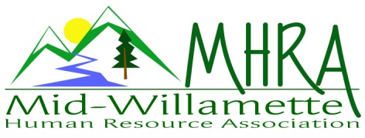
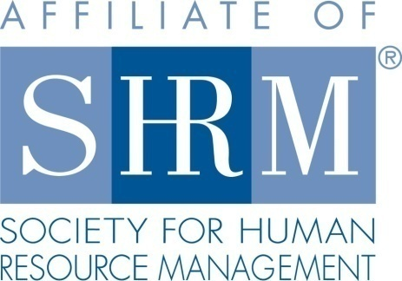

MHRA Mission Statement: to provide knowledge, skills, and resources while working to enhance personal and professional development.

BOARD MEETING (Chapter 202) June 24, 2015, 7:30 – 9:00 am – Corvallis, Oregon

Jean Bonifas | Past President/Membership
DeeDee Gordon | Diversity Chair |  | Robynn Pease* | Workforce Readiness
Claudia Hamilton | Sponsorship Chair |  | Karlina Christensen Lee* | President
 |  |  | Kathy Westberg | Foundation Chair
Jason Bushnell | Treasurer |  | Jared Haddock* | Website Chair
Bonny Ray* | President Elect |  | Cindy Bene | Legislative Chair
Kristen Taylor* | Secretary/Certification
Highlighted designates PRESENT. *Indicates SHRM Foundation donation made for 2015.

Approval of Minutes: Jean moved to accept the May minutes. Claudia seconded. Motion carried.

SHAPE: Karlina will send out an email of the items left to complete. We are on track for Platinum..

Programming: 21 people responded to the May presentation evaluation - the most ever! Bonny asked for and received a suggestion about how best to keep presenters on track. The October program is confirmed with Sally Ellis, a presenter who has both experience as a manager and as a union advocate. The topic is "The Labor Relations Continuum". Bonny will provide a flier for the August half-day to put out on the tables at the July meeting. Karlina will get them printed. Krishna - our May speaker - has agreed to offer a half-day training in 2016. The September half-day, HR 101, will be our membership event for the year, so we'll get postcards printed through Vista and mail them out to at-large members within our area. Having enough chairs available was an issue at the last meeting. Bonny will up our Eventbrite numbers by 5 when communicating with Kristin prior to the next meeting. In addition, one of us will be responsible for watching the flow of people and knowing where to find extra chairs in case Kristin isn't attending. Bonny reported that the meeting evaluations consistently include concerns about food - and at the last meeting - there wasn't enough coffee. It was suggested that she let Kristin know that we are willing to pay for an extra pot of coffee. It is not unusual for there to be a few negative comments about the food on a regular basis. Given that feedback about catering is not generally well-received, it was suggested that Bonny use her own discretion with regard to addressing or not addressing individual catering concerns. It was agreed that the December meeting topic be "HR Super Heroes"; that as a board we design the format, flow, and facilitate that meeting; that we can begin planning that event at our annual programming meeting. Karlina will send out an email to the board asking programming meeting Friday evening preferences for August through October.

Sponsorship: August and December are still open. Jean suggested Chris Sheesley of In-accord Mediation might be interested in Anne Gillies. Karlina suggested we ask SHRM to sponsor the December event as they are encouraging Chapters to ask for their financial assistance.

Treasurer’s Report: Jason presented treasurer’s report. Current month income was higher than expenses. Assets continue over $10K. The SHRM quarterly payment was received and Trillium's sponsorship ($450) of the June 25th Veteran's event. We anticipate receiving the following sponsorship payments: Saalfeld Griggs - $450; AKT - $450; Samaritan Health Plans - $300 (for July). Jason reported that he processed the 2014 taxes - so they are up-to-date. There was discussion about how much we need to donate this year to fulfill on the 2015 SHAPE. Raffling off a registration to the HR 101 half-day at our August meeting should take us over the 2014 donation. Karlina suggested once we receive the outstanding sponsorship payments we talk about redeeming the 6 month CD we cashed in 2013 for $2500 . Cindy moved to accept report. Robynn seconded Motion carried.

SHRM/HRCI Certification: Kristen was not in attendance.

Foundation: Kathy was not in attendance. Jason reported that he sent $150 to the Foundation for the Summer Basket.

Legislative Updates: Cindy encouraged us to write to our state representatives with regard to minimum wage issues as there are still active proposals being considered; to watch the exempt employees salary threshold legislation as well. She
asked how we ought to make best use of the two cases of cider donated by Two Town. We agreed to split the cases into their already repackaged 4 packs and give them away separately as evaluation survey completion prizes.

Membership: Jean reports another new member. Karlina suggests we ask for audited list. Jean will also order the at-large list to mail out info for our membership event in September, the HR 101 half -day. Giving roses out to new members was discussed. It was agreed that distributing roses at each meeting although a great idea, isn't practical ($12.99/dozen); that we'd distribute roses to new members who have not received them yet once a quarter, and only if their name is on the Eventbrite list for that meeting. [Next meeting would be September.]

Workforce Readiness: Robynn continues to work on Veteran’s tool kit. Met with associate of Dennis Carr's at LCC who talked about the success they've been having in employing veterans since they changed the interview questions better consider their experiences as it relates to employment opportunities. Bonny asked if that person might be a good fit for the November veterans' employment panel. Robynn asked about how we might help David Byrd increase the visibility of LBCC's internship recruiting program. She said she'd be happy to assist him in crafting a 2 minute presentation he could give more often at MHRA meetings; and encourage him to join our Chapter to increase his networking opportunities.

Website: Jared was not in attendance today.

Diversity: DeeDee was not in attendance today.
Other comments about Veteran’s social and recruiting event scheduled for tomorrow, June 25th 4:30-7pm included: How to help DeeDee at the event; the uniformed parking attendants will not be available; the MHRA bag goes with Cindy to the event. The board appreciates all the work that DeeDee has done to pull this event together. It was agreed that we want to express our appreciation publicly.

Other: Jean announced that her studio will not be available for our board meetings for the months of September and October. It was agreed that the Board would meet at New Morning instead.

Reception table for July 8: Claudia and Jason will be at the reception table for July 8th.

Meeting adjourned at precisely 9:00 a.m.

