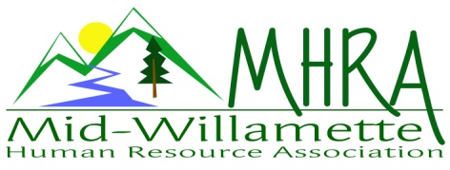
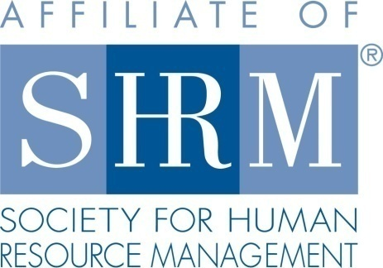

MHRA Mission Statement: to provide knowledge, skills, and resources while working to enhance personal and professional development.

BOARD MEETING (Chapter 202) June 22, 2016, 7:30 – 9:00 am – Albany, Oregon

 |  |  | Darcee LaCalli* | Legislative
DeeDee Gordon | Diversity Chair |  | Laurie LaRiche | Workforce Readiness
Claudia Hamilton | Sponsorship Chair |  | Karlina Christensen Lee* | Past President/Programming/Sec.
 |  |  | Kathy Westberg* | Foundation Chair
Jason Bushnell* | Treasurer |  | Jared Haddock* | Website Chair
Bonny Ray* | President |  | Cindy Bene | Membership Chair
Kristen Taylor | President Elect/Certification
Highlighted designates PRESENT. *Indicates SHRM Foundation donation made for 2016.

Approval of Minutes: Karlina moved to accept the May minutes. Claudia seconded. Motion carried.

SHAPE: 2016 Membership initiatives are strongly underway. We have already accomplished several. All others are in process. We still need to host a membership drive meeting.

Treasurer’s Report: Jason presented current treasurers report. Income is higher than expenses. Total assets are back over 16K. A SHRM payment of $643.75 came through. Mennonite Village has not yet invoiced for last month. We had one paid attendee for the June meeting. Jason is working on the 2015 tax forms. To be completed by next month.

July Meeting: Sponsor is Timber Linn Chiropractic. Still need to invoice. Karlina has a door prize. Sponsor will bring one too. Barren Liebman is facilitating the topic of workplace violence policy. This is a paid program. They have not yet invoiced us for the speaker.

Oct. 7th Additional Program: We will partner with Salem on a Performance Management program. 50/50 split on proceeds with our contribution of volunteers. Salem chapter has confirmed location. Karlina will do handouts. Her team has already created a flyer for advertising. We will provide volunteer coordination. Kristen has submitted for continuing ed. credit. SHRM 7 PDC’s, HRCI is 5.5 credits pending. Jason, Claudia, and Darcee are volunteering. Attendance is capped at 40 participants. If we quickly fill up there is an option to add another day of the program for Oct. 6th. Consider mailing a post card to MHRA and SHRMA membership if it looks like registration is slow and at risk of not filling up.

Workforce Readiness: Laurie not in attendance today due to attendance at the SHRM National Conference.

Diversity: DeeDee not in today.

Membership: We are currently at 103 members. We are now a medium size chapter designation. We need to do a new member analysis to determine what’s working in member recruitment. Cindy will be in attendance next month for a more comprehensive report. Board members have been reaching out to local HR people not yet affiliated.

Programming: Karlina has already started confirming 2017 programming. Events are live on event brite through the remainder of the year except August. Still need to confirm a speaker and date for our additional FLSA event. Will look at a program for disaster preparedness for early 2017.

Website: Jared has begun posting board meeting minutes on the website for member review. They are posted through April. May minutes were approved today. Kristen will send Jared the May minutes today. Links are ready for programming. Reminder emails are going out.

OSU Update: Based on the departure of the HR Manager that was coordinating with us, this partnership effort is currently on hold pending the replacement hire for this goal. October chapter meeting will be held at the regular Mennonite Village location. This has been confirmed.

Foundation: Kathy will shop for the foundation basket that will be raffled during the July meeting. Tickets will be sold at the reception desk. Kathy will speak to some foundation talking points at the meeting. Reminder to board members to make their 25.00 donation if not done already.

Legislative: Discussed Dec. 1 FLSA change preparation. OSHA updates clarify rules regarding retaliation/discrimination protection for work related injuries. Rule changes around post accident testing are probably the most notable.

2016 Sponsorship: Karlina is working on a brochure for sponsorship. No sponsor for the month of August. Everything else is set in place for the remainder of the year. Not all have been invoiced.

SHRM/HRCI Certification: 2015 closed with 43 SHRM certified members. We show 45 certified members as of the 2016 first quarter summary report. We confirmed study class details as offered by Deborah Jeffries from the Salem chapter. She is offering the class at a very reasonable rate plus a discount on materials. This was announced to membership at the May Chapter meeting and emailed to membership during the past month. Dennis Carr will also do an announcement in the August meeting for his Corvallis based class this Fall. HRCI credit is pending for the shared October program with SHRMA. SHRM credit is submitted.

We will keep this discussion open for future consideration. DOL reps are going to come to the September meeting to a do a brief thank you to the chapter for our partnership with the Veterans event that was held earlier in the year.

2017 Board Membership and planning: We will want a co-programming chair for 2017 to back up Karlina and her new mom status. Planning session for 2017 will be held in lieu of the August (8/24) board meeting from 4-7pm. Bonny will confirm location.

DeeDee interested in certification for 2017.
Jason, Claudia, Kathy, Darcee, Jared, Karlina interested in same positions.
Brainstorm members to reach out to for potential board membership.

Reception table: Darcee and Kathy will cover July reception.

Meeting adjourned at 9:00 a.m.

