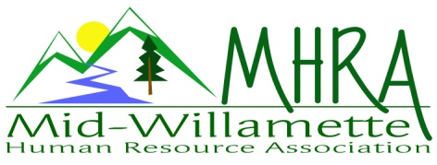
1 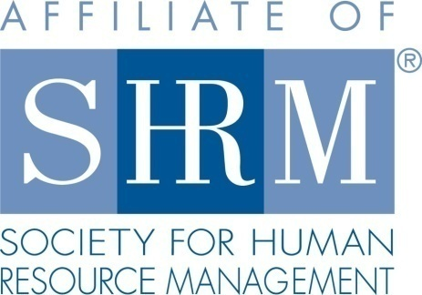

MHRA Mission Statement: to provide knowledge, skills, and resources while working to enhance personal and professional development.

BOARD MEETING (Chapter 202) June 28, 2017 7:30 a.m. to 9:00 Allan Bros. Albany, Oregon

Kristen Taylor | President |  | Jared Haddock | Website Chair
DeeDee Gordon | Certification/President Elect |  | Laurie LeRiche | Diversity/Workforce Readiness
Claudia Hamilton | Sponsorship Chair |  | Karlina Christensen Lee | Programming
Darcee LaCalli | Legislative |  | Kathy Westberg | Foundation Chair
Jason Bushnell | Treasurer |  |  | Membership Chair
Bonny Ray | Past President/Secretary
Highlighted designates PRESENT.

The meeting began at 7:30 a.m.

Approval of Minutes: The May 2017 minutes were reviewed. Karlina moved for approval with a couple corrections noted. Darcee seconded the motion. The minutes were approved.

July Membership Meeting Logistics: There was a mix up with the June/July registration link and Karlina has reached out to those registered to clarify. We are continuing to track people who register but don’t show and/or show but don’t register. Darcee will continue to do membership check in at the meeting, and is maintaining the rosters for trending purposes. We have books for door prizes. July meeting topic is mental health in the workplace. Kurt, an attorney from Central Oregon is presenting. Accommodation, law, etc. will be covered. We will owe him mileage. Best Western has sponsored the hotel. We were billed for 36 in attendance last month instead of the 31 RSVP. Kristen will talk to Kierra at TFS about a credit for July.

Treasurer’s Report: Jason passed out the monthly report. It was a poor month based on income lower than expenses. We had $45.00 from Eventbrite for the June meeting. We have two outstanding invoices for sponsorship. The Red Kite sponsorship fee of 300.00 came in after the report was created, so that will show up on the next report. 3 month CD rolled over. Total assets are still in excess of 19K. We have doubled our assets in the last 5 years and grown from a small to a medium chapter.

Membership Update: It makes sense to do an at large reach out at this time due to recent loss of members. Not everyone knows that if SHRM membership lapses at all that they will need to do a new designation form for the chapter. We are currently sitting at just over 100 active members based on recently audited roster. At out peak we were at 118.

Position Reports

Certification: Credits have been submitted for everything so far this year, although the November meeting date will need to be updated to reflect change to December.

Workforce Readiness/Diversity: The student chapter is up and running and it will take some coordinating to see how we can support them. Jared and Laurie attended the student chapter charter ceremony. By all reports it was fantastic. There are currently 30 student members. Resume building and meeting invites are a way we can encourage them to participate with our chapter. We will want to continue to brainstorm ways we can partner. Potentially explore sponsoring a student scholarship for the assurance of learning test. Support for participation in the annual student competition is also an idea. Discussed the idea of giving limited free invites to our chapter meetings and then a reduced cost of $10.00 for excess of what we can donate. An after-hours networking event is also something we may plan for when school is back in session this fall. Jared will reach out to Michelle Swift to assess what the student chapter goals are and ask them to present us with a proposal for how we can help. Laurie is open to attending some of their meetings to serve as an MHRA liaison.

Foundation: SHRM Foundation sent us a thank you for our contributions. Kathy will read it to the members at the July meeting. We have a free ticket for the annual strategic conference we can raffle. We also have signed Joey Harrington football for raffle. Both of these can be advertised for upcoming raffles. Our goal is to exceed $420.00 for the year.

Legislative: Darcee presented updates. Predictive scheduling for retail, food service, and hospitality is likely to go through. 2 week advance scheduling is required and allows flexibility to worker schedule on short notice changes. Increased pay would be required for shifts with less than 10 hours turn-around from prior shift. Pay equity passed.

Programming:. July topic is mental illness in the workplace. Debra Jeffries has switched her presentation date to December. The program topic is still to be determined, but we focus on a more fun/lighthearted topic as is typical for the December program. We are now needing to back fill November based on Debra’s date change. Karlina is starting to build out the 2018 schedule. We may be able to get another harassment program for the November gap. Board brainstormed some ideas for topics to stay relevant, new, and interesting. The goal is to get the full year filled so that we can do the post cards with the entire 2018 line up like we did for 2016.

Sponsorship: AKT is the July sponsor at $450. September is Corvallis Clinic $450. October is Willamette Neighborhood Housing at $300. We could possibly move our October sponsor to November if we charge for our October meeting. Saafeld Griggs has not sponsored yet so Claudia will approach them about August where they could give a legislative update to. Best Western is sponsoring our speaker’s hotel for July. Karlina has two possible sponsors Pacific Source and a tech company that she will pass on to Claudia.

Website: Jared cleaned up the website this month to ensure all information is current. He discussed means for web based archiving of documents so we have historical data secured. Member rosters should be held. Face book page is up and running. It is getting a lot of traction with our members. There are regularly notifications of new views. We are posting meeting information and random bits of good info. Hootsuite is still needed so we can cross post to other social media. FB and LinkedIn can be updated simultaneously this way.

Future Planning: We are working on at least one half-day program for the future that we could charge for. Board succession planning is also a concern. Board succession planning is an on-going topic. Jared will add a testimonies section to the website where we can all write about our experience and value for board volunteerism. Perhaps posting the SHRM board job descriptions as well. We should look aligning our board position titles with the SHRM titles. Jill from Garmin is potentially interested in board membership. Jason will talk with her about taking on membership.

Next Board Meeting: July 26, 2017 same place and time.

Meeting adjourned at 9:00 a.m.

