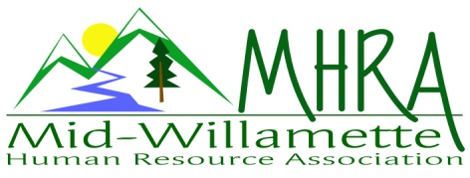
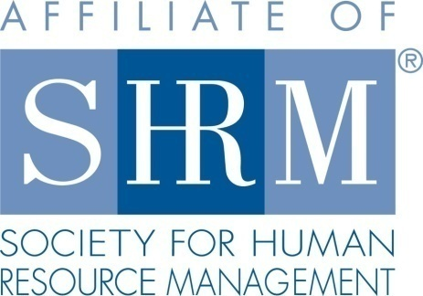

MHRA Mission Statement: to provide knowledge, skills, and resources while working to enhance personal and professional development.

BOARD MEETING (Chapter 202) May 27, 2015, 7:30 – 9:00 am – Corvallis, Oregon

Jean Bonifas | Past President/Membership
DeeDee Gordon | Diversity Chair |  | Robynn Pease* | Workforce Readiness
Claudia Hamilton | Sponsorship Chair |  | Karlina Christensen Lee* | President
 |  |  | Kathy Westberg | Foundation Chair
Jason Bushnell | Treasurer |  | Jared Haddock* | Website Chair
Bonny Ray* | President Elect |  | Cindy Bene | Legislative Chair
Kristen Taylor* | Secretary/Certification
Highlighted designates PRESENT. *Indicates SHRM Foundation donation made for 2015.

Approval of Minutes: Jared moved to accept the April minutes. DeeDee seconded. Motion carried.

SHAPE: Continue to be on a solid very track for our 2015 SHAPE.

Programming: Last month’s meeting went a little over time. Bonny to make increased effort moving forward to ensure presenters are cognizant of meeting times. October program is not yet confirmed. Have a possible presenter for financial wellness. Membership request is looking for something on labor relations. Will explore that also. DeeDee recommending Stacy Stack based on the recent presentation at OEC State Conference. Bonny has a lead on a presenter to address interest based bargaining in negotiation.

Sponsorship: AKT is confirmed for June. Samaritan Health is confirmed for July. September (Red Kite), Willamette dental October, Corvallis Clinic has sponsored the November meeting. August and December are still open.

Treasurer’s Report: Jason not present today, no report available at this time.

SHRM/HRCI Certification: Kristen is still waiting on program details for the months of October, November, and December, plus the HR101 program to be held on September 25, 2015. All other HRCI and SHRM credits are approved to date. The August program is divided into two parts. 1.5 credits will be available as per our usual meeting schedule. There will be an additional 2 credits available for those who are able to stay for the second session that day. SHRM-CP and SCP ribbons are available at the reception table at check-in so members can advertise their credentials.

Foundation: Kathy putting together basket for summer raffle. Contributions are coming together nicely. Do still need some items. Give donations to Kathy if you have anything to share. Tickets will be $5.00 each or 5 for $20.00. Raffle to be done at the June meeting. *sign after the name in the above board member roster list indicates that suggested donation to the SHRM Foundation has been made for the 2015 calendar year.

Legislative Updates: Cindy sent an email to the group for review. There are current proposed updates to the FLSA. SHRM is encouraging members to reach out to legislators in voicing opposition to the proposal. There is still a lot of activity at the State level with proposed bills.

Membership: Jean reporting 12 new members for the year with a current total of 98 members. Jean has an updated at large list. We are going for a 3% increase over last year to keep membership superstar status. New members were announced and celebrated at the last meeting. Jean will get the individual roses again for special recognition at the next meeting.

Workforce Readiness: Robynn to post a readiness section on the MHRA website. Opportunities for internships and contact information included at both the college and high school level for work coop. Veteran’s tool kit also to be made available in the Fall.

Website: Membership list is regularly updated on the website. Jared is posting sponsorship logos as they come in. The veterans recruiting event will be posted on the website once the flyer is created.

Diversity: Vets Spring Fling--Veteran’s social and recruiting event is scheduled for June 25th 4:30-7pm at the Children’s Farm Home Chapel building. Trillium will be sponsoring the event. We will need invoice for check request. Sgt. Brenda Thompson is a transition specialist with ESGR. She is assisting with employer contact for this event. Resume building, mock interviews, employer reps will be present. Jean has a lead on catering. Still need to explore advertising options for the event. Claudia can advertise on Indeed and Craigslist. Robynn can check for posting on the vet center board at OSU. Reaching out to local papers, website, and flyer will go out. Jean offered to draft invite. Employer reps should be there by 3:30 or 4pm. Bonny, Kathy, Robynn will be there for the reception and greeting table. Cindy will pick up decorative American flags etc.

Other: Bonny to reach out to Mennonite Home to touch bases regarding venue. Members are reporting liking the venue overall. Some minor complaints regarding coffee/catering, but overall seems to be a good fit thus far.

Reception table for June 10: Claudia and Jared will be at the reception table for June 10. Meeting will need to begin promptly at 7:30 due to time constraints. Raffle tickets for the foundation basket to be sold at the reception table.

Meeting adjourned at approximately 9:00 a.m.

