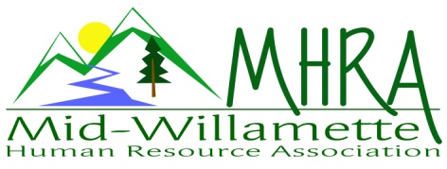
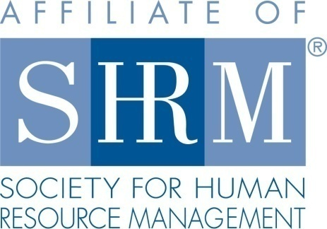

MHRA Mission Statement: to provide knowledge, skills, and resources while working to enhance personal and professional development.

BOARD MEETING (Chapter 202) May 25, 2016, 7:30 – 9:00 am – Albany, Oregon

 |  |  | Darcee LaCalli* | Legislative
DeeDee Gordon | Diversity Chair |  | Laurie LaRiche | Workforce Readiness
Claudia Hamilton | Sponsorship Chair |  | Karlina Christensen Lee* | Past President/Programming/Sec.
 |  |  | Kathy Westberg* | Foundation Chair
Jason Bushnell* | Treasurer |  | Jared Haddock | Website Chair
Bonny Ray | President |  | Cindy Bene | Membership Chair
Kristen Taylor | President Elect/Certification
Highlighted designates PRESENT. *Indicates SHRM Foundation donation made for 2016.

Approval of Minutes: Karlina moved to accept the April minutes. Claudia seconded. Motion carried.

SHAPE: 2016 Membership initiatives are strongly underway. We have already accomplished several. All others are in process. We still need to host a membership drive meeting.

Treasurer’s Report: Jason presented current treasurers report. We showed a loss for this month. Expenses were about $1000.00 more than income. The May meeting generated $150.00 in guest attendance. Our meeting cost was a little higher, however, due to increased participation and speaker related fees. 3 month CD rolled over. Jason has the info he needs for remaining sponsor invoicing.

June Meeting: Handouts are being provided by the speaker. Wells Fargo is sponsoring. We will need to invoice still.

Oct. 7th Additional Program: We will partner with Salem on a Performance Management program. 50/50 split on proceeds with our contribution of volunteers. Salem chapter is confirming location. Karlina will do handouts. We will provide volunteer coordination.

Workforce Readiness: Laurie not in attendance today.

Diversity: DeeDee asked about verifying programming for next year to address transgender issues in the workplace.

Membership: We are currently at 104 members. This is a chapter record! This moves us from “small” to “medium” size chapter designation. We need to do a new member analysis to determine what’s working in member recruitment.

Programming: Karlina has already started confirming 2017 programming. Recommendation to bring back the speaker we had last month for continued exploration of workplace preparedness regarding active shooter incidents. BOLI has created a new training with FLSA, Oregon Minimum wage and other new laws. Recommended partnering with BOLI for this training on a 50/50 profit split and do this program in the Fall. Minimum speaker cost is $300.00 Program content runs 3 hours. Consider late September for this. Saalfeld Griggs may also provide the training at lower or no cost. Karlina will explore this.

Website: Jared has posted the most recent board meeting minutes to the website. He will verify with Kristen what he needs for getting the rest of 2016 to date posted. We continue to cross post with LinkedIn for many announcements. We have implemented the new member spotlight section. This is being met with a variety of interest from new members. A few have declined spotlight.

OSU Update: October membership meeting is set to be held on campus. Details still to be worked out. Cielia (primary HR contact for the University) is leaving her position. This could change the partnership goals potentially. Board is looking to set a date to advertise chapter benefits with the OSU HR team as a membership effort.

Foundation: Kathy not in attendance today. She is interested in doing a summer basket raffle and asked if the board is willing to make a small cash contribution towards the content. Claudia moved to contribute $50.00 towards content. Karlina seconded. Motion carried. We will ask Kathy to speak to foundation benefits at the meeting where drawing occurs. Probably July.

Legislative: The long awaited FLSA rule has announced. On May 18, DOL announce the new minimum exempt wage threshold to be set at $913 per week, or $47,476.00 annually. The threshold will increase every three years. Commissions only count towards 10% of the wage requirement. SHRM is still encouraging member advocacy.

2016 Sponsorship: Claudia presented current 2016 sponsorship line up. December is the only month open at this point, Jared will announce website ROI to generate interest in future sponsorship. Revisited ideas for ROI. Talked about all business cards entered in the drawing are given to the sponsor. Announce this to membership and start it at the June meeting. Board members will add our own cards following the drawing. Bonny will create a table sign that details this. We will also implement a table sign for the sponsor to be placed on the breakfast buffet table. Claudia will create the sponsor sing. We can also consider providing a $200.00 level for those sponsors hesitant to come in at the $300.00 or $450.00 level.

SHRM/HRCI Certification: 2015 closed with 43 SHRM certified members. We show 45 certified members as of the 2016 first quarter summary report. Provided we don’t experience loss, this serves to meet this component of the certification SHAPE goal. All confirmed programs to date for 2016 have continuing ed credit secured with both HRCI and SHRM. We confirmed study class details as offered by Deborah Jeffries from the Salem chapter. She is offering the class at a very reasonable rate plus a discount on materials. This was announced to membership at the May Chapter meeting.

Other: Discussed the idea offer for members to buy member name tags so they are more professional than the paper peel and stick that we currently use. Discussed volunteer participation in helping with the NRHMA conference. Will approach members to see if anyone is interested in a short term leadership commitment.

Congratulations Bonny on her new promotion

Reception table: Laurie will cover June reception.

Meeting adjourned at 9:00 a.m.

