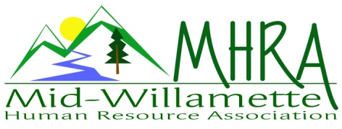
1 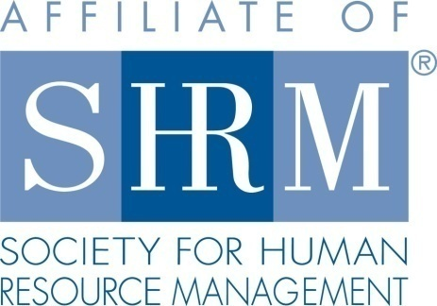

MHRA Mission Statement: to provide knowledge, skills, and resources while working to enhance personal and professional development.

BOARD MEETING (Chapter 202) April 26, 2017 7:30 a.m. to 9:00 Allan Bros. Albany, Oregon

Kristen Taylor | President |  | Jared Haddock | Website Chair
DeeDee Gordon | Certification/President Elect |  | Laurie LeRiche | Diversity/Workforce Readiness
Claudia Hamilton | Sponsorship Chair |  | Karlina Christensen Lee | Programming
Darcee LaCalli | Legislative |  | Kathy Westberg | Foundation Chair
Jason Bushnell | Treasurer |  | Cindy Bene | Membership Chair
Bonny Ray | Past President/Secretary
Highlighted designates PRESENT.

The meeting began at 7:40 a.m.

Approval of Minutes: The March 2017 minutes were reviewed and Karlina moved for approval. Laurie seconded the motion. The minutes were approved.

May Membership Meeting Logistics: The new location worked well. Kristen asked them to set up more chairs then we RSVP for next time. It was nice to have the food in the hallway and the coffee in the room. At the May meeting we will be in a different room. They put the welcome table at the entry way which was helpful. Food wise the presentation and quality was good. We ran low but Dee Dee asked for more and it worked out.

Treasurer’s Report: Jason was unable to come today. He passed on the following: We are still having a glitch with an Eventbrite due to them processing an issue getting money into the account from Citizen’s bank. They have needed to hand key the payment in for the past year at times even though Eventbrite has the correct account number.

Membership Update: Current membership list has 111 people on it. It was a lower number than expected. Some members have fallen off the list. Kristen will reach out to SHRM to get their list so she can compare the two to see if we can reach out to members to re-affiliate.

Position Reports

Certification: Dee Dee was unable to attend today but passed on that she has May credit established. She has contacted Debra Jefferies about a potential SHRM certification study course. Several members expressed interest at the April meeting.

Workforce Readiness/Diversity: The Pacific NW Diversity Council is holding a kick off meeting in Seattle 11:30 to 1:00 on May 18, 2017. It is quite a distance away but it is free. The Board discussed if we should send this to membership by e-mail or not. This is a networking meeting with professionals from the NW region.

Foundation: No update this time. We received an award for our Foundation donations. Kristen received a letter verifying our $140 donation.

Legislative: Equal pay in Oregon is up for public comment. Many bills are dying due to no movement and budget concerns.

Programming: Jennifer Bouman Steagall will speak on Culture in June. October will be a speaker named Emily Drew from Willamette on facilitating difficult conversations which is a diversity topic. This might be a possible ½ day workshop. There is a comedian who will come in March next year that Karlina has booked. This would be a good evening meeting. Karlina is working on lining up a speaker for a ½ day training. A possible December topic would be an improv group coming in with their presentation focus on scenarios HR professionals encounter.

Sponsorship: May is Barker Uerlings. They are bringing 4 people and will sponsor at $450. In June Jennifer will sponsor at $300. July is AKT sponsoring at $450. September is Corvallis Clinic $450. October is Willamette Neighborhood Housing at $300. We could possibly move our October sponsor to November. Saafeld Griggs has not sponsored yet so we could approach them about August where they could give a legislative update to.

Website: Karlina set up a Facebook page. Currently just the Board is participating on this page. We should begin adding content so that when we push information out it is robust. Jared was traveling and unable to attend.

Workforce Readiness: Michelle Swift is looking for volunteers for the professional development class again. She is looking for 3-4 volunteers per a class session. This class helps young business professionals prepare for interviews. It could help membership also by becoming more comfortable with interviews. It is also a possible recruiting tool for our membership. It was decided that we would send it out to membership as it is an opportunity to hire up and coming talent. Laurie will send an e-mail out. Also, they are holding a Management Club banquet and they will celebrate and commemorate the start of the Student SHRM chapter. They have invited Laurie and Kristen to attend. Kristen asked if we want to create a student chapter position on our Board. We will also welcome SHRM student members to attend our meetings. Karlina could add a student member line to the Eventbrite. Claudia also shared about an event through Rotary to do mock interviews at Crescent Valley High School with autistic students on May 10 from 9:45 to 10:45 a.m. They are looking for volunteers.

Future Planning: We are working on at least one half day program for the future. Board succession planning is also a concern. Kristen is willing to take on membership next year. Claudia may be interested in Membership and Sponsorship. We should cross train in rolls as well. Kristen will check on term limits. Laurie may be interested in the President role also in the future.

Next Board Meeting: May 24, 2017 same place and time.

Meeting adjourned at 9:00 a.m.

