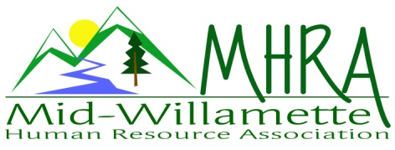
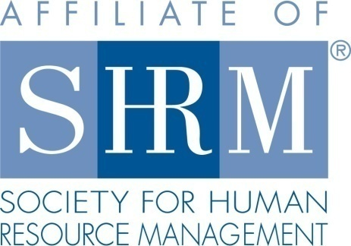

MHRA Mission Statement: to provide knowledge, skills, and resources while working to enhance personal and professional development.

BOARD MEETING (Chapter 202) April 27, 2016, 7:30 – 9:00 am – Albany, Oregon

 |  |  | Darcee LaCalli* | Legislative
DeeDee Gordon | Diversity Chair |  | Laurie LaRiche | Workforce Readiness
Claudia Hamilton | Sponsorship Chair |  | Karlina Christensen Lee* | Past President/Programming/Sec.
 |  |  | Kathy Westberg* | Foundation Chair
Jason Bushnell* | Treasurer |  | Jared Haddock | Website Chair
Bonny Ray | President |  | Cindy Bene | Membership Chair
Kristen Taylor | President Elect/Certification
Highlighted designates PRESENT. *Indicates SHRM Foundation donation made for 2016.

Approval of Minutes: Darcee moved to accept the February minutes. Karlina seconded. Motion carried.

SHAPE: 2016 Membership initiatives are strongly underway. We have already accomplished several. All others are in process. We still need to host a membership drive meeting.

Treasurer’s Report: Jason presented current treasurers report. Total assets remain over 16K. We had another good month. Income exceeded expenses. We are still waiting on the venue invoice for last month. Jason still needs to invoice Wells Fargo, Timberhill, and Saalfeld Griggs for sponsorship.

May Meeting: Topic is active shooter in the workplace. Karlina has print outs ready. Hotel accommodations are set for the speaker. We also agreed to pay mileage. 38 people registered at this point. No sponsor for this meeting. Karlina will bring door prize. We usual set the room for 40-45 participants. Based on current registration we may need to look at a different set up for the room. Max capacity for the room is about 60. Karlina will verify for sure and let Jared know so that he can send an email blast to remind people to register early if they want to ensure an open spot.

Oct. 7th Additional Program: We will partner with Salem on a Performance Management program. 50/50 split on proceeds with our contribution of volunteers. Salem chapter is confirming location. Karlina will do handouts.

Workforce Readiness: Laurie has enrolled in a SHRM workforce readiness webinar to be held next week. Expressed interest in increased HR internship opportunity with local employers. Consider exploring the idea for a Chapter intern for 2017 and what the learning agreement with the sponsoring school would look like. Laurie to check into this.

Diversity: DeeDee stated no new report at this time. Consider planning a specific diversity topic for next year programming. Transgender integration in the workplace as a suggested topic.

Membership: 11members have expired. Cindy has sent renewal reminders. We had 4 new members in April. We need to exceed 5% over last year’s 88. Cindy not in attendance today. She is out of the country until June, but is working remotely on the membership goals. DeeDee will team with Cindy to assist with membership.

Programming: Karlina has already started confirming 2017 programming. Still looking for a good FSLA speaker for a Fall additional program. OSU is willing to partner on this.

Website: We have had a chapter member ask that we post our board meeting minutes to the website. Jared will ensure there is a spot to post and take care of posting the current year minutes. Kristen will forward minutes to date to Jared. Diversity statement has been added. We continue to do new member spotlight. Consider posting this to the Linkedin news

OSU Update: Confirmed our October membership meeting will be held on campus. Details still to be worked out.

Foundation: Look towards summer for the next basket raffle. Consider alternative raffle options like a weekend get-away or an iPad.

Legislative: Minimum wage proposal is signed into effect. It is the first multi-tiered proposal in history. Increased rate goes into effect July 1st and annually thereafter for the next few years. New pay stub requirements roll out in January 2017. SHRM position on paid leave is that industry specifics should be taken into consideration for paid leave mandates.

2016 Sponsorship: Discussion on ROI for sponsors. What are we doing to solicit and maintain repeat sponsors? Idea to reach out to the sponsors to structure their presentation so they can track new business based on the meeting. This will help them see the actual return. Another idea is to offer sponsor booth opportunities for the half or full day events. Maybe we need to consider more options within different tier levels. Assess what sponsors are getting at each level and considering more lower cost options. Idea to post a “sponsored by” notice on the breakfast table and the eventbrite post. July has been covered by Timber Linn Chiropractic. Claudia continues to fill in the gaps. There are only a couple of months not covered at this point. We can advertise on both the website and linked in as well.

SHRM/HRCI Certification: 2015 closed with 43 SHRM certified members. Payment was received from SHRM for the 20.00 per certified member! We will also get this payment for 2016 newly certified members. All confirmed programs to date for 2016 have continuing ed credit secured with both HRCI and SHRM. We will confirm local certification study groups and courses to advertise for our members. We can potentially purchase a couple set of study materials in order to offer it to members at our discounted rate for purchase.

Other: 2 free SHRM e-blasts are available per quarter. By-law changes were voted on last chapter meeting. This was passed. By-laws ratified. Discussion around first time meeting attendees being free or paid. Board consensus is that we will honor a free preview first meeting for potential new members, but that other guests will pay the $15.00 guest fee to help offset meeting costs.

Reception table: Laurie will cover May reception.

Meeting adjourned at 9:00 a.m.

