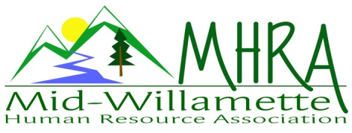
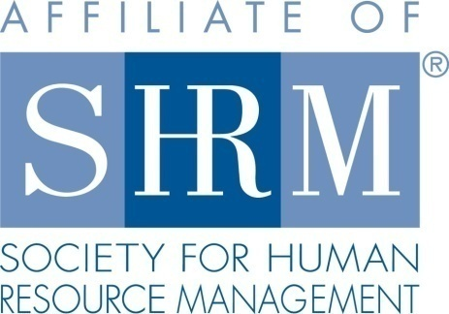

MHRA Mission Statement: to provide knowledge, skills, and resources while working to enhance personal and professional development.

BOARD MEETING (Chapter 202) March 23, 2016, 7:30 – 9:00 am – Albany, Oregon

 |  |  | Darcee LaCalli* | Legislative
DeeDee Gordon | Diversity Chair |  | Laurie LaRiche | Workforce Readiness
Claudia Hamilton | Sponsorship Chair |  | Karlina Christensen Lee* | Past President/Programming/Sec.
 |  |  | Kathy Westberg* | Foundation Chair
Jason Bushnell* | Treasurer |  | Jared Haddock | Website Chair
Bonny Ray | President |  | Cindy Bene | Membership Chair
Kristen Taylor | President Elect/Certification
Highlighted designates PRESENT. *Indicates SHRM Foundation donation made for 2016.

Approval of Minutes: Darcee moved to accept the February minutes. Jason seconded. Motion carried.

SHAPE: 2015 SHAPE is returned with Platinum award! Great job team. 2016 Membership initiatives are already going.

Treasurer’s Report: Jason presented current treasurers report. This was a great month. Total assets are over 15K. This is solidly better than we’ve had in the past. SHRM deposit came in for the 43 certified members in 2015. Mennonite Village increased our rate a little. It is based on RSVP number now. Went from a flat rate to tiered by volume. The change is still fair and reasonable. 3 and 12 month CD’s rolled over. Kalina moved to accept the report, Kathy seconded. Motion carried.

March meeting: March fundraising event was successful. We made $950.00 on the event.

April Meeting: Jean has asked if she can have photographers present at the meeting for her promotional needs. Concern expressed that it may be distracting, but we also recognize that she has presented for free on multiple occasions. We will ask that the photography be limited to the end of the session so that the main presentation is not affected.

Workforce Readiness: No new report today.

Diversity: DeeDee not in attendance today. There is a veterans recruiting event in Salem on April 7th. It is set up as a casual networking event. Employers will have the opportunity to both share job openings as well as tips/advice for attendees. This is sponsored by ESGR/DOL and partnered with the Salem Chapter. State council is offering assistance. We may need to also offer some financial assistance for our participation. Karlina moved to offer 100.00 towards the event. Kristen seconded. Bonny will follow up with DeeDee to enhance the chapter diversity statement for posting on the website.

Membership: 1 new member this month. Bonny passed around cards for the board to sign so we have them available for new members and guests. Cindy not in attendance today.

Programming: Are we interested in a performance management event shared with Salem chapter October 7th? This could be a good fundraiser event. Bonny to get more details from the Salem chapter as to how we would structure profit share. 7 HRCI/SHRM credits are approved. Cost would be 125.00 for SHRM members. As long as there is limited risk to the Chapter this could be a great opportunity. Saalfeld Griggs is open to doing another event for us. FLSA is a good topic if the changes are getting pushed through. FMLA/OFLA is another potential topic. An evening event in early summer might be good for this. Children’s Farm Home Chapel is potential location for this. Forks and Corks is willing to sponsor with catering the event.

Website: Jared not in attendance today.

OSU Update: They are working to accommodate parking for events held on campus. University plaza is proposed for parking. Thought the Hilton would be a good compromise if we can’t get something on campus. Discussion that this would be for the October chapter meeting. OSU is offering to pay for the room and the breakfast cost. OSU is asking for a later start time. This could be difficult for general membership if we shift it later. The survey results showed 65% of member respondents were favorable to this. We can market this as a membership drive.

Foundation: 50/50 raffle and themed baskets seems to be positively received on the survey results. The baskets probably earn more for the foundation than the 50/50. Look towards summer for the next raffle.

Legislative: Minimum wage proposal is signed into effect. It is the first multi-tiered proposal in history. FLSA proposals are underway. Darcee reviewed current proposals. Karlina met with congressmen to discuss FLSA. We need our member voice for advocacy against. The rules have been sent to the Senate. There is strong support for it at this point.

2016 Sponsorship: There is no sponsor for the April meeting. Claudia is continuing to round out openings for the remainder of the year plus the additional events.

SHRM/HRCI Certification: 2015 closed with 43 SHRM certified members. Payment was received from SHRM for the 20.00 ;per certified member! We will also get this payment for 2016 newly certified members. It was announced at the March chapter meeting that member Danae Overman is organizing an informal study group for those interested in the Spring testing window.

Other: 2 free SHRM e-blasts are available per quarter.

Reception table: Darcee and Kathy will cover April reception.

Meeting adjourned at 9:00 a.m.

