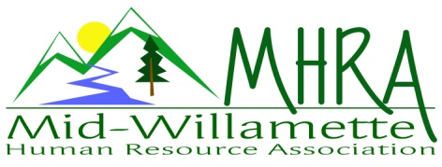
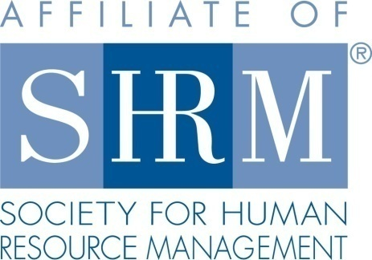

MHRA Mission Statement: to provide knowledge, skills, and resources while working to enhance personal and professional development.

BOARD MEETING (Chapter 202) February 22, 2017 7:30 a.m. to 9:00 Allan Bros. Albany, Oregon

Kristen Taylor | President |  | Jared Haddock | Website Chair
DeeDee Gordon | Certification/President Elect |  | Laurie LeRiche | Diversity/Workforce Readiness
Claudia Hamilton | Sponsorship Chair |  | Karlina Christensen Lee | Programming
Darcee LaCalli | Legislative |  | Kathy Westberg | Foundation Chair
Jason Bushnell | Treasurer |  | Cindy Bene | Membership Chair
Bonny Ray | Past President/Secretary
Highlighted designates PRESENT.

Approval of Minutes: Meeting began at 7:35 a.m. The January 2017 minutes were reviewed and approved. Karlina motioned and Kathy seconded the motion. Minutes approved with one correction changing Laurie’s spelling of her name.

Brief Discussion about Board donation to the foundation and about designating our chapter.

March Meeting Logistics: “The Aging Workforce” – Rebecca Watkins will be speaking. Darcee will keep the bag for the meeting and after that we will keep the box and bag at the Farm Home meeting room. Jason brought cash for the bag in smaller bills. Karlina has a stack of books as door prizes. Best Western is the sponsor and will bring a door prize. Jason and Kristen both have spare door prizes. Karlina believes we are at 30 or higher in terms of attendance. Karlina will print and bring a roster. She will close registration the night before instead of leaving it open. Karlina will add a note to Eventbrite about the need to register accurately so that we can have an accurate food count. We ran out of food last meeting. There was discussion about asking people to state if they will eat or not at the meeting. Karlina will send an e-mail about this issue from Eventbrite in March. Kristen asked that we keep a copy of the roster in the registration bag. Kristen would like to give an estimated head count the Friday before to the Farm Home and any variations will be provided to the venue representative on Monday. After the March chapter meeting we will really emphasize this issue. Kristen will create a campus map showing the new venue location and picture to hand out to members at the chapter meeting. There is a concern that new members are not on the e-mail list. Kristen will ask Cindy to e-mail Jared as well when signing up new members. At the first meeting at Farm Home Kristen would like to give the caterer a chance to talk about her venue and the opportunities other types of meetings members might want to have there.
Presidents Update: Kristen covered her update in the meeting logistic discussion above.
Position Reports

Treasurer’s Report: We had more expenses than income. We had $60 in from Eventbrite. We also made $140 for the SHRM Foundation from the raffle. The expenses included amounts for speaker gifts, Allan Bros. Breakfast and sending the SHRM foundation donation. Jason increased the budgeted amount for the breakfast costs at the new venue. There was no sponsorship payment for January or an invoice from the Mennonite Village. Motion carried to roll the CD’s.

Membership Update: One new member joined this month. Kristen will ask Cindy for a copy of the roster. She believes we are at about 119 members.

Certification: March and April were submitted and approved. April’s topic was approved for strategic credit for OEC so we will check to see why it was not approved as strategic for us. We will continue to offer HRCI and SHRM credits. We need to grow our certified membership by at least 1 and need to publicize it. We will invite Deborah Jefferies to talk about her certification class when she speaks in November. We could advertise her class also this summer. This is an initiative related to Certification. We will also begin asking at chapter meetings if anyone in attendance is newly certified so we can acknowledge them.

Workforce Readiness/Diversity: There is a National Diversity Council workshop or symposium called “Women in Leadership” in Portland. Karlina’s company has a video on black history month. She will forward this to the Board. Jason shared that his agency started an inclusion committee. Laurie is connecting with the OSC Diversity Director about passing on any diversity related events. We will communicate statewide and local opportunities to our membership. This is an initiative for 2017. Michelle Swift at OSU is also asking for help with mock interviews for her classes. It is an opportunity to mentor and help future HR professionals. The process occurs in a group so that students can observe each other. OSU is starting a student chapter. Laurie has participated in this several times. Her co-worker has also attended. As an initiative MHRA would like to continue to support this. We will partner with them. The need to affiliate with SHRM first. We could possibly invite them to a meeting this year and highlight upcoming HR professionals. Laurie offered funds from her employer role to help with the student chapters She offered this statewide and a Portland College has asked for $4000. Bonny mentioned that the Oregon Humanities Group has many speakers that can talk on a wide variety of diversity topics. The Board had a discussion regarding dates on resumes. It appears that leaving dates off is a new trend.

Foundation: We made $140 this past month on a raffle. We have set a goal of $450 this year. Kathy would like to spread the raffles out and continue to sell tickets at the table. Board members are asked to make donations this year of $30. We are still considering a head shot fundraiser. Dee Dee suggested a donation jar that members could put spare change in. Also, the foundation will provide videos. Kathy will check in about this. Bonny will bring 3 videos to March’s meeting.

Legislative: OSHA postings were discussed. Electronic submission is required for some by July. Saafeld Griggs did a comprehensive update in February.

Programming: May is set for an OSU expert who will speak on Earthquake Preparedness and Cascadia. Mrs. Clause does not have another training to offer at this time. Karlina has a resource through SHRM that would allow the Board to present the December meeting as a group. She is also working on a couple of ½ day workshops related to regulatory topics. July’s topic is Mental Illness in the workplace and will be a significant meeting. Another idea is in the works for Social Media and Employer Branding. So far, we are not paying for any speakers but are paying some lodging or mileage costs. Laurie suggested having a topic such as Mediation or regarding Student Visas. Karlina has contacted a speaker regarding the Transgender experience. It may involve a fee.

Sponsorship: February was Great Northern. Claudia is still working on those mentioned in January’s Board Meeting. She has also been talking with Linn Benton Community College Small Business Center as a new sponsor.

Website: Jared was not able to attend and did not have an update. The Board asked if the Facebook page is up and running. It is not at this time. This will be a website initiative.

Next Board Meeting: March 22, 2017 - same place and time.

Meeting adjourned at 9:03 a.m.

