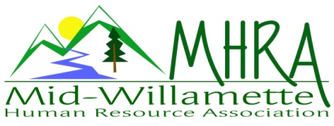
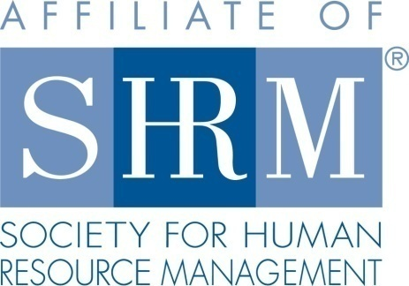

MHRA Mission Statement: to provide knowledge, skills, and resources while working to enhance personal and professional development.

BOARD MEETING (Chapter 202) February 24, 2016, 7:30 – 9:00 am – Albany, Oregon

 |  |  | Darcee LaCalli* | Legislative
DeeDee Gordon | Diversity Chair |  | Laurie LaRiche | Workforce Readiness
Claudia Hamilton | Sponsorship Chair |  | Karlina Christensen Lee* | Past President/Programming/Sec.
 |  |  | Kathy Westberg* | Foundation Chair
Jason Bushnell* | Treasurer |  | Jared Haddock | Website Chair
Bonny Ray | President |  | Cindy Bene | Membership Chair
Kristen Taylor | President Elect/Certification
Highlighted designates PRESENT. *Indicates SHRM Foundation donation made for 2016.

Approval of Minutes: Jared moved to accept the January minutes. DeeDee seconded. Motion carried.

SHAPE: 2016 SHAPE initiatives are near finalized. Membership initiatives are already going. The chapter diversity/non-discrimination statement will be posted on the website. SHRM e-blasts are going out to at large members. Workforce Readiness: Announcements regarding the DHS-TANF program to provide education about the program is proposed. Perhaps Greg Ivers would come in to do some workforce readiness education. Certification initiatives are underway. Consider MHRA purchase of a set of SHRM study materials that would be available to members for check out. Member survey will go out to explore chapter desires for initiative offering.

Treasurer’s Report: Jason presented current treasurers report. Positive month. Total assets are over 14K. This is the highest it has been. Successful eventbrite deposits are coming through. Mennonite Village expense will be going up. It is not certain at this point how much it will go. They reported that they are not breaking even at the current 280.00 per month. CD’s are currently maturing. Bonny moved to rollover, Jared seconded. Motion carried.

March meeting: Registration is going well so far for the March fundraising event. Cindy will be at the greeter table with Darcee.

OSU Partnership: There are more than 80 HR professionals employed at the university. We are considering having a few meetings there per year to provide HR education opportunities. They would provide space, however, we need to take SHRM membership into consideration for our chapter meetings. We could do this as a SHRM membership drive. This would advertise MHRA as well as reach out to local professionals. These would be in conjunction with our regular chapter meetings with the host location rotating a few times per year. Parking is a potential barrier that needs to be worked through. Early morning or evening is best for parking availability. Perhaps consider using the campus Hilton Hotel as an alternative that is still close to campus. OSU continues to be a significant supporter of SHRM certification preparation through collaboration with Dennis Carr. Looking at June or October to run a trial program.

Chapter Bylaws: Reviewed and discussed at today’s meeting. Kristen moved to amend section 5.1 to allow for occasional reschedule of the regular chapter meetings. Kathy seconded. Motion carried. This will be explored for presentation to the membership and process for amendment.

Workforce Readiness: Laurie not in attendance today. No new information at this time.

Diversity: Consider working with the Salem Chapter and/or OSC to sponsor a large Veterans recruiting event.

Membership: Cindy reports 3 new members since last month.

Programming: 2016 programming is fully scheduled. March will be a half day (3 hour) program. Krishna will facilitate. This will be fundraising event for the chapter. $20.00 for members and $25.00 for non. Leave and accommodation is the identified topic. Idea is to bring case study presentation to process through real employer challenges. Also consider another half day in addition to regular programming in the Fall like we did last year. All the eventbrite registration links are loaded.

Website: Send your promotion or website/linkedin ideas to Jared. Jared to update the 2016 registration links to match the programming changes for the year.

Foundation: $285.00 in raffle purchases have been sent in for the foundation. Consider another basket raffle for this summer. Give donations to Kathy.

Legislative: Minimum wage proposal has cleared the House. This is only waiting for final Governor sign off. It is the first multi-tiered proposal in history. FLSA proposals are anticipated to go into effect this summer. Employers are encouraged to prepare early. This is a short legislative period so there are not a lot of new bills. All updates will be posted to the website.

2016 Sponsorship: Wells Fargo is not yet ready to invoice. All others have been sent to Jason for invoice at this time.

SHRM/HRCI Certification: 2015 closed with 43 SHRM certified members. All 2016 programs are entered for credit except August. This will go in soon.

Other: 2 free SHRM e-blasts are available per quarter.

Reception table: Cindy and Darcee will cover March reception.

Meeting adjourned at 9:00 a.m.

