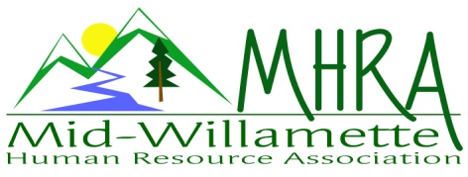
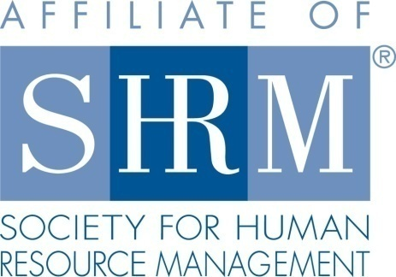

MHRA Mission Statement: to provide knowledge, skills, and resources while working to enhance personal and professional development.

BOARD MEETING (Chapter 202) January 28, 2015, 7:30 – 9:00 am – Corvallis, Oregon

Karlina Christensen Lee | President
Bonny Ray | President Elect |  | Robynn Pease | Workforce Readiness
Claudia Hamilton | Sponsorship Chair |  | Jean Bonifas | Past President/Membership
 |  |  | Kathy Westberg | Foundation Chair
Jason Bushnell | Treasurer |  | Jared Haddock | Website Chair
DeeDee Gordon | Diversity Chair |  | Cindy Bene | Legislative Chair
Kristen Taylor | Secretary/Certification
Highlighted designates PRESENT.

Approval of Minutes: Jean/Karlina moved to accept the November 26, 2014, minutes (December meeting was cancelled). Motion carried.

SHAPE: We potentially qualify for platinum award. Jean to submit report today.

Programming: Bonny is updating and keeping the eventbrite registrations current. New meeting location is at the Mennonite Village. Will need to have good signage since its new to people. They are offering it at $290.00 for the room and breakfast. Room includes the media cart. The February meeting presenters have changed, but topic remains the same. Currently working with a labor relations presenter. Need to poll the membership as to what specific relations topic we want him to focus on. This will be either the October or November meeting.

A half day workshop is a potential. Ann Gilles is open to this (cognitive bias) and Randy and David are open to doing an HR 101 workshop. Look at a charge for this meeting and invite outside participants as well. Location to be determined. Check with Mennonite Home to see if this an option. Potentially consider partnering with OEC also. This could open up the room at Central Willamette.

Sponsorship: Claudia requesting report of past sponsors. Robynn to send that along with our template for request letter. First 2 months of the year are covered. Give ideas to Claudia. Potentially target local law firms, benefit providers, or Samaritan.

Treasurer’s Report: Jason distributed copies of the report and noted that our total assets dipped below $10,000 for the first time. Expenses were higher than income last month. Board breakfast costs are down, however! Year end total income v. expenses was nearly identical. Sponsorship was the biggest area of discrepancy in actual versus budget amount. $305.00 was contributed to the foundation last year. Need to look to exceed that amount in 2015 for SHAPE award. Motion to approve the report. Motion carried.

HRCI Certification: Karlina and Kristen will meet tomorrow to discuss transition of certification materials. We will need to develop a system for tracking who has completed the SHRM certification. Discussed entering people in a raffle who transfer the cert and let us know.

Diversity: DeeDee is new to the diversity chair role. Jean will assist as she is the State diversity chair for this year.

Foundation: Will be doing a raffle next month. Include details for this on the meeting announcement and the eventbrite registration link.

Minutes—January 28, 2015
Page 2

Legislative Updates: Cindy sent an email today to the group for review. Looking forward, we will provide this data to membership, rather than just the board members getting it.

Membership: SHAPE report is due. Jean audited membership list from SHRM and notes chapter membership of 85. Potential membership of 94 based on our membership list.

May meeting: an evening networking meeting. Social media will be the topic. Recommending a Corvallis site for this time since we had the last one in Albany. Robynn recommended an interactive style for the presentation. Karlina reported we have access to an interactive app we can use for meeting reminders, surveys, etc.

Consider doing an event that is strictly networking or make it a little longer to give people more time to socialize.

Workforce Readiness: Kristen and Robynn to meet to exchange SHAPE information. Karlina also has a connection for returning veterans that she will share with the board. It would include coaching and resume review to place veterans returning to the home workforce. Hero to hire is the group. Oregon has a large returning veteran group in the coming months.

Website: Jared has been keeping it updated. He has a group contract list for all members and a separate one for the board. Jared to cross train other board members to use the system. New members are added to the list so that distribution of information is consistently getting to all members. Jared to double check to make sure list is accurate since a couple of board members don’t seem to be getting the MHRA emails.

Other:

Karlina will be traveling for much of February. Bonny to assist in her absence.

Need to ensure we are using the correct logo on all of our materials. Logo is available as a graphic on our letterhead.

SHRM certification: Needs to be designated on people’s nametags who are certified. Kristen will develop a system for recognizing these people at the chapter meetings. Upon introduction we can ask people to share that they’ve certified.

February reception hosts: Jean volunteered for greeting at the door. Claudia will be at the desk.

Kathy suggested meeting wrap ups always conclude with reminders to bring guests or encourage new members.

Meeting adjourned at approximately 9:00 a.m.

