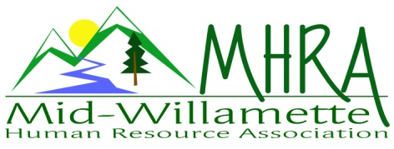
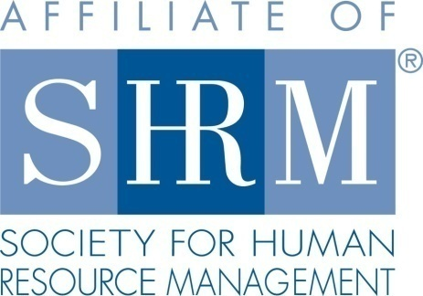

MHRA Mission Statement: to provide knowledge, skills, and resources while working to enhance personal and professional development.

BOARD MEETING (Chapter 202) October 28, 2015, 7:30 – 9:00 am – Corvallis, Oregon

Jean Bonifas | Past President/Membership |  | Darcee LaCalli | Guest attendee
DeeDee Gordon* | Diversity Chair |  | Robynn Pease* | Workforce Readiness
Claudia Hamilton | Sponsorship Chair |  | Karlina Christensen Lee* | President
 |  |  | Kathy Westberg | Foundation Chair
Jason Bushnell* | Treasurer |  | Jared Haddock* | Website Chair
Bonny Ray* | President Elect |  | Cindy Bene | Legislative Chair
Kristen Taylor* | Secretary/Certification
Highlighted designates PRESENT. *Indicates SHRM Foundation donation made for 2015.

Approval of Minutes: Kathy moved to accept the September minutes. Cindy seconded. Motion carried.

SHAPE: The fall certification prep class was advertised at the September HR 101 seminar. This meets the final shape goal for certification. Membership goals are being tracked. We are on track for Platinum again this year. Karlina has started the Shape report for submission.

Treasurer’s Report: Jason not in attendance today. Overall financial health is stable for the chapter. The turnout for the HR 101 seminar was good. $930.00 was collected in registration fees. It is about $800.00 positive cash flow after the bills were paid.

Workforce Readiness: Robynn not in attendance today. She will facilitate the November panel session.

Diversity: DeeDee proposed some potential contacts for facilitation of a diversity topic for 2016 programming. Another recruitment event is proposed for early in the year. Bonny proposed an armory as a location for a veteran’s event to increase attendance.

Membership: September report shows 88. This is down from 91 on the August report. We need to show 5% increase over 2014 to maintain superstar status. 2014 closed at 84 members.

Programming: First 4 months of 2016 are confirmed. January is wellness in the workplace (Mike Waters, Timberhill Athletic). February will be legislative updates again. Krishna is confirmed for the March chapter meeting/half day event. Jean will facilitate a listening skills topic for April. Red Kite is also confirmed for a chapter meeting-topic to be determined.
2015: Only 3 surveys were completed for the October 14 meeting so the data is limited. The November meeting has a good variety of veteran panel members. December 9th is HR superheroes. It will be activity based for team building and employee engagement ideas. Each board member will facilitate one activity. Members will leave with a super hero tool kit.

Website: Jared not in attendance today.

Foundation: Kathy completed the foundation survey for the year. We have donated 415.00 year to date. There will be another raffle at the December meeting.

Legislative: No report this meeting. There is not a lot of current action at this point. FLSA proposal seems to be stalled.

2016 Sponsorship: Reach out to Mike Waters to see if he is interested in sponsoring his own meeting. We have repeat annual sponsors that Claudia will confirm (Saalfeld Griggs, RedKite). AKT, Willamette Dental, Corvallis Clinic, Samaritan, and Wells Fargo and others are likely. Ideally we would sponsor all the monthly events plus the additional adjunct programming. No new updates since the last meeting.

Positions for 2016: Ballot went out to members last week. Secretary is open at this time. Karlina is on the ballot as interim for now. Kristen will pursue President Elect and maintain certification. Bonny President, DeeDee Diversity, Kathy Foundation, Claudia Sponsorship, Cindy Membership, Jason Treasurer, Claudia Sponsorship, Karlina Programming, Jared Website. Darcee

SHRM/HRCI Certification: SHRM Chapters will continue to be able to submit HRCI credits for approval free of charge. Board decision is to not pursue “preferred” status which would ultimately allow us discretionary decision making on program approval, but at a cost of $350.00 per year. Turn-around time on HRCI approval has been very fast recently. Board will continue offering both HRCI and SHRM credit in the coming year. Many of our members still wish to maintain HRCI. November program is approved for credit. Kristen will need an accurate head count at the close of the year for the number of members who obtained SHRM certification. This will be the baseline for next years’ goal of increasing that number.

Other: December meeting is proposed to be a food drive event. Kathy and DeeDee to work on the details around this. Door prizes for November are needed. Corvallis Clinic may provide since they are sponsoring. Claudia will confirm. Bonny suggested that we have a formal hand off for board members who are changing roles as a means to support the incoming board member. Next board meeting 11/23. It is the Wednesday before Thanksgiving. Karlina will send an RSVP to ensure we have a quorum that day.

Reception table: Claudia and Kathy will be at the reception table for November 12. Jean and Cindy will be there for December.

Meeting adjourned at 9:00 a.m.

