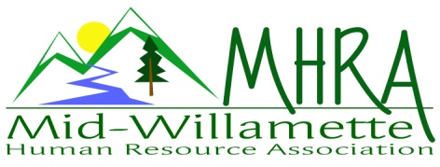
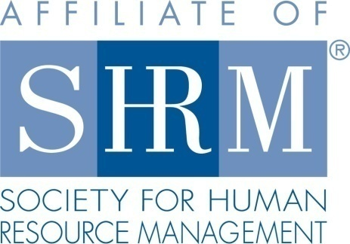

MHRA Mission Statement: to provide knowledge, skills, and resources while working to enhance personal and professional development.

BOARD MEETING (Chapter 202) October 26, 2016, 7:30 – 9:00 am – Albany, Oregon

 |  |  | Darcee LaCalli* | Legislative
DeeDee Gordon | Diversity Chair |  | Laurie LaRiche | Workforce Readiness
Claudia Hamilton | Sponsorship Chair |  | Karlina Christensen Lee* | Past President/Programming/Sec.
 |  |  | Kathy Westberg* | Foundation Chair
Jason Bushnell* | Treasurer |  | Jared Haddock | Website Chair
Bonny Ray* | President |  | Cindy Bene | Membership Chair
Kristen Taylor | President Elect/Certification
Highlighted designates PRESENT. *Indicates SHRM Foundation donation made for 2016.

The meeting begin at 7:35 a.m.

In Attendance: Bonny Ray, Jared Haddock, Laurie LeRiche, Kathy Westberg, Darcee LaCalli and Claudia Hamilton

Minutes: The September Board Meeting was cancelled so there were not minutes to review. The August minutes are in process and the Board will review them at the November 7, 2016 Board Meeting/Board Appreciation Dinner.

November 9, 2016 membership meeting: Darcee will greet. Rick Rebel is going to sponsor from AKT.

President’s update: Bonny reported on the October 7, 2016 Workshop sponsored with SHRMA. Claudia and Darcee attended and shared some of the items they learned. The Board agreed that it was a good thing to try out. The speaker may be willing to come and speak at one of our meetings. She was very knowledgeable. The Salem chapter allowed us to keep the profits after paying for the speaker. This was generous of them. It was about $572.

The group also processed the October chapter meeting held in Corvallis in partnership with OSU. Everyone was surprised that more OSU staff did not attend. It was significant however that 12 members who normally cannot attend because the meeting is in Albany said thanks for having an event there. The food was incredible and was provided by Forks and Corks. OSU Professional Development with Meddie Sims is willing to host another event and suggested summer as a better time, possibly July. Jared recommended that we also connect with Linda Powell, the Director of Shared Services at OSU who oversees the business centers as she might also promote the event in the Business Centers more. Mediation and Communication might be good topics.

On November 7, 2016 we will have the Board Appreciation Dinner at Carinos in Albany at 5:30 p.m.

The November 1, 2016 FLSA/Compensation workshop has 16 registered. Bonny will pick up refreshments from Costco for this event. Claudia will meet Bonny at 3:30 to set up. Corvallis Clinic is sponsoring but does not want to speak so we will just introduce them and thank them.

Treasurer’s report: Jason sent the report via e-mail. Bonny passed around a copy for review. We received over $500 from our sponsorship of the Performance Management Event in Salem. We also received our quarterly SHRM payment of $687. The Board agreed that overall financial status was great with assets over $17,000.

Membership Report: Bonny reported on Cindy’s behalf that we currently have 116 members! Cindy has agreed to stay on and help with membership and is doing an excellent job!

Certification: Kristen sent her update by e-mail. Credits have been submitted for the November 1 event. Kristen is training Dee Dee on how to apply for SHRM and HRCI credits as she will take over certification. Kristen sent out a ballot for Board Members Election for 2017 and we have 27 responses. We believe this is enough but will check the bylaws.

Diversity: No update from DeeDee at this time

Foundation: Kathy will look into possible scholarships for student memberships through the Foundation.

Legislative Affairs: Darcee reported on the FLSA. There is a lawsuit filed against the DOL still pending. Also the EEOC has added summary pay data as a requirement on their reporting. Darcee also shared that the VLRC is a good resource for Board members.

Programming: Karlina sent her update by e-mail. The first 6 months of 2017 are planned! Jeff Geddings is willing to come back and speak but would like more direction on the topic. Consensus around of the Board was that a tool kit would be helpful… such as 6 steps to take away and do at your place of employment whether you are a public or private company or a small or big company. Also programming wise the Board thought a ½ day or full day workshop would be ideal on topics such Risk Management or Legal Compliance with your New Hire Paperwork. Maybe a series of speakers (3-4) on related topics such as I-9 and HB-1 visas, handbooks, onboarding. Maybe OSU would provide the space and we could get sponsors to help cover food. We could charge $50 a person and it could be really great. Jared had some ideas from planning a conference for CUPA that might help our team take this on successfully.

Sponsorship: Claudia needs the list of 2017 speakers so she can begin matching up sponsors. Another Financial Industry Business wants to sponsor and the Board discussed having them sponsor an evening or additional event. Also the Board thought it would be a good idea to start saying the breakfast is provided today by the sponsor.

Website: Jared reported that he added a signature line to the website and will take off Karen Main’s name.

Workforce Readiness: Laurie reported that she met with Michelle Swift professor at OSU and she wants to start a student SHRM chapter with our support. This could be an excellent initiative for next year and could possibly be a place to provide some financial support from our chapter for membership scholarships or chapter startup costs. Laurie also shared about two Workforce Readiness Events that members can participate in including the December LBCC Youth Job and volunteering in Michelle Swift’s class to help future HR professionals with resumes.

Other Business: We want to send a thank you note to Forks and Corks Catering. Bonny will bring a note to the Board Meeting for all to sign. Bonny will forward the Oregon State Council - OSC December meeting information to interested Board members who would like to attend and learn more about OSC.

The next Board meeting is November 7th, 2016 at Carinos in Albany at 5:30 p.m. This will be the last Board Meeting of the year.

Meeting adjourned at 9:10 a.m.

