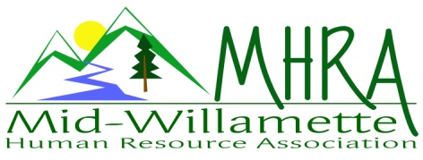
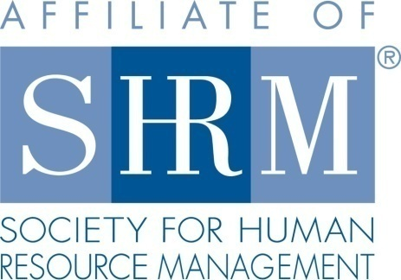

MHRA Mission Statement: to provide knowledge, skills, and resources while working to enhance personal and professional development.

BOARD MEETING (Chapter 202) January 25, 2017 7:30 a.m. to 9:00 Allan Bros. Albany, Oregon

Kristen Taylor | President |  | Jared Haddock | Website Chair
DeeDee Gordon | Certification/President Elect |  | Laurie LeRiche | Diversity/Workforce Readiness
Claudia Hamilton | Sponsorship Chair |  | Karlina Christensen Lee | Programming
Darcee LaCalli | Legislative |  | Kathy Westberg | Foundation Chair
Jason Bushnell | Treasurer |  | Cindy Bene | Membership Chair
Bonny Ray | Past President/Secretary
Highlighted designates PRESENT.

Approval of Minutes: The October 2016 minutes were reviewed and approved. Karlina motioned and Jared seconded the motion.

February Meeting Logistics: The topic is Legal Updates. Saalfeld Grigggs is presenting. We will do a foundation raffle for the OSC conference. Kathy will sell tickets for raffle for 1 ticket for $5 or 5 tickets for $20. Welcome table greeters are Darcee and Karlina. Darcee committed to being at each meeting by 7 a.m. each month and keeping the bag.
Presidents Update: Kristen- We are losing our venue in April. Farm Home School has an option of $10 a head. Claudia said Corvallis Country Club would also charge $10. One issue is the amount of food that we pay for versus the amount of food that is ordered. It often feels wasteful. In effort to maintain free chapter meetings we need to have accurate head counts for our meetings. Kristen said very few chapters have free meetings. We will announce this in the February and March meetings so members are aware. We will re-look at this if we are losing money. With sponsorship, we have been able to cover breakfast and want to continue to do this. Motion to accept new venue idea made by Kathy and Jared seconded it.
SHAPE/EXCEL Planning: Bonny submitted SHAPE and EXCEL awards for 2016 in December. Kristen explained that they are separate now. We are on track for hopefully a platinum award. Kristen said that a lot of chapters are using Facebook instead of Linked in. Karlina recommended hootsweet to push our information in a scheduled manner out on multiple social media platforms. Jared is willing to try this. He will create a group on Facebook. Pick several people to the Board to have access as things change this would be helpful with administrator rights.
Treasurer’s Report: Jason provided the year- end report. We receive greater amounts of SHRM membership payments and had good sponsorship levels plus profit from meetings we charged for. The current month income is higher than expenses. We ended the year at $17381.87. We received 3 sponsorship payments in December. February sponsor already paid. NHRMA money will now go to the state and will be distributed so we may not receive this. We came in close to our budget for the year. We may need to bump up food costs budgeted for membership meetings with the venue change. CD’s are maturing at the end of February. They will role. Jason finished the 2015 taxes and will do 2016 taxes later in the year. We are a 501C-6 organization tax wise. We will charge for 1-2 meetings this year and possibly co-sponsor a meeting with Salem or Lane chapters.

Membership Update: Our SHRM audit number closed us at 112 for the year but we were at 118. We need to keep our members and Cindy is including Kristen and membership e-mails.

Position Reports:

Certification: January was submitted and approved but we cancelled so we will update this for August. February was submitted and approved also. We will continue to offer HRCI and SHRM credits. We get $20 for each member that gets SHRM certified. We get an extra $10 for everyone that recertifies in 2017 as well. Kristen will check in to more details about this.

Workforce Readiness/Diversity: Lori is out sick. No report today.

Foundation: We want to be mindful of exceeding the $420 we achieved in 2016. Board members are asked to make donations this year of $30. Board members who make their donation this year will get to attend free one of our paid events this year. Possible head shot fundraiser.

Legislative: OSHA postings by February 1. We have until July to get electronic posting. W-2’s are due and the new I-9 forms need to be in place at the end of this month. The ACA may be repealed this year. This is a good idea topic wise for a fall meeting when it is clear what changes are made. Oregon’s Legislative session starts February 1, 2017. OSC is trying to plan a day on the hill for Oregon SHRM members. Paid parental leave is coming up as a possible law. Predictable scheduling is also a trending issue. Overtime rule is pending/on hold. We may want to consider offering short sessions for members as laws are passed quickly this session to help members with application of these new laws.

Programming: February is Legislative updates. The March topic is aging workers with Karishna. In April Jean is speaking on communication. This may be strategic credit. Our August speaker is Identity theft. The July topic is on Mental Illness. An attorney in the workplace from Bend will be speaking who presented at OSC. Stacy Stack is speaking in September and Jennifer Bouman Steagall is speaking in October. Debra Jefferies will speak in November. They are willing to speak but have not picked topics. Jeff Geddings cancelled due to employment related change. Karlina may try Chemeketa for Active Shooter resources. May, June and December are open. Lisbeth Claus may be willing to speak for free too. We will do a programming list to hand out to members when all the months are planned. We will do Starbuck cards for speaker gifts again.

Sponsorship: February is Great Northern. Maybe Rick Rebel for March. Jared has a lead on a Financial Advisor. Claudia will ask Jean. May is Barker Uerlings. Jennifer Bouman Steagall will do October. Saalfeld Griggs will do a fall meeting. Identity Theft speaker may sponsor the August meeting. If we do a half day workshop we should consider allowing them to set up a table or booth for a half-day session. Corvallis Clinic and Samaritan Health plans are possible options to reach out to. Dee Dee has a contact with Health Care Services. Darcee also has contacts with Propel. Maybe Paulette Barren/Liebman would sponsor a meeting if they speak as well. She has a presentation set up already regarding Transgender employees. Claudia will send Jason a sponsorship list for invoicing.

Website: Normal updates happening. The Board page was updated. Kristen mentioned that it says 2014 still. Jared will update this. Claudia will send Jared a list of Sponsors for 2017. Jared will look at creating the Facebook page too. Jared will add the 2017 SHRM and the HRCI seals on the website.

Future Planning: Come to the next Board meeting prepared to pitch an initiative for your core area so we can map these out for the SHAPE and EXCEL

Next Board Meeting: February 22, 2017 same place and time.

Meeting adjourned at 9:00 a.m.

