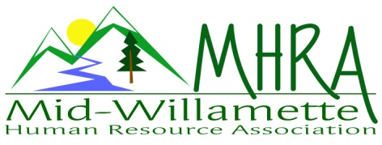
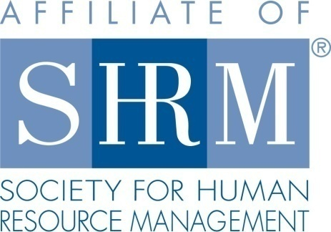

MHRA Mission Statement: to provide knowledge, skills, and resources while working to enhance personal and professional development.

BOARD MEETING (Chapter 202) January 27, 2016, 7:30 – 9:00 am – Albany, Oregon

 |  |  | Darcee LaCalli | Legislative
DeeDee Gordon | Diversity Chair |  | Laurie LaRiche | Workforce Readiness
Claudia Hamilton | Sponsorship Chair |  | Karlina Christensen Lee | Past President/Programming/Sec.
 |  |  | Kathy Westberg | Foundation Chair
Jason Bushnell | Treasurer |  | Jared Haddock | Website Chair
Bonny Ray | President |  | Cindy Bene | Membership Chair
Kristen Taylor | President Elect/Certification
Highlighted designates PRESENT. *Indicates SHRM Foundation donation made for 2016.

Approval of Minutes: Karlina moved to accept the November minutes. Cindy seconded. Motion carried.

SHAPE: Karlina has submitted the 2015 SHAPE data. We anticipate hearing the outcome early spring. 2016 SHAPE initiatives are being finalized.

Treasurer’s Report: Jason not present today. Karlina reported the $1200.00 NHRMA Shape award check came in. We are anticipating the $20.00 payment for SHRM certified members soon. There are 43 certified this year.

Workforce Readiness: Laurie distributed info regarding the OSU career fair. They are soliciting business to do mock interviews with participating OSU students. Benton county career convention is also looking for businesses to do mock interviews. This is a high school level event. Laurie to contact Greg Ivers regarding the State sponsored internship program and advertise this opportunity to membership. Karlina discussed the idea of improved ways to connect our currently unemployed members with local HR opportunities.

Diversity: DeeDee out today. Kristen took report following the actual board meeting. DeeDee is scheduled for a diversity recruiting event in August. This event can be advertised for our membership. It is the continued recommendation that our chapter create and post a diversity statement to the website. A veterans even in conjunction with OEC is still in the works. DeeDee is requesting Karlina’s assistance in the planning of this.

Membership: Current audit shows 92. This reflects a 6% increase. Cindy is sending post cards to at large members. She will also spotlight new members on the website. Consider an on-going member spotlight section. This can be posted on linkedin too.

Programming: 2016 programming is scheduled except for the month of July. March will be a half day (3 hour) program. Krishna will facilitate. This will be fundraising event for the chapter. $20.00 for members and $25.00 for non. Leave and accommodation is a proposed topic. Idea is to bring case study presentation to process through real employer challenges. Also consider another half day in addition to regular programming in the Fall like we did last year. All the eventbrite registration links are loaded. Barren Liebman has offered to facilitate July, but it’s not free. This would be at a cost of $450.00. Topic would be policy development around work place violence and risk management. Darcee moved to approve the cost, Kristen seconded. Motion carried. Karlina would like to update the monthly feedback survey. Send ideas for targeted questions to her.

Website: Jared will advertise the Stoel Reeves raffle for February on the website. He has updated the SHRM and HRCI logos on the website with the 2016 changes. OSU is sponsoring a BOLI training. Board may be able to do a presentation for MHRA at this meeting. Several of the OSU employees are SHRM members but not yet affiliated. We would need to sponsor breakfast, but is a possibly significant membership drive opportunity. Send your promotion or website/linkedin ideas to Jared.

Foundation: We will be raffling 1 ticket for the State SHRM labor conference by Stoel Reeves at the February meeting. Bonny will make sure Kathy is updated.

Legislative: Gov. Brown is backing a new minimum wage proposal. FLSA proposals are anticipated to go into effect this summer. Employers are encouraged to prepare early.

2016 Sponsorship: Claudia has soft confirmations on 5 meetings. Randy Sutton, Barker Uerlings, Jennifer Baumann, AKT, Corvallis Clinic. Timberhill Chiropractic is possible. Some are set for specific months, some are still to be determined. Claudia is actively recruiting with others to spread the word regarding sponsor value. Several other ideas were proposed. Consider doing a smaller scale sponsorship option at a lower cost in addition to the two options we already have.

SHRM/HRCI Certification: 2015 closed with 43 SHRM certified members. The 2016 Shape goal is to increase this number. Still need March, April and July data for credit application. All others are done. February is approved for Business credit with HRCI. There are defined goals for certification that need to be attended to each year. Recommend teaming with the Salem chapter regarding the certification study classes they are doing. Debra Jeffries teaches this course.

Other: 2 free SHRM e-blasts are available per quarter. E-blast will go out the at large members for the February meeting. Also send one for the March event. Include a free preview meeting on the member post card mailing. We have 37 registered for the February meeting. There is some concern about ensuring the room is set up. Last month we had to set the room ourselves. Karlina to check with Kris Gregory at Mennonite Village regarding this concern. As membership grows, we may need to actually explore a new venue.

Bonny reported out about the volunteer leader summit. Discussed ideas from the summit to increase membership interest and employer benefit. SHRM will offer a year of free membership for unemployed professionals. SHRM has a new commercial. We can show the commercial during the pre-meeting time frame at the next meeting.

Reception table: Cindy and Jared will cover February reception.

Meeting adjourned at 9:00 a.m.

