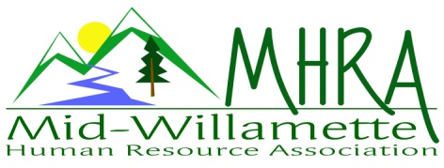
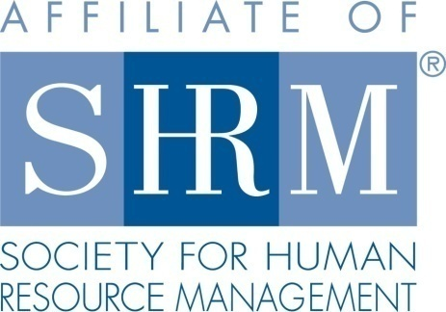

MHRA Mission Statement: to provide knowledge, skills, and resources while working to enhance personal and professional development.

BOARD MEETING (Chapter 202) June 27, 2018 7:30 a.m. to 9:00 Allan Bros. Albany, Oregon

DeeDee Kaundart | President |  | Lucille Valley | Website Chair
Kristen Taylor | Certification/Past President |  | Laurie LeRiche | /Workforce Readiness
Claudia Hamilton | Sponsorship Chair |  | Karlina Christensen Lee | Programming
Darcee LaCalli | Legislative Liaison |  | Kathy Westberg | Foundation Chair
Jason Bushnell | Treasurer/President Elect |  | Jill Sharp | Membership Chair
Bonny Ray | Secretary |  | Robin Bilyeu | Treasurer Elect
Ginny Kroshus | Diversity Chair
Highlighted designates PRESENT.

The meeting began at 7:40 a.m. Welcome by DeeDee.

Approval of Minutes: The Board reviewed and approved the May 23, 2018 minutes. The motion was made by Darcee and seconded by Jill.

President’s Report: The meeting started with DeeDee recapping our June meeting. We discussed a flyer at registration for people so they understand that the business cards left in the drawing will be given to the sponsor- like an opt in for the door prize. Karlina agreed to make the sign. DeeDee gave an update on the PO Box and there were a few more questions so she is checking with the Secretary of States office to see what we really need before we purchase a box.

Treasurer’s Report: The chapter made $75 off the May meeting on safety. Robin shared we received our SHRM payment finally and the Corvallis Clinic paid their sponsorship. She shared we are still waiting for the NHRMA payment and have not received a bill for the last membership meeting from Trillium yet. Karlina asked for a note to be added to the Treasurer report with the minimum required in the account to not pay fees so we institutionalize the knowledge.

Certification: DeeDee shared the update that July is submitted for credit as Kristen was not present.

Website: No update as Lucile was not present at the meeting.

Workforce Readiness: No update was given as Laurie was not present. DeeDee did share that the student chapter at OSU received an award for Merit in Excellence for 2017-18.

Membership Update: Jill shared that we audited the chapter in June and have 104 members. This is 11 new members but 13 fell off. She is working on catching up with those whose membership may have lapsed. DeeDee is writing a letter for at large and they are looking at a mailing for our area.

Legislative: Darcee shared she has new brochures and swag for legislative affairs. She got several ideas from SHRM on things she can do and would like to have a legislature speak to the chapter so will look to see if she can make that happen as an afterhours when someone is in district. Also, a reminder that minimum wage increases on July 1st.

Programming: Karlina gave a programing update starting with the July meeting which is focused on Identify Theft. She shared that we are working on adding 2 additional programs- one for quarter 3 and one for quarter 4. It will include a half day training on investigations and an afterhours on suicide prevention. She also mentioned we need to start lining up programs for January thru March.

Foundation: No update as Kathy was not present.

Diversity: No update as Ginny was not present at the meeting.

Sponsorship: Claudia shared that Corvallis Clinic is sponsoring July. August is Saalfield Griggs with September being Barker Urlings and October is LBCC. November is Zoup! She is working on other sponsors such as Anytime Fitness.

Next Board Meeting: July 25, 2018 7:30-9:00am.

Meeting adjourned at 9:00 a.m.

