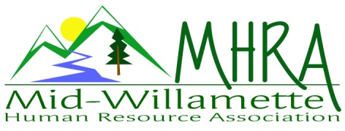
1 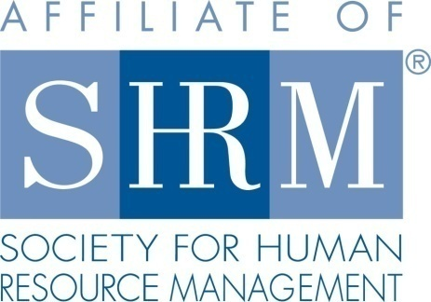

MHRA Mission Statement: to provide knowledge, skills, and resources while working to enhance personal and professional development.

BOARD MEETING (Chapter 202) July 26, 2017 7:30 a.m. to 9:00 Allan Bros. Albany, Oregon

Kristen Taylor | President |  | Jared Haddock | Website Chair
DeeDee Gordon | Certification/President Elect |  | Laurie LeRiche | Diversity/Workforce Readiness
Claudia Hamilton | Sponsorship Chair |  | Karlina Christensen Lee | Programming
Darcee LaCalli | Legislative |  | Kathy Westberg | Foundation Chair
Jason Bushnell | Treasurer |  | Jill Sharp | Membership Chair
Bonny Ray | Past President/Secretary
Highlighted designates PRESENT.

The meeting began at 7:30 a.m. The Board welcomed Jill Sharp who was visiting and considering joining the Board in the Membership position. She shared about herself and her career background. Jill specializes in leave and recruiting at Garmin. Jill will consider the membership role and get back to Kristen.

President Announcements: State Council of SHRM there is a call for donations for Alan Cabelli a SHRM leader in Oregon over many years. He is retiring. They are asking about donations to name a classroom after him at Portland State. The State Council is willing to match donations. Proposal to donate $100 was approved by consensus. Darcee made a motion. Karlina seconded the motion.

The Board reviewed the bylaws. There was a question regarding term limits. It appears the bylaws limit Board members to two terms in a position. A motion was made to edit bylaws to allow for longer terms when there is not another volunteer to fill specific roles. This language is located in Article 6, Section 6.5. Karlina proposed this and Claudia seconded the motion. Kristen will send a request for these changes to our local representative Diana for assistance with this change to the bylaws.

The August Board meeting is usually a planning meeting. Dee Dee will facilitate the August meeting. Kristen requested that Board members contact her with Board interest in positions and availability. The Board discussed positions for next year and interest in President Elect. Jason will take some time to consider this.

Approval of Minutes: The June 2017 minutes were reviewed. Karlina moved for approval and Kathy seconded the motion. The minutes were approved.

August Membership Meeting Logistics:

Treasurer’s Report: Jason passed out the monthly report. It was an awesome month. Current month income exceeded expenses. We are coming up on $21,000 in assets. Sponsorship payments were received from Corvallis Clinic and Red Kite. We received $631 from SHRM and $565 from NHRMA. Expenses for speaker gifts, speaker mileage, Board Breakfast and membership breakfast costs. Jason also filed the 2016 taxes. Outstanding sponsors include Saafeld Griggs, Willamette Neighborhood Housing and LBCC.
Claudia mentioned that Willamette and LBCC will likely pay in the fall after they speak/present at meetings. Budget wise income we are over $5000 for the year and expenses are at $2000 so we are on target. Karlina made her Foundation donation. The recommended amount is $35.

Membership Update: Kimberly with SHRM just sent out the quarterly update and is showing 103 members. Our roster shows 109 members. Kristen has identified the 6 people that have fallen off and will contact them. She explained that as a 100% chapter it is important that all members have designated and joined the chapter. Karlina provided some welcome to the chapter cards. Kristen will bring them to the next meeting. Jill will help Kristen. Kristen realized at the State Council meeting that we are supposed to use a chapter application for new members. An example was provided of what SHRM requires. If it is a transfer from another chapter it requires our membership form and a designation form. We also need a chapter membership application. Kristen and Jill will meet in August. Bonny asked if Kristen had the SHRM audit roster from last August to compare to our current roster and she does not. Kristen will see if Cindy still has this. Bonny will look to see if she still has a copy. If not Kimberly with SHRM could send us the audit roster from last year. Sherry Carter, Katrina Larsen, Kristen Lewis, Mark MacEntire, Stephani O’Conner, Bridget Robertson. Liz Herring from Allan Bros. is a potential new member. Kristen will reach out to her. David Parrish is a new member Kristen has been in contact with too. Bonny mentioned that we could also access the e-blasts to at large members to reach SHRM members in our area about our meetings. Karlina recommended that we ask for our at large list and contact SHRM members who are local regarding our fall meetings.

Position Reports

Certification: The Salem Chapter is hosting a chapter study group. An e-mail blast went out to members. It is also on our website and facebook page. It is the most affordable class in the area at only $600. It is a great value. Dee Dee will announce this at the next meeting. Also we continue to grow certified members. We were at 46 last year and now have 52.

Workforce Readiness/Diversity: Laurie was not here to give an update.

Foundation: Kathy announced the upcoming raffle at the July meeting for the August meeting. This is for a ticket to the Strategic Conference in Salem. Karlina, Darcee and Kristen will help with the raffle. Tickets are $5 each or 5 for $20. Foundation donation wise we are at $140. We need to go for exceeding $420. We will do a couple more raffles and if needed we will donate from chapter funds. Darcee asked about the change jar for the foundation if we should continue putting it out. Kristen suggested that we have a sign explaining the foundation and that every penny counts.

Legislative: The new I-9 form needs to be in use by September. The list of acceptable documents has changed. Hands free driving/distracted driving is going into place October 1, 2017. There are special rules regarding manufacturing overtime also that are in process of passing.

Programming: Last month’s speaker was really good. Salem split Kurt’s cost with us. We are done for the year. Deborah Jefferies is going to train in December on a possible strategic credit topic. August is identity theft in the work place. September is Stacey Stack from Express. October is Emily Drew on Difficult Conversations. It will be a longer meeting and we will charge $25. Kristen noted that Dee Dee is waiting on certification information for this. November is sexual harassment. Kurt is willing to come back next year and may consider a ½ day training. He may speak on social media in the workplace. At this point January through March and May are planned for next year. Barren Liebman will speak on retaliation on the workplace next year also. March is the comedian that does HR comedy and it will be an evening meeting. January is bystander intervention related to sexual harassment. Bonny mentioned that the Employer Partnership for Diversity is willing to partner with us on a meeting next year with a Diversity topic.

Sponsorship: August is Saafeld Grigg. October is Willamette Neighborhood Housing. November is LBCC. Claudia will look for a December sponsor. Claudia mentioned that she is not sure the $200 sponsorship level is helpful to the chapter. Some money is better than no money. We could go to the sponsorship offerings of $300 and $450 and separate the flyer out for the $200. She would like to offer the $450 and $300 level first. The Board agreed.

Website: Jared was absent so no website update.

Future Planning: Board meeting here next month.

Next Board Meeting: August 23, 2017 same place and time.

Meeting adjourned at 9:00 a.m.

