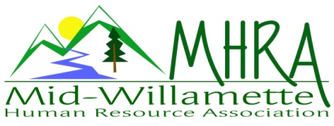
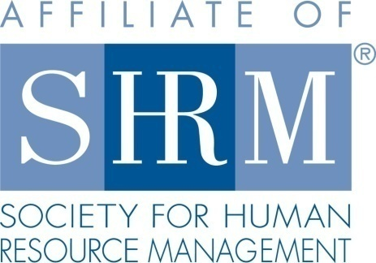

MHRA Mission Statement: to provide knowledge, skills, and resources while working to enhance personal and professional development.

BOARD MEETING (Chapter 202) October 25, 2017 7:30 a.m. to 9:00 Allan Bros. Albany, Oregon

Kristen Taylor | President |  | Jared Haddock | Website Chair
DeeDee Gordon | Certification/President Elect |  | Laurie LeRiche | Diversity/Workforce Readiness
Claudia Hamilton | Sponsorship Chair |  | Karlina Christensen Lee | Programming
Darcee LaCalli | Legislative |  | Kathy Westberg | Foundation Chair
Jason Bushnell | Treasurer |  | Jill Sharp | Membership Chair
Bonny Ray | Past President/Secretary
Highlighted designates PRESENT.

The meeting began at 7:30 a.m. Welcome to our guest Lucille. Kristen stated that the goal of the meeting to finalize roster for 2018 as the CLIF needs to be submitted to SHRM by December 1, 2017.

Approval of Minutes: The August 2017 minutes were reviewed. Lori moved that the minutes be approved. Karlina seconded the minutes and they were approved.

Review of Roster Positions for 2018: Dee Dee President; Kristen Certification; Karlina Programming; Jared will be stepping down so website chair will be vacant; Laurie Workforce Readiness and Diversity; Jason President Elect and Treasurer; Claudia Sponsorship; Jill Membership; Darcee Legislative; Bonny Secretary, Lucille will take on the website role. We will be looking for a person to shadow Jason in the Treasurer role.

Treasurer’s Report: This was a two month report as we did not have a September meeting. Our current month income exceeded the expenses. The breakfast meeting from October meeting brought in $300. We had two sponsorship payments come in. SHRM payment came in for $643. Kristen gave Jason foundation receipts. The foundation raffle brought in $40 so far. We will draw for the football in November. The $100 was the amount sent to PSU for the Allen Cabelli donation. Three month CD rolled over. No outstanding sponsor invoices for the rest of the year. Our assets are looking very good. Karlina moved that we roll the 3 month CD. Laurie seconded the motion. CD will be rolled. Karlina proposed that we send a check to the Foundation for the gap amount. Karlina made a motion. Jared seconded the motion. Jason budgeted for this and will send a check. Jason also gave Kristen the money bag for the chapter meeting with correct change. Jared recommended

November Membership Meeting Logistics:

Membership Update: Jill explained that in the audit there was some discrepancies. Five people have let their membership lapse and Jill reached out to them with a link. Also a couple of members have moved memberships to other chapters. The final count was 101. Jill hopes to remind people before they expire. Kristen, Jill and Jared got the website updated regarding basic SHRM membership facts also now. Jill asked that Jared send her the current membership e-mail list.

Other Discussion: Karlina mentioned that it is cheaper to pay for breakfast meetings than to be a member of SHRM so we may want to change our pricing to incentivize SHRM membership. SHRM membership is going up to $210 a year. The Board agreed to raise the price in 2018 to $25 for non-SHRM members. Laurie motioned and Claudia seconded the motion. Jared recommended that we send out an e-mail communication to let members know. Bonny recommended that we put information about this at the check in table also. Laurie asked about the student chapter visitor cost. The group agreed that it would be $10 and there would be a promo code for this on Eventbrite. Jared mentioned that when we don’t have a sponsor we should take that time in the meeting to show the SHRM website and membership benefits.

Position Reports

Certification: Kristen said there is no update.

Workforce Readiness/Diversity: Laurie spoke at the student chapter at OSU. Laurie provided a PPT that Diana Gould shared and added additional information. Laurie talked for an hour to a group of about $25 students. Jared mentioned that connecting students who want to volunteer to members could be helpful. The student chapter also wants to sponsor a meeting where MHRA members come to a meet and greet with the students. This is a recruiting opportunity for members also. Students are interested in opportunities to gain experience. This will be in January of 2018. This will be a mid-week evening event. They want to do a round table type speed dating format. They are going to open it up to marketing student groups too. The students are wondering about sponsorship for a SHRM conference in June. Karlina said that the State Council has decided not to sponsor this for students. Evidently there is a local NHRMA conference that is being planned for students also that we could promote/support. Lucille suggested that we subsidize partial fees for students such as meals or mileage. Jared mentioned this could be a SHAPE initiative to support the student chapter.

Foundation: Kathy was absent and we did not have an update.

Legislative: Darcee was absent and did not have an update.

Programming: Only two more spots for next year. Paula Barren will do a ½ HR Conference for us. Karlina has more speakers then spots. Emily Drew and Kurt are returning for next year. Karlina wants to do postcards again that show. She sent information to Claudia also. Allie Johnston is presenting on Sexual Harassment in November. Deborah Jefferies is presenting in December. Allie Johnston will also present in January. February is Saalfeld Griggs, March is the Comedian, Kurt may return in April. Karlina is attempting to align speakers with law changes. Paula Barren will speak on Transgender also in the fall. Jared mentioned that they might sponsor as well if we ask them. At this point we are not paying for speakers beyond mileage and hotel.

Sponsorship: ADP may be interested in August when Equal pay is discussed. November is LBCC at the $300 level. They have already sent the payment. Claudia will begin working on sponsors for next year in November/December. Saalfeld and Neighborhood Housing sent their sponsorship payments also. Karlina sent Claudia the updated sheet taking off the $200 level. Claudia mentioned that sponsors this year are likely willing to sponsor next year also.

Website: Jared said that he is starting to wrap things up and has created some documents on passwords and usernames. Jared recommended that Lucille remove him from the accounts. It is easier to use the website with the g-mail account notifications rather than sending out directly from the website. Jared recommended that Lucille forward the g-mail account to another e-mail so that the messages that come through get noticed. Jared also created a google drive account that can be utilized. December will be in Australia for December and thanked everyone for the time on the Board and recognized all the growth in the chapter.

Future Planning: Kristen will send the survey monkey out for voting for board membership to Jared so that this can go out to members.

Next Board Meeting: November Board meeting appreciation dinner Monday November 13, 2017 at Carinos in Albany at 5:30 p.m.

Meeting adjourned at 9:00 a.m.

