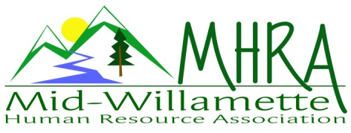
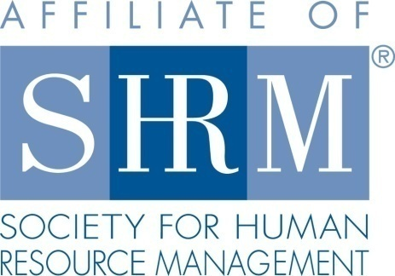

MHRA Mission Statement: to provide knowledge, skills, and resources while working to enhance personal and professional development.

BOARD MEETING (Chapter 202) February 28, 2018 7:30 a.m. to 9:00 Allan Bros. Albany, Oregon

DeeDee Kaundart | President |  | Lucille Valley | Website Chair
Kristen Taylor | Certification/Past President |  | Laurie LeRiche | Workforce Readiness
Claudia Hamilton | Sponsorship Chair |  | Karlina Christensen Lee | Programming
Darcee LaCalli | Legislative |  | Kathy Westberg | Foundation Chair
Jason Bushnell | Treasurer/President Elect |  | Jill Sharp | Membership Chair
Bonny Ray | Secretary |  | Ginny Kroshus | Diversity Chair
Highlighted designates PRESENT.

The meeting began at 7:30 a.m. Welcome by DeeDee of Ginni Kroshus who was visiting the Board meeting from OSU interested in the Diversity Position. The Board took time to do introductions. Robin Bluyeu will be taking over the Treasurer Elect position as well and will be meeting with DeeDee and Jason. Also there are three new members since our last chapter meeting.

Approval of Minutes: The January 24, 2018 minutes were reviewed. The minutes were approved.

2017 final details: CLIF report was submitted on time for the 2018 board roster. SHAPE report is due next week before the 31st. This is mostly done at this point, pending verification of a few minor details.

President’s Report: DeeDee attended the State Board meeting yesterday. There is spam going on in chapters with financial requests coming from Board President’s asking for checks and is on SHRM’s radar. They are working on it and it is happening nationwide. State bylaws have been amended to allow the director and elect to do two year terms. They are working on details of the conference that is being held today on Strategic HR. Thank you to Kathy for the basket and raffle. Jason inquired about when and where state council meetings are held. DeeDee explained more about the State Council dynamics and requirements. DeeDee would like to do a membership survey to seek input about their needs and if they are satisfied or have ideas. DeeDee has a survey template from the Volunteer Leaders’ Summit. Darcee suggested that we hammer out a survey at a Board meeting giving group input. The Volunteer Leaders Summitt is in D.C. on November 15-17, 2018.

Treasurer’s Report: Jason reported on financials. There were more expenses then income. There are outstanding sponsor checks coming in too. Eventbrite payment of $25, $100 from raffle and interest. Jason lowered the sponsorship budget to $2500 and the SHRM payments to $4000. He also added a line to support the student conferences. Expenses related to meeting $460 to Trillium, $100 to SHRM, $80 Board breakfast. Today our CDs roll over both 3 and 12 month. Jason confirmed also that we wanted to open a 6 month $1000 CD and the Board confirmed. Invoice out to Red Kite for $300 and to Saafeld Griggs for $450 and $500 needed for student NHRMA conference. We dipped below $20,000 this month for the first time since June 2017. Kristen asked what we donated last year to the foundation. Jason reported that it was $425. We have budgeted for $450 now. DeeDee said we paid $100 more than needed for food last month because people did not show up. DeeDee motioned that you be charged $10 if you register and don’t show. The Board approved. Jason mentioned that we should make it clear that you can come if you don’t register by accident too. They set and charge by chair so this is tough. We pay for catering by the head and need to let the membership know. Bonny suggested that we put this information on Eventbrite. Lucille suggested we do member communications first and also allow for a box to elect out of breakfast. Kristen suggested that we send a specific communication to people who consistently show without registering or register and don’t show. Then we could send a general communication about the fee for not showing with a start date. DeeDee will draft a communication to go out.

March Membership Meeting Logistics: No update.

March Diversity training: We need Board assistance with room set up please come March 21st to the chapel to help set up at 4:30 p.m. Since this is not a Trillium event they cannot do set up.

Membership Update: Kimberly sent a chapter list for audit purposes. Seven had dropped off and Jill has contacted them. Some of actually moved. There were 12 additional additions on our MHRA list that don’t match and Jill is working on these. Four new members have sent a designation recently to Jill. We currently have 103 members. There is a column about when their membership expires on the audit list and Jill is reaching out to them too. Maybe we need SHRM 101 chapter logistics information time for our members. Shauneen Scott the SHRM director is attending our March meeting and could give our membership an overview. DeeDee thought about having a position spotlight for Board members at Membership introductions too. Jason mentioned that when your renew yearly you can also do your Foundation donation.

Position Reports

Certification: HRCI has changed its requirements for this year. Chapters are no longer able to submit individual programs for credit review as we have done in the past. It is now required to submit an approved provider application. Kristen has received an approved application and is in a one year monitoring/auditing process. Then she will have discretion to decide if a program meets the requirement for credit or not. The approved provider seals are now on the website also.

Workforce Readiness/Diversity: Laurie was absent.

Foundation: The January raffle took in $100. The basket Kathy created for the conference was delivered to Karlina. We will be working on a couple more fundraisers to work on the $350 for the Foundation that is left to raise.

Legislative: Saafeld Griggs did a great update.

Programming: Karlina was absent but sent an update. Trending well for March with attendance. Karlina is working on the April logistics. Paula Barren is presenting and the topic is pending. Jason asked if Yamhill charges for meetings. DeeDee said she believes that they do. We are one of few chapters that still don’t charge for meetings. Bonny asked if we could give members a card of 2018 meetings.

Sponsorship: No one for March, April or May yet. Jennifer Bouman with Red Kite will do June. September is covered by Barker Uerlings. August is covered by Saafeld Griggs. Claudia has hotel rooms covered for the speakers that need those too. Months we don’t have a speaker we could bring up our website on the screen and use the time for training such has how to update your information. Claudia checked out the sponsorship information on the website too and the information is correct/current. AKT will sponsor but has not decided on the month yet. Corvallis Clinic is also going to sponsor but has not picked a month. There is a new member who may be interested in sponsorship role on the Board at some point also.

Website: Lucille has recently updated the website. She needs help with Jill with the update of e-mails as some people have different e-mails. There are three sources for e-mails from the chapter that appear to have slightly different lists. They will work together to figure out how to audit it. They will also think of a process where members can provide us with updated contact information. Maybe at the registration table at the chapter meetings people could also use a form to update us.

Next Board Meeting: March 28, 2018 7:30-9:00am.

Meeting adjourned at 9:00 a.m.

