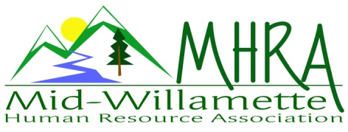
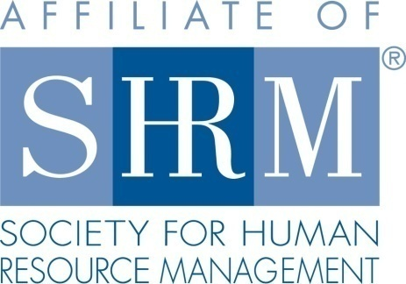

MHRA Mission Statement: to provide knowledge, skills, and resources while working to enhance personal and professional development.

BOARD MEETING (Chapter 202) April 25, 2018 7:30 a.m. to 9:00 Allan Bros. Albany, Oregon

DeeDee Kaundart | President |  | Lucille Valley | Website Chair
Kristen Taylor | Certification/Past President |  | Laurie LeRiche | /Workforce Readiness
Claudia Hamilton | Sponsorship Chair |  | Karlina Christensen Lee | Programming
Darcee LaCalli | Legislative Liaison |  | Kathy Westberg | Foundation Chair
Jason Bushnell | Treasurer/President Elect |  | Jill Sharp | Membership Chair
Bonny Ray | Secretary |  | Robin Bilyeu | Treasurer Elect
Ginny Kroshus | Diversity Chair
Highlighted designates PRESENT.

The meeting began at 7:30 a.m. Welcome by DeeDee of Robin Bilyeu who will be working with Jason as Treasurer Elect.

Approval of Minutes: The Board reviewed and approved the March 28, 2018 minutes with some grammatical changes. Bonny made these changes and the new copy of the minutes were made and saved.

President’s Report: The all-day HR Basics Training had 20 people registered for it. It went well overall. We were hoping for more. The attorney’s involved did a great job.

Treasurer’s Report: Jason reported on financials. Jason received $2000 in checks. He also filed our 2017 taxes. Jason discussed the audit process as we do not have the Secretary of State authorization in our file. This was discovered in the process of purchasing a new CD. The last person to maintain this was Susan Gray in 2012. We have two choices – register as a new company and pay a $50 registration fee or do a waiver request and try to be reinstated and for our lapsed registration we will need to pay all the fees from the time we missed and attach documentation about what happened. It appears that it would be better for us to start over as a new company. If we needed to keep the same BIN we should do so but we don’t need this number. We have been filing our taxes and we are following other rules related to non-profit organizations. The Board voted to register as a new non-profit after considering these options. The raffle also brought in $30. From the training yesterday several Board members need to pay their food cost from the HR Basics training. The Board will likely have some profit from this training once invoices have cleared.

Certification: Kristen had nothing new to report. She has submitted for May.

Website: Lucille was not in attendance.

Workforce Readiness: Laurie attended the SHRM student conference in April. Oregon was well represented. She worked registration and attended the events. It was successful. The students were very excited to be there. The Board discussed having a student come and share about the experience. NHRMA and HR chapters were able to support a huge part of this conference.

Sponsorship: Claudia was not in attendance.

Membership Update: Jill has 110 members at this time as one member left due to moving to Portland. We have a visitor who has come three times but has not yet provided a SHRM number. Jill also needs to talk to Lucille regarding when members sign up at the website as it gives them the perception that completing steps on the website include a complete application but the forms do not go to Jill. Dee Dee reached out to Kimberly at SHRM for a template for a letter to send to new potential members at businesses that have HR employees that are not connected to a chapter. Dee Dee is working on this process. The sponsor asked for a list of members this past month. The Board agreed we would reach out to the members that attended and ask if there information can be shared.

Legislative: Darcee reported that there will be a new withholding tax starting July 1, 2018 related to statewide transportation taxes. There is a new disability claim law procedure regarding denial of disability claims. Employees can now access 401K funds if they are denied disability payments.

Programming: Karlina was absent.

Diversity: Ginny reached out to Jane Waite and Dr. Laurence Houston and will connect with them regarding Diversity Initiatives at OSU and in the community.

Other Discussion: What needs to happen to prepare for the NHRMA conference we are co-sponsoring in 2019? Darcee, Ginny, Kristen and Bonny would be interested in being on a planning committee for this.

Next Board Meeting: May 23, 2018 7:30-9:00am.

Meeting adjourned at 8:20 a.m.

