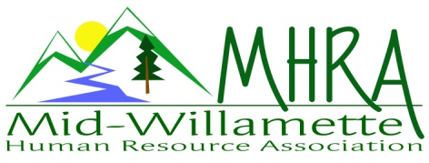
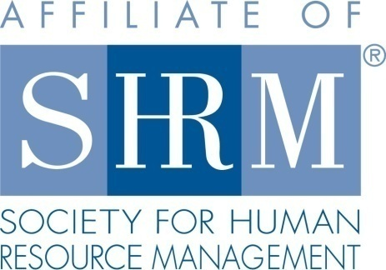

MHRA Mission Statement: to provide knowledge, skills, and resources while working to enhance personal and professional development.

BOARD MEETING (Chapter 202) March 25, 2015, 7:30 – 9:00 am – Corvallis, Oregon

Jean Bonifas | Past President/Membership
DeeDee Gordon | Diversity Chair |  | Robynn Pease | Workforce Readiness
Claudia Hamilton | Sponsorship Chair |  | Karlina Christensen Lee | President
 |  |  | Kathy Westberg | Foundation Chair
Jason Bushnell | Treasurer |  | Jared Haddock | Website Chair
Bonny Ray | President Elect |  | Cindy Bene | Legislative Chair
Kristen Taylor | Secretary/Certification
Highlighted designates PRESENT.

Approval of Minutes: A couple of corrections were made to the February minutes . Jean moved to accept the minutes, DeeDee seconded. Motion carried.

SHAPE: Certification efforts are in good shape to meet award standards, Consider having someone speak at a chapter meeting to promote the National Conference and value. We already advertise on website.

Programming: HR 101 is confirmed for 9/25/15. This is a half day event as a fundraiser. Member price $30.00, Non member price $60.00. Motion and second for the pricing. Motion carried. Hoping for about 40 participants. Event is facilitated by Saalfeld Griggs. Feedback wasn’t great for the last program. Perhaps provide Dave feedback about focusing his future presentations to the learning goals. People felt it was too case study specific. Discussed entering people into a separate raffle for completion of surveys. Jean moved to try it, Jason second. Motion carried.

Sponsorship: Saalfeld Griggs is committed to sponsor again this year, but not finalized yet. Probably later in the year after the legislative session ends. Claudia reached out to Vigilant for April. Signa EAP was suggested. Goal is for each remaining meeting to be sponsored. Other ideas: Accord, Gazette Times potentially—Mike Nalley as a contact, Timber Hill Athletic, Samaritan Health, Kathy Griffiths. AKT is confirmed for June. September, and November are also confirmed.

Treasurer’s Report: Jason presented treasurer’s report. Current month expenses were higher than income. We are still waiting on sponsor payment from the Corvallis Knights. Claudia will follow up with them today. 105.00 was collected for the foundation at last month’s raffle. Motion and second to approve. Motion carried. Brainstormed ideas for donations of raffle prizes as a way to save money.

SHRM/HRCI Certification: Dennis Carr has requested time to speak at the next chapter meeting regarding the upcoming SHRM study group through OSU. He will promote the credential and the benefit of formalized study group participation. This advertising is a way to partner with them between the chapter and the study group. Chapter members are also offered a discount participant rate. Allowing him time in meetings prior to each study group may increase interest in obtaining SHRM credential amongst our members. This will serve to meet the goal of holding informational session at least 2 chapter meetings for the year. May program description and presenter bio were submitted. SHRM PDC credit has been submitted under categories of ethics and business acumen. HRCI credit is applied for, but they have requested additional information. Kristen will need the slide deck to proceed. Kristen will be out of town for next chapter meeting. DeeDee will bring continuing education certificates.

Foundation: Kathy not in attendance. Goal for our annual donation is 306.00 in order to exceed what we did last year. Board is asked to individually donate in the amount of 25.00 each. Perhaps do another gift basket raffle this summer. Summer picnic basket was presented.

Legislative Updates: Cindy sent an email to the group for review. Updates are now being posted to the website for greater member access. The link is attached to chapter meeting reminders as well.

Membership: Jean reporting 2 new members and possibly a third this month. One of the new ones was a prior student member so she had to change her SHRM membership status. This is a total of 5 new members on the calendar year. Jean will request a new audit list as well as an updated at large list. We can distribute justification to supervisor letters to encourage employer support. Jean will edit the letter to include MHRA specific information and have the template available on the website. Membership events: Idea for Sage Gardens community event this summer. This would be non-related to regular programming. An OSU networking event is still an idea. Goal to reach out to the business center staff. Hilton Gardens is a prime location. Robynn suggested LaSells Stewart Center is a possibility too. Claudia will approach the Hilton as a sponsor also. Try this route first, then LaSells through Hilton, then LaSells direct last.

Workforce Readiness: Continue to work on language for the readiness section on the website. Robynn will coordinate with Jared on this. David Bird from LBCC attended our last meeting. We will partner with his department for intern opportunities.

Website: Jared posted advertisement for the OSU SHRM study group on the chapter website. Icon on the page to advertise both SHRM PDC and HRCI credit for programs. Workforce readiness section to be added. Membership award is on there.

Diversity: Sub-committee has been meeting with the heroes for hire program. Goal is to improve veteran re-integration to the workforce following deployment. Idea presented to match veterans with employment mentors. May be able to use the CFH Chapel building for meeting site.

Other:

Robynn and DeeDee will manage reception for the April meeting,

Meeting adjourned at approximately 9:00 a.m.

