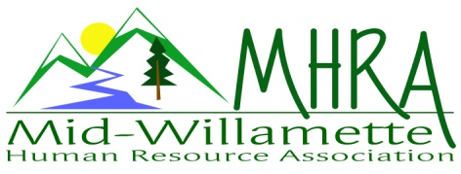
1 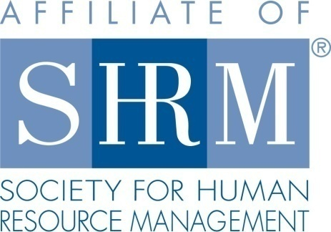

MHRA Mission Statement: to provide knowledge, skills, and resources while working to enhance personal and professional development.

BOARD MEETING (Chapter 202) August 23, 2017 7:30 a.m. to 9:00 Allan Bros. Albany, Oregon

Kristen Taylor | President |  | Jared Haddock | Website Chair
DeeDee Gordon | Certification/President Elect |  | Laurie LeRiche | Diversity/Workforce Readiness
Claudia Hamilton | Sponsorship Chair |  | Karlina Christensen Lee | Programming
Darcee LaCalli | Legislative |  | Kathy Westberg | Foundation Chair
Jason Bushnell | Treasurer |  | Jill Sharp | Membership Chair
Bonny Ray | Past President/Secretary
Highlighted designates PRESENT.

The meeting began at 7:30 a.m.

President Announcements:

Carry over from last month. Kristen will submit the updated bylaw request this week. As per July meeting: The Board reviewed the bylaws. There was a question regarding term limits. It appears the bylaws limit Board members to two terms in a position. A motion was made to edit bylaws to allow for longer terms when there is not another volunteer to fill specific roles. This language is located in Article 6, Section 6.5. Karlina proposed this and Claudia seconded the motion. Kristen will send a request for these changes to our local representative Diana for assistance with this change to the bylaws.

Approval of Minutes: The July 2017 minutes were reviewed. Kristen moved for approval and Claudia seconded the motion. The minutes were approved.

September Membership Meeting Logistics: Stacy Stack presenting, Corvallis Clinic is sponsor.

Treasurer’s Report: Jason passed out the monthly report. Expenses were slightly higher than income this month but all in all financial picture continues to look good. We discussed doing away with the $200.00 sponsorship option because we were not really seeing increased sponsors, but rather existing sponsors simply choosing the cheaper option with limited impact on ROI. Karlina has already updated the flyer and distributed. 3 month CD is about the mature. Laurie moved to roll it over, DeeDee 2nd. Motion to roll carried.

Membership Update: Membership details have been passed on to Jill for follow up. Thank you Jill! We discussed getting an at-large list imminently to start pushing invites to our October meeting as a membership drive event.

Position Reports

Certification: The Salem Chapter is hosting a chapter study group. We will continue to advertise this opportunity to members. All programming for the remainder of the year is submitted for credit.

Workforce Readiness/Diversity: No new updates at this time.

Foundation: We raised 80.00 at the August meeting raffling the ticket to the strategic conference this fall. This bring us to 220.00 year to date. Goal is to exceed 420.00. We are going to try something new for the next raffle—run it all fall long: offer tickets for sale at the September, October, and November meeting in honor of football season. We will then draw in November for the signed Joey Harrington football. We will need to have people print their names on the tickets and need not be present to win. We also discussed trying to do some more formal, perhaps email education about what the Foundation does.

Legislative: No new legislative updates since the last meeting. Darcee presented a review of attendance as compared to the monthly registration for the chapter meetings. We consistently have a few no shows and a few drop ins. On average our reported head count for catering purposes has been very close.

Programming: Karlina was not in attendance today. The remainder of the year is set and next year is filling out. October is Emily Drew on Difficult Conversations. It will be a longer meeting and we will charge $25.

Sponsorship: September, October, November are covered. No December sponsor at this time. Claudia will stay in the sponsorship role next year and continues to reach out.

Website: Jared was absent so no website update.

Future Planning: Board meeting here next month.

Next Board Meeting: September board meeting is being cancelled due to conflict with the Bend NHRMA Conference and most of us unable to attend. Next meeting at the regularly scheduled date/time: October 25, 2017

Meeting adjourned at 9:00 a.m.

